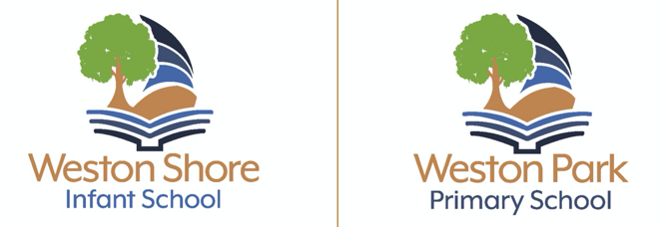

Art and Design Technology Intent statement
Intent: Introduction, Vision and Philosophy
Art and Design Technology is delivered within a coherent, well sequenced and balanced Art curriculum. This document explains how we deliver Art and Design Technology to all our children and demonstrates how all needs are met.

We want our children to experience the use of materials, different media techniques, acquire knowledge and skills, by exploring the work of artists and art forms in different contexts. The children will study the works of a range of artists, and designers that are selected to give a broad and balanced view of Art and Design across different cultures, both past and present.

We recognise different ways of learning: Art and Design Technology provides a way of enabling children to make mistakes, which promotes using their problem-solving skills. The teaching of Art and Design Technology involves teaching skills and concepts in an inclusive, inspiring, engaging and relevant way. The process of making art is just as relevant as a finished piece. This allows scope for further opportunities developing the children’s understanding around reflecting on pieces of work, their methods when revisiting work and evaluating their work.

We also provide opportunities for children to develop their Art skills through afterschool clubs across KS1 and KS2.

We believe every child is an artist and needs:

- Observational skills
- Imagination and ability to learn
- The ability to express thoughts and feelings through visual arts
- Encourage every child to experiment
- To increase subject knowledge, skills and vocabulary
- To instil a passion and a way of developing an understanding of the world through art and design.
- To incite and make connections with the world around
- To analyse and critique their artwork and the work of others.

Implementation: What does Art and Design look like at Weston Schools Federation?
Art and Design Technology is taught either weekly or blocked to link into the wider curriculum.
Children’s work is evidenced in sketch books, displays and within the classrooms. Children will learn through the following skills:

- Drawing
- Painting
- Printing
- Sculpture
- Collage
- Textiles
- Cooking (linked through healthy eating, science)

Impact: Evidence and Assessment
Each child has a sketchbook (Years 1 – 6) to document work and reflect practice and they are used to record pupils’ process and development of skills and techniques. Each sketchbook should document a child’s progress in the skills areas (as indicated above).

Children will be encouraged to use their own ideas and experiences to create work that is valued and allowing for chances for children to work independently and with others.

Art and Design Technology in the EYFS
In the Early Years we believe that art and design can support the whole curriculum because positive experiences can develop creativity and independent thinking, and boost confidence, self-esteem, and personal, social and emotional development. As such, children are able to access a wide variety of open-ended art resources every day which they can take part in independently and create a physical representation of their thoughts and feelings.

We recognise that quality early years art can largely be divided into two key skill sets. The first is the practical skills needed to be able to make a piece of art. This could involve holding a paint brush, using scissors appropriately, manipulating a material such as playdough or clay, or knowing that there are different types of glue that have to be used at different times. We support children all year to develop these skills. Sometimes these are taught as a whole class, and then children are given the opportunity to apply them. Other times, adults join children as they explore a tool or technique and help them work out the best way to use it.

The second skill set is having the confidence and imagination to represent these ideas in their artistic endeavours. Children are encouraged to discuss their plans before they make their model, drawing or painting, but also to have the confidence to change their ideas as they come up with new ones. EYFS celebrate pieces of art as whole classes, giving children the opportunity to come to the front and discuss the key features of their work. As classes, teachers and children often discuss favourite features of the children’s artwork so that others can learn from their peers. Art resources are available from a help yourself station, so children can always get started on an activity.

Assessment: Teachers in EYFS will use the Early Learning Goals and KS1/KS2, will use the National Curriculum outcomes. Children are provided with tips and reminders about how to use tools and techniques.

