Weston Park Primary School
Designated Safeguarding Lead is Nicki Windle
Contact on 02380448962
n.windle@weston-park.org.uk

Key Reminders:
Are your contact details up to date with the office? We require at least 2 people’s contact details for use in case we need to contact you, for example your child becomes unwell during the day or there is an emergency / urgent message to share. Please update the office with any current contact details and remember to keep us posted if this changes.
Your support with this is really appreciated.
Hello and welcome to our first monthly safeguarding newsletter where we will be sharing with you any current key focuses, updates and messages linked to keeping safe and safeguarding. We trust you will find this useful.

Staying Safe Online
The NSPCC have recently reported a significant increase in online grooming. Figures from a freedom of information request to 42 police services in England and Wales have found that:
• In 2021 there is was an all-time high, a jump of around 70%.
• Snapchat and Instagram were the most common tools used by offenders.
• There were 5,441 offences of sexual communication with a child recorded between April 2020 and March 2021.
There can be little doubt that lockdown played a significant role in this, and a couple of important points are made:
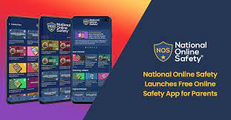
• These are recorded offences; it is widely suspected that the majority of offences go unreported and undetected.
• Although the most common tools used by offenders to groom children were Snapchat and Instagram, grooming can happen anywhere, e.g. it can take part a

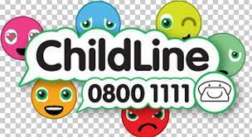

game and to private chat within an app or within the game.

Advice
Talk to your child. Their online lives and the myriad of games/apps they are using can appear overwhelming, but unless you understand their online lives, the support you can give them is limited.
Use parental controls. All games, apps and consoles come with parental controls such as turning off chat. Many children and young people use gaming for socialising with their friends so if you do allow them to chat, keep a watchful eye on their friends list.

