Weston Federation Schools
Designated Safeguarding Lead is Nicki Windle
Contact on 02380448962 / 02380 390399
n.windle@weston-park.org.uk

Weston Federation Community Hub
Hello and welcome to our monthly safeguarding newsletter / update.
If there is any aspect of safeguarding and staying safe you would like us to share please let one of the team know.

Weston Federation Community Hub
Name
What is this?

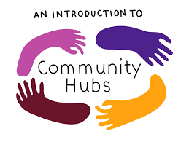

At the Weston Federation of schools, we are super excited to let you know of a further service the school will be offering the community. We are opening a Community Hub based at Weston Park Primary.

A community hub is somewhere that provides services for the community. The community hub will be led by James Wiltshire, Nicki Windle; supported by Zoe Billows.

The community hub will be multipurpose, providing and hosting a range of activities and services to support you the community we support.

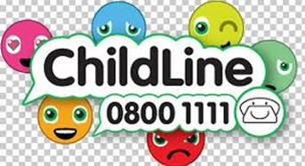

Coming soon

The activities and services offered will be delivered by local people and local groups / organisations that will offer the help and support needed. School staff will also be there at times to offer support and help as appropriate.

The activities and support we will offer is as follows (but as always, we are happy to hear from you about anything you think would be beneficial):

- A weekly drop-in SOS session where you can pop along and speak to someone about any support / help you needed -even just pop in for a chat
- Behaviour / SEND support
- KICK START workshops
- Housing / financial support
- Learning English (language
- Help with life admin – paperwork, forms, and applications etc
- Support with mental health / anxiety – adult and child
- Health and wellbeing
- Parenting support
- And so much more

We really believe these sessions will enhance what we offer to the community – we really look forward to working with you and your families.

What help could it offer me / my family / the community?

As above the support on offer will cover a broad range of themes and areas of support – from housing, to financial, to food banks, to mental health support, to access to health practitioners, support with ‘life admin’ such as form filling, school applications, to parenting support and more.

There will be support there each week should you need to talk to someone, get advice / help, get a referral – the door is open to anyone who needs help.

When and where?

The main session will be on a Wednesday morning, straight after school ‘drop-off’.

We may offer other courses or workshops that will run on other mornings, but we will advertise these in advance. Please speak to Zoe in the KS1 office for more details on a week-by-week basis.

Name will be held in the Reema block based at Weston Park Primary School – this can be accessed via the Chamberlayne Leisure Centre field or the Weston Lane school entrance.

There is no expectation to attend every week, you are welcome as regularly as you find it useful.

If you have little ones, they are welcome to come along with you to the weekly session – course and workshops may vary with this.

Refreshments will be provided.

What next?
Where can I find out more?

We are working hard to get Name ready to launch as early in the new term as we can and will be sending out more information in due course – keep a look out!

If you are interested in joining us, and we hope you are, do let us know.

If there is something you think we could offer through our community hub that we haven’t already mentioned please speak to James Wiltshire, Nicki Windle or Zoe Billows – we welcome working with you.

In the meantime, we would like to welcome you all back to school for the new year – we are really looking forward to another positive year across the Weston Federation of schools. We hope the summer has been positive for you and your families.

We know times are challenging for many just now and want to remind you we are here to help where we can – please speak to one of us if you need any help / support.

NVR – Limited Places

As part of our community hub we are offering the NVR course – this is a really fantastic opportunity we are able to offer to parents / families who are wanting to develop new ways of managing behaviour at home. This is an especially good ocurse for parents / carers of children who may have ASD / ADHD.
We can offer 15 places on this course, please see Nicki Windle if you feel this would be of interest, or to find out more.

