Weston Park Primary School
Designated Safeguarding Lead is Nicki Windle
Contact on 02380448962
n.windle@weston-park.org.uk

Hello and welcome to our monthly safeguarding newsletter / update.
If there is any aspect of safeguarding and staying safe you would like us to share please let one of the team know.
Key Reminders:
Please make sure your child is bringing their PE kit into school on their PE days. It is an important part of health and safety that the children change into appropriate clothing and footwear for physical activity – it is also good hygiene.
Please NO EARRINGS on PE days to keep the children safe from injury.
Firework Safety
Firework safety – the basics
• Make sure children stand at a safe distance from the bonfire
• Keep everyone well back from the display.
• Never return to a lit firework.
• Never throw fireworks.
• Keep fireworks in a closed metal box.
• Always follow the instructions when using fireworks. Sparkler safety A sparkler can reach a temperature of up to 2,000 degrees Celsius – 20 times the boiling point of water.
• Always hold sparklers at arm’s length and wear gloves when handling them.
• Don’t hold babies and young children while you’re holding a sparkler – they can reach out unexpectedly and grab at them.
• Don’t give sparklers to children under 5. They’re too young to hold them safely and don’t understand why they might be dangerous.
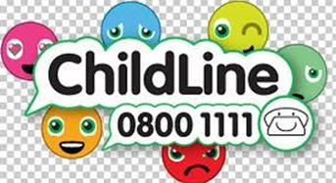

• Once sparklers are out, make sure you put them in a bucket of water

Mental Wellbeing
Evidence suggests there are 5 steps you can take to improve your mental health and wellbeing. Visit the NHS website to view these 5 steps and to access some supportive contacts and networks
www.nhs.uk/conditions/stressanxietydepression/improve-mental-wellbeing
Anxiety UK Charity providing support if you have been diagnosed with an anxiety condition.
Phone: 03444 775 774 (Mon to Fri, 9.30am to 10pm; Sat to Sun, 10am to 8pm)
Website: www.anxietyuk.org.uk

