

Hamwic Education Trust & Weston Shore Infant School
Child Friendly Privacy Notice

Reviewed on |  | September 25 |  | Review frequency |  | Annually
Next review due |  | September 26 |  | Template Yes / No |  | Yes
Owner |  | Head of Compliance |  | Approved by |  | Executive

History of Policy Changes
Date | Page | Change | Origin of Change

Contents
1. History of Policy Changes 2
2. Contents 2
3. Introduction 3
4. Who are we? 3
5. What information do we hold about you? 3
6. Why do we need this information? 4
7. Where do we get your information from? 4
8. What do we use your information for? 4
9. Where do we keep your information? 4
10. What are your rights? 4
11. Contact 4
12. Monitoring & Review 4

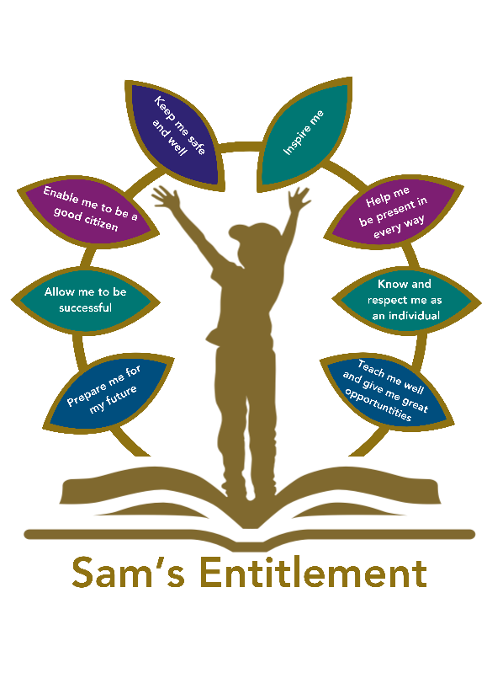

Introduction
“Hamwic Education Trust (HET) believe that all pupils should receive a high quality, enriching, learning experience in a safe and inclusive environment, which promotes excellence through a broad curriculum that prepares them for their future and opens doors to a diverse array of opportunities as well as that all pupils and adults within HET flourish as individuals and together.” This policy sets out……

Who are we?
We are Weston Shore Infant School and we are responsible for the information we collect and hold about you. We are part of the Hamwic Education Trust (HET) which is a multi-academy trust incorporating a number of different schools.

What information do we hold about you?
We collect a lot of information about you while you are at school such as your name, address and details of other family members. We also collect information about your progress in school such as how often you attend school, how well you do in different subject areas and information about your health and wellbeing.

Why do we need this information?
We collect this information because we have a legal duty to. Sometimes the government or our local council asks us to collect this information so that they can see how we are performing compared to other schools.

Where do we get your information from?
If you join us from another school, your old school will pass us your information when you move. In other cases, most of the information will have been provided by your family when you started school and then we collect information from you as you progress through school.

What do we use your information for?
We use your information so that we can teach you and provide you with any support you might need. We also use your information to make sure we keep you safe.

Where do we keep your information?
Your information is kept safe in our electronic records. We have protection in place to make sure your information can only be accessed by people who need to see it so that we can teach you, support you or keep you safe.

What are your rights?
We will keep your information for as long as you are a pupil here. If you move to a different school, we will pass your records to your new school. If you complete your education here, we will keep your information for a number of years after you leave because we have to by law.

Contact
We have a person called the Data Compliance Officer (DCO) at the school. They can answer any questions about this privacy notice or what the school does with your information.
If you want to speak to them, then you can do that by calling the office on 02380390399

You can also contact HET’s Data Protection Officer (DPO), Gemma Carr, Deputy CEO.
Email: compliance@hamwic.org. Telephone: 023 8078 6833.
Address: Hamwic Education Trust, Unit E, The Mill Yard, Nursling Street, Southampton, Hampshire SO16 0AJ.

Monitoring & Review

This policy will be reviewed annually by the owner

