
Weston Schools Federation
Designated Safeguarding Lead is Nicki Windle
Contact on 02380448962
n.windle@weston-park.org.uk

Key Reminders:
Speak to a member of staff if you feel you may need the support of a food bank or similar over the summer break.
Hello and welcome to our monthly safeguarding newsletter / update.
If there is any aspect of safeguarding and staying safe you would like us to share please let one of the team know.

Sun Safety
For the best protection use all five forms of sun protection – clothing, sunscreen, a broad-brim hat, shade and sunglasses

Make sure you:
- spend time in the shade when the sun is strongest. In the UK, this is between 11am and 3pm from March to October.
- never burn.
- cover up with suitable clothing and sunglasses.
- take extra care with children.
- use at least factor 30 sun cream.

Sun damage and protection myth-busting
There are a lot of misconceptions about the strength of the sun here and how much damage it can do. Such as:

- The sun is not strongest when it feels the hottest. Instead, the highest risk of sun damage is when the sun is highest in the sky, which in the UK is between 11am and 3pm.
- Sunscreen does have an expiry date. It won’t be effective after that date, so always check if you are using last year’s sunscreen product.
- Sunscreen needs to be reapplied throughout the day. This is the case even if the bottle says it’s a once-a-day product.
- Sunburn does not only happen in the summer. In the UK, the sun can be strong enough to burn from March to October, even on cloudy days. The key is
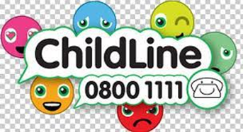

the UV index – the graphic below explains what UV ratings mean in terms of necessary protection, and you can find the UV index for your area by searching https://www.metoffice.gov.uk/

REMEMBER
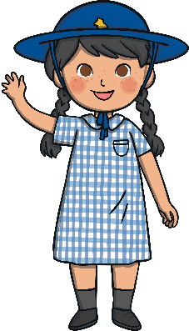
Always wear a hat when playing in the sun. If you can, find one that shades your face, neck and ears.

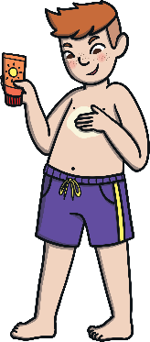

Use high factor sunscreen to protect your skin. Don’t forget to top it up every couple of hours!

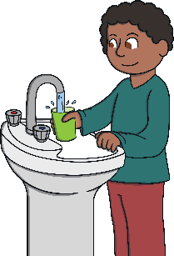
Drink lots! It’s easy to dehydrate, especially if you’re running around.

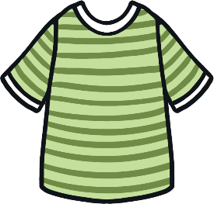

Cover up with a T-shirt



