
Weston Federation
Designated Safeguarding Lead is Nicki Windle
Contact on 02380448962
n.windle@westonschoolsfederation.co.uk

Reminders:
Please refer back to our Online Safety Newsletter earlier this year to see the risks about grooming online.
Hello and welcome to our monthly safeguarding newsletter / update.
If there is any aspect of safeguarding and staying safe you would like us to share please let one of the team know.

Grooming – What is Grooming?
Grooming is a process that "involves the offender building a relationship with a child, and sometimes with their wider family, gaining their trust and a position of power over the child, in preparation for abuse." (CEOP, 2022)

Grooming can happen anywhere, including:
- online
- in organisations
- in public spaces (also known as street grooming)
(McAlinden, 2012).

Children and young people can be groomed by a stranger or by someone they know – such as a family member, friend or professional. The age gap between a child and their groomer can be relatively small (NSPCC and O2, 2016).

Grooming techniques can be used to prepare children for sexual abuse and exploitation, radicalisation (Department for Education (DfE), 2017) or criminal exploitation (Children's Commissioner, 2019).

Grooming – What is Grooming?
It's rare for a child to tell an adult about being groomed.

Children may not feel able to seek help because they:

- are unaware that they're being groomed.
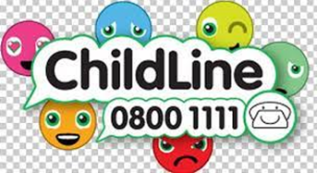

- believe they are in a caring relationship and are worried about jeopardising it are scared of what the groomer will do if they speak out don't want to get the groomer in trouble blame themselves for getting involved in the relationship are ashamed or worried about sharing what’s happened to them with other people.

If a child does speak out, you should reassure them that they’ve done the right thing in telling you, and that what’s happening to them is not their fault.

Which signs should I look out for?
Professionals should be aware of and able to recognise signs that a child may be being groomed.

Signs a child is being groomed include:

- sudden changes in behaviour, such as spending more or less time online
- spending more time away or going missing from home or school
- being secretive about how they’re spending their time, including when using online devices
- having unexplained gifts, big or small
- misusing alcohol and/or drugs
- having a friendship or relationship with a much older person
- developing sexual health problems
- using sexual language you wouldn’t expect them to know
- seeming upset or withdrawn
- mental health problems

Grooming Behaviours
Groomers typically use certain patterns of behaviour to lead a child to believe that what is happening is normal, or to make the child feel trapped. The grooming relationship can move quickly from being something that seems to have positive benefits for the child to being very frightening and isolating.

Gaining trust
A groomer hides their true intentions and over time "gains the child’s trust and confidence" in order to abuse them (Sexual Offences Act 2003: explanatory notes). The child or young person is conditioned to respect, trust and love their groomer. They may not understand they are being groomed because they consider their groomer to be a friend, boyfriend or girlfriend (Coffey and Lloyd, 2014).

The groomer may also work to gain the trust of a whole family, to allow them to be left alone with a child. If the groomer works with children they may use similar tactics with their colleagues.

Groomers gain trust by:

- pretending to be someone they’re not, for example saying they are the same age as the child online
- offering advice or understanding
- buying gifts
- giving the child attention
- using their professional position or reputation
- taking the child on trips, outings or holidays
(Rigg and Phippen, 2016).

Gaining Power
Once they’ve established trust groomers will exploit the relationship by isolating the child from friends or family and making the child feel dependent on them. Groomers will use power and control to make a child believe they have no choice but to do what the groomer wants.

Secrets
Groomers may introduce 'secrets' to control or frighten the child. Sometimes they will blackmail the child or make them feel ashamed or guilty to stop them telling anyone about the abuse.

Manipulation
Groomers use a range of strategies to entrap a child and manipulate them. They present themselves as approachable, likeable and having shared interests with the child they are targeting.

Our Childline service offers support and advice to children and young people who have been groomed. One young person told us about how a manager of an online game had used the offer of making him a moderator as part of the grooming process.

Groomers will test a child’s compliance by persuading them to carry out inappropriate or abusive activities. They use tactics such as reverse psychology (for example, "I’m not sure about this, I think you might be too young") or strategic withdrawal (such as, "It was just an idea, it’s completely up to you") which give the child the impression they are in control of the situation (Lorenzo-Dus, Izura and Perez-Tattam, 2016).

Online grooming
Groomers can use social media, instant messaging apps or online gaming platforms to connect with a young person or child. It's easy for groomers to hide their identity online – they may pretend to be younger than they are, and then chat and become 'friends' with children.

Groomers don't always target a particular child. Sometimes they'll send messages to hundreds of young people and wait to see who responds.

Groomers don't need to meet children in real life to abuse them. After making online contact, a groomer may convince a child to meet in person. However, groomers can also sexually exploit children and young people by persuading them to take part in online sexual activity (IICSA, 2020). The Internet Watch Foundation found that over 70% of identified child sexual abuse images in 2021 were self-generated (IWF, 2022).

Social media and other online platforms are also used to groom children to involve them in criminal exploitation, for example county lines (Children's Society, 2019).

Protecting children
Raising awareness
Communities can be the strongest allies in protecting children from grooming (Coffey and Lloyd, 2014).

It's important for all professionals working with children to be aware of:

- what grooming is
- signs of grooming displayed by children
- typical grooming behaviours.
It's also important that professionals are aware of, and know how to respond to, the different types of abuse and exploitation grooming can lead to, including:

- sexual exploitation
- sexual abuse
- online abuse
- county lines
- radicalisation.
- Empowering children

Professionals working with children and young people should help empower them to recognise and speak out about abuse. This includes:

- teaching children and young people about healthy relationships
- helping children and young people develop the awareness and skills needed to keep safe online
- helping children to identify the safe people and places they are happy to go to for support.
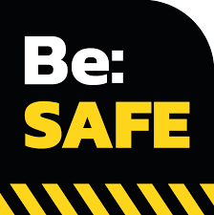

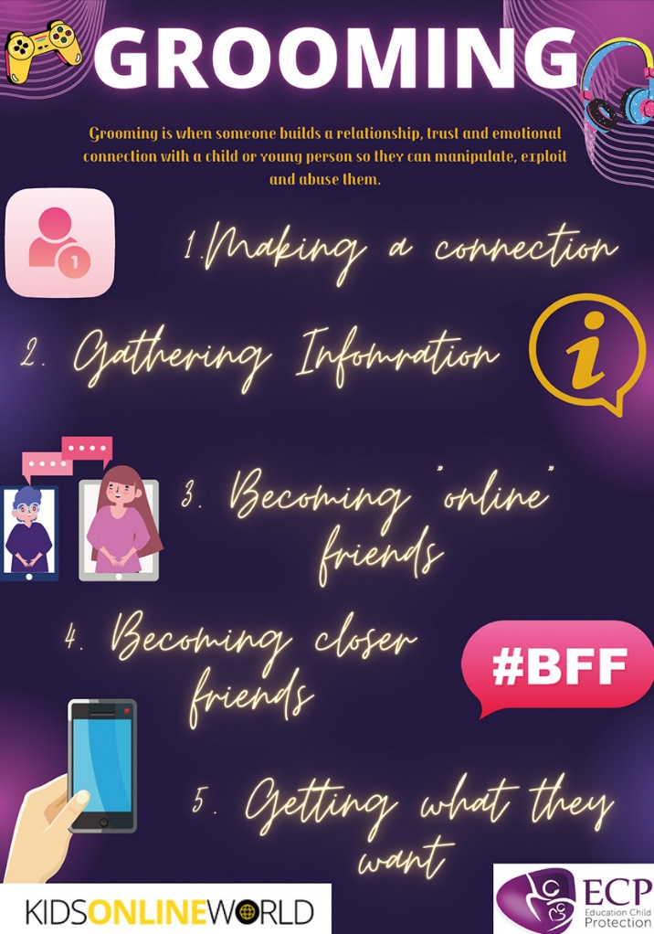

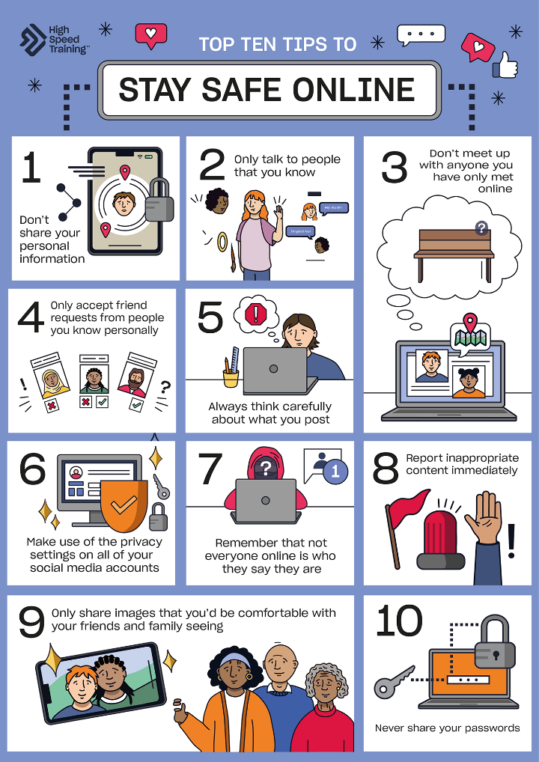

Staying safe online – some reminders!
There are several ways to keep safe online.

If there is something that concerns you or is said / done to you that worries or upsets you there are several things you can do –
- Tell a trusted adult
- Block the person / people
- Check your safety settings are in place correctly
- Report any inappropriate contact online to help everyone stay safe
  - Report to CEOP
  - NSPCC 08088005000
  - Report Remove | Childline
  - Report Harmful Content - We Help You Remove Content
  - Report online child sexual abuse imagery or 'child pornography'

The NSPCC have a range of support and resources online to supporting keeping our children and young people safe online.

Keeping children safe online | NSPCC

If there are any element of threat, harassment or signs of grooming behaviour then we would encourage you report this to the police via 101, via the phone or online.
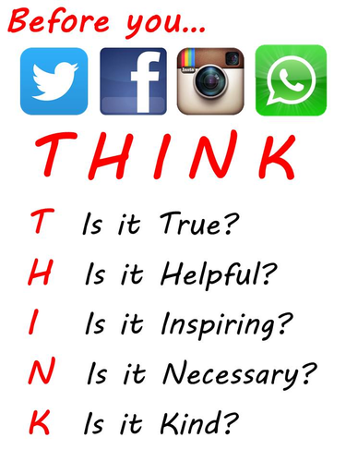
If you are concerned about the safety or wellbeing of a young person online you can share this with the school safeguarding team (DSLs) and also to the Children’s Resource Service on 02380 833004.

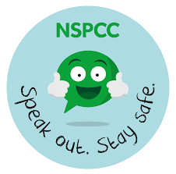

REMEMBER
Support children to understand that their behaviour online, what they say and do matters as much as it does in person.

Whatever they say or do online is there forever, a ‘footprint’ will be left.

The same rules (and law) apply to what we say and do online as it does offline.

