Weston Park Home Learning Overview: Spring Term 2
Year: 2 | Class: 2M, 2A, 2T | Date: February 23rd - 27th March 2026
Reading
Boomreader

Wow! Thank you so much for your engagement in BoomReader. Some children are reading such a lot and I have been incredibly impressed. There continues to be a true excitement in finding out how many reads everyone has managed to do. It is lovely to see the children beaming with pride. For clarity, you don’t have to finish a book in order to add it on BoomReader. Some children are reading long chapter books now and so if they just read a few pages, that’s fine. Please do keep adding adding adding. Children are being rewarded in school for reading regularly at home, make sure your child doesn’t miss out.
A shout out, deservedly needs to go to Hannah, in 2M, who has now read 232 times and is our self-professed Reading Queen! Huge congratulations Hannah for your dedication! Watch out though, Julia is also hot on your heels with 186 reads!
Accelerated Reader

Children can change these books any day. When they have finished reading a book, they know to ask to do a quiz and then choose their new book. If you know your child has finished their book, it would be helpful if you could remind them to do their quiz in the morning, as they can get a laptop as soon as they come in. Thank you.
Little Wandle Phonics – Some children are consolidating their phonics and reading Little Wandle phonics books. If your child is reading these books, please ensure they bring them to school on a Friday so that they can be changed.
Library
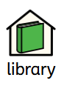 | Year 2 library day continues to be Friday. Please ensure library books are in school on Fridays so they can change them.
Reading in school
Our topic this half term is Plants and we will be reading some brilliant books with a plants/nature theme.
In reading lessons, we will continue to practise our skills of inference and retrieval while also practising prediction.
We will be trying to make predictions based on what we already know and use our oracy skills to explain this. I think this is going to happen…… I think this because…….
We will also be continuing to work on our fluency and expression which is coming on leaps and bounds.
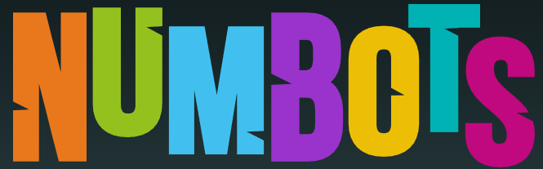
Maths
Thank you for your continued support with encouraging your child to do TTRS or Numbots. Practising for 5 minutes a day will have an amazing impact on their understanding of number.
In Maths lessons this half term, we will be learning more about adding and subtracting two digit numbers, but this time, the ones digits will cross ten. We will, as always begin by using concrete apparatus and we will be learning how to regroup the ones for a ten. Then we will learn how to represent this in different ways such as on a number line. An important strategy to understand for this is the ‘make ten’ strategy where we think… How many do we need to make 10? If I add these on, how much more do I have left to add? You could really help your child by practising their number bonds with them at home. This will help to speed up their mental calculations.
After Addition and Subtraction we will move onto Money and Shape. At home, it would be great if you could spend some time looking at coins together and seeing if the children can recognise them.
Home Learning Creative Project : - Due in during the last week of term
Choose from one of these projects:
Invent a new plant that could survive in a chosen habitat (desert, jungle, Arctic, etc)
Choose whether to present it as a :
labelled drawing, a model using junk materials or as a short information text.
Or
Be a Plant Spotter by exploring plants growing in our local area.
Choose whether to: create a:nature scrapbook, bark or leaf rubbings or photographs/drawings of plants with labels on them
Hot Topic:
As part of our learning about plants we will be thinking about Where does our food really come from?
You could discuss at the dinner table: Which foods come from plants? What happens before food reaches the supermarket?
Spelling
Spellings will continue to be sent home on a Friday for Look Cover Write Check practice and are tested the following Friday. These spellings are often linked to our learning in English so knowing them really helps the children to be successful in their independent writing. Please find all the Year 1 and 2 words that the children need to be able to spell below. Practising these at home would be very worthwhile.
Year 1 |  |  | Year 2
a | full | once | after | father | pass
are | go | one | again | find | past
as | has | our | any | floor | path
ask | he | pull | bath | gold | people
be | here | push | beautiful | grass | plant
by | his | put | because | great | poor
come | house | said | behind | half | pretty
do | I | says | both | hold | prove
friend | is | school | break | hour | should
full | love | see | busy | improve | steak
go | me | she | child | kind | sugar
has | Mr | so | children | last | sure
he | Mrs | some | Christmas | many | told
here | no | the | climb | mind | water
his | of | there | clothes | money | who
house | said | they | could | most | whole
I | says | to | door | move | wild
is | school | today | even | Mr | would
love | see | was | every | Mrs
me | she | we | everybody | old
Mr | so | were | eye | only
Mrs | some | where | fast | parents
no | the | you | find | pass
of | there | your | floor

