Weston Park Home Learning Overview: Spring Term 1
Year: R | Class: FR, FD, FC | Date: 05th Jan – 13th Feb 2026
Reading
Boomreader

Your child will have the opportunity to bring home up to three books to support their reading journey:
1. Phonics Decodable Book
These books are carefully selected for your child and matched to their current reading level. They will be changed once a week by the Year R team.
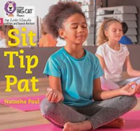
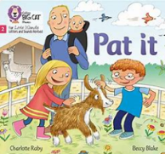

2. Love of Reading Book
These books are available on the trolley outside the Year R classrooms and make a great bedtime story!

3. Library Book
Your child will visit the school library once a week.

All reading can be logged on your child’s Boom Reader account. The more reads logged, the more fun and engaging Boom Reader becomes!
Phonics:
This half term in Phonics we have been revisiting some phase 2 sounds and beginning to learn phase 3. This includes learning digraphs (two letters that make one sound) and trigraphs (three letters that make one sound)
Here are the sounds we have been learning:
Week 1 – ai ee igh oa
Week 2 – oo oo or ar
Week 3 – ur ow oi ear
Week 4 – air er
Week 5 – Revisit and review

When we practice reading these sounds we call them reading our ‘speedy sounds’. We use flash cards and encourage the children to recognise the sound quickly. At the end of the half term we will send all the new digraphs and trigraphs home with the children for them to practice reading them at home.

In phonics we learn the sound that each letter makes and we encourage the children to sound talk a word and blend it together.
For example SH – O – P “shop”
Reading everyday will help to support your child to be able to sound talk and blend words independently.

Tricky words
There are some words that you cannot sound talk and blend and these are known as our tricky words. These are words we just need to remember because parts of them are tricky.
Here are the tricky words we are learning this half term.

Week 1 & 2 – was, you, they
Week 3 – my, by, all
Week 4 – are, sure, pure

Maths:


We have now launched Numbots for Year R and will be giving out weekly certificates for the most engagement at home. If you need a reminder of your child’s login, please do ask. Logging on at least three times a week will support your child’s number skills.
Handwriting:
Please support your child in learning to write letters correctly. If you notice that your child writes one of the letters the wrong way round, please take the time to correct this and practice so that it doesn’t become a habit. Here is an example of our handwriting script

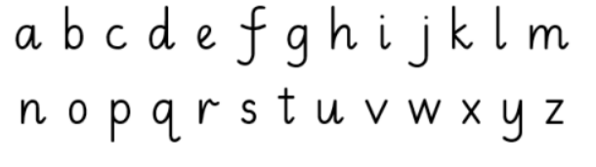

Pencil grip:
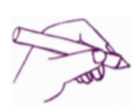
We support children to hold their pencil correctly every time they are writing. We have a rhyme that helps them to remember how to do this:

Pinch your fingers
Quack, quack, quack,
Pick it up and
Filp it back

Hot Topic:

Our topic this half term is ‘To infinity and beyond’. We will be learning all about the planets in our solar system and what it takes to become an astronaut. Take time to have a look up at the stars at night and discuss what you see? What do we know about our planet? What do we know about other planets? Would you like to visit space? Why? How could we get there?

Important Dates for your diary
- Number day – Monday 5th January
- Attendance shop open – Thursday 5th February
- Story on the moon’ – Thursday 12th February come into school and share your child’s learning.
- INSET DAY – Friday 6th March

