Weston Park Home Learning Overview: Spring Term 2
Year: R | Class: FR, FD, FC | Date: 23rd Feb – 27th March
Reading
Boomreader

Your child will have the opportunity to bring home up to three books to support their reading journey:
1. Phonics Decodable Book
These books are carefully selected for your child and matched to their current reading level. They will be changed once a week by the Year R team.
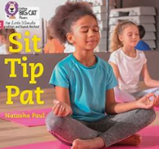
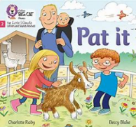

2. Love of Reading Book
These books are available on the trolley outside the Year R classrooms and make a great bedtime story!

3. Library Book
Your child will visit the school library once a week.

All reading can be logged on your child’s Boom Reader account. The more reads logged, the more fun and engaging Boom Reader becomes!
Phonics:
This half term in Phonics we will be revisiting all the previously taught digraphs and trigraphs. We will be continuing to sound talk words and blend them together. We will be working on blending words and being able to read a simple sentence.
Here are the sounds we will be learning:
Week 1: ai ee igh oa oo ar or ur oo ow oi ear
Week 2: er air
Week 3: words with two or more digraphs
Week 4: longer words, words ending in –ing
Week 5: longer words

Tricky words
We will not be learning new tricky words this half term but we will be revisiting ones already taught.
Here are the tricky words we have learnt:
Is, the, I, put, pull, full, as, has, and his, her, go, no, to, into, she, he, push, of, we, me, be

Maths:
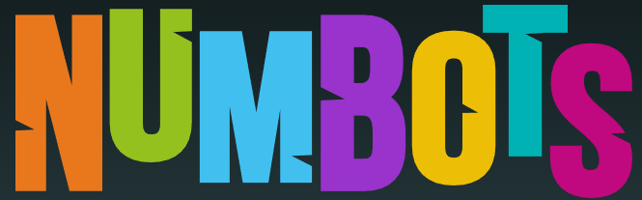

We have now launched Numbots for Year R and will be giving out weekly certificates for the most engagement at home. If you need a reminder of your child’s login, please do ask. Logging on at least three times a week will support your child’s number skills.
Handwriting:
Please support your child in learning to write letters correctly. If you notice that your child writes one of the letters the wrong way round, please take the time to correct this and practice so that it doesn’t become a habit. Here is an example of our handwriting script

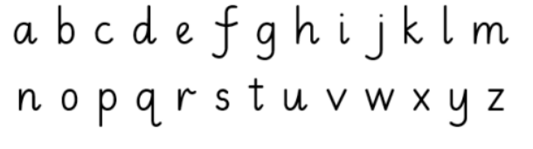

Pencil grip:
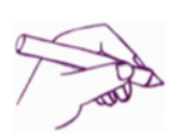
We support children to hold their pencil correctly every time they are writing. We have a rhyme that helps them to remember how to do this:

Pinch your fingers
Quack, quack, quack,
Pick it up and
Filp it back

Home learning creative project:

Our topic is ‘The land before time’ we will be discovering fossils and learning all about dinosaurs. To celebrate this, we would like you to create a dinosaur art project. This could be a dinosaur land in a shoe box, dinosaurs or bones made from play dough, a drawing, painting or junk modelling. Please allow the children to use their imaginations and create this how ever they would like.
Here are some pictures for inspiration:
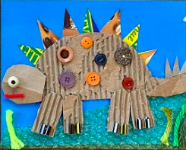
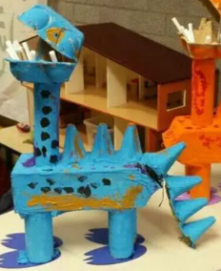
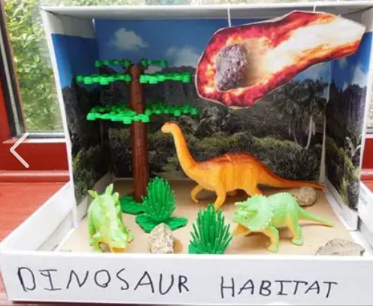

Please bring in your finished project by Monday 23rd March so we can display them and create a dinosaur exhibition!
Hot Topic:
‘The land before time’ encourages children to think about the past and events that have happened a long time ago. To support children to understand the concept of ‘the past’ we would like you to send in a photo of you child when they were a baby. It would be great to have discussions about the past. This could be places you visited in the past, memories you have, how things may have changed.
Important Dates for your diary
- 5th March - World Book Day
- 6th March – INSET day
- 23rd March – Dinosaur art project
- 27th March – Last day of term

