Summer Term Weston Schools Federation Newsletter

Summer Term

Message From Mr. Wiltshire
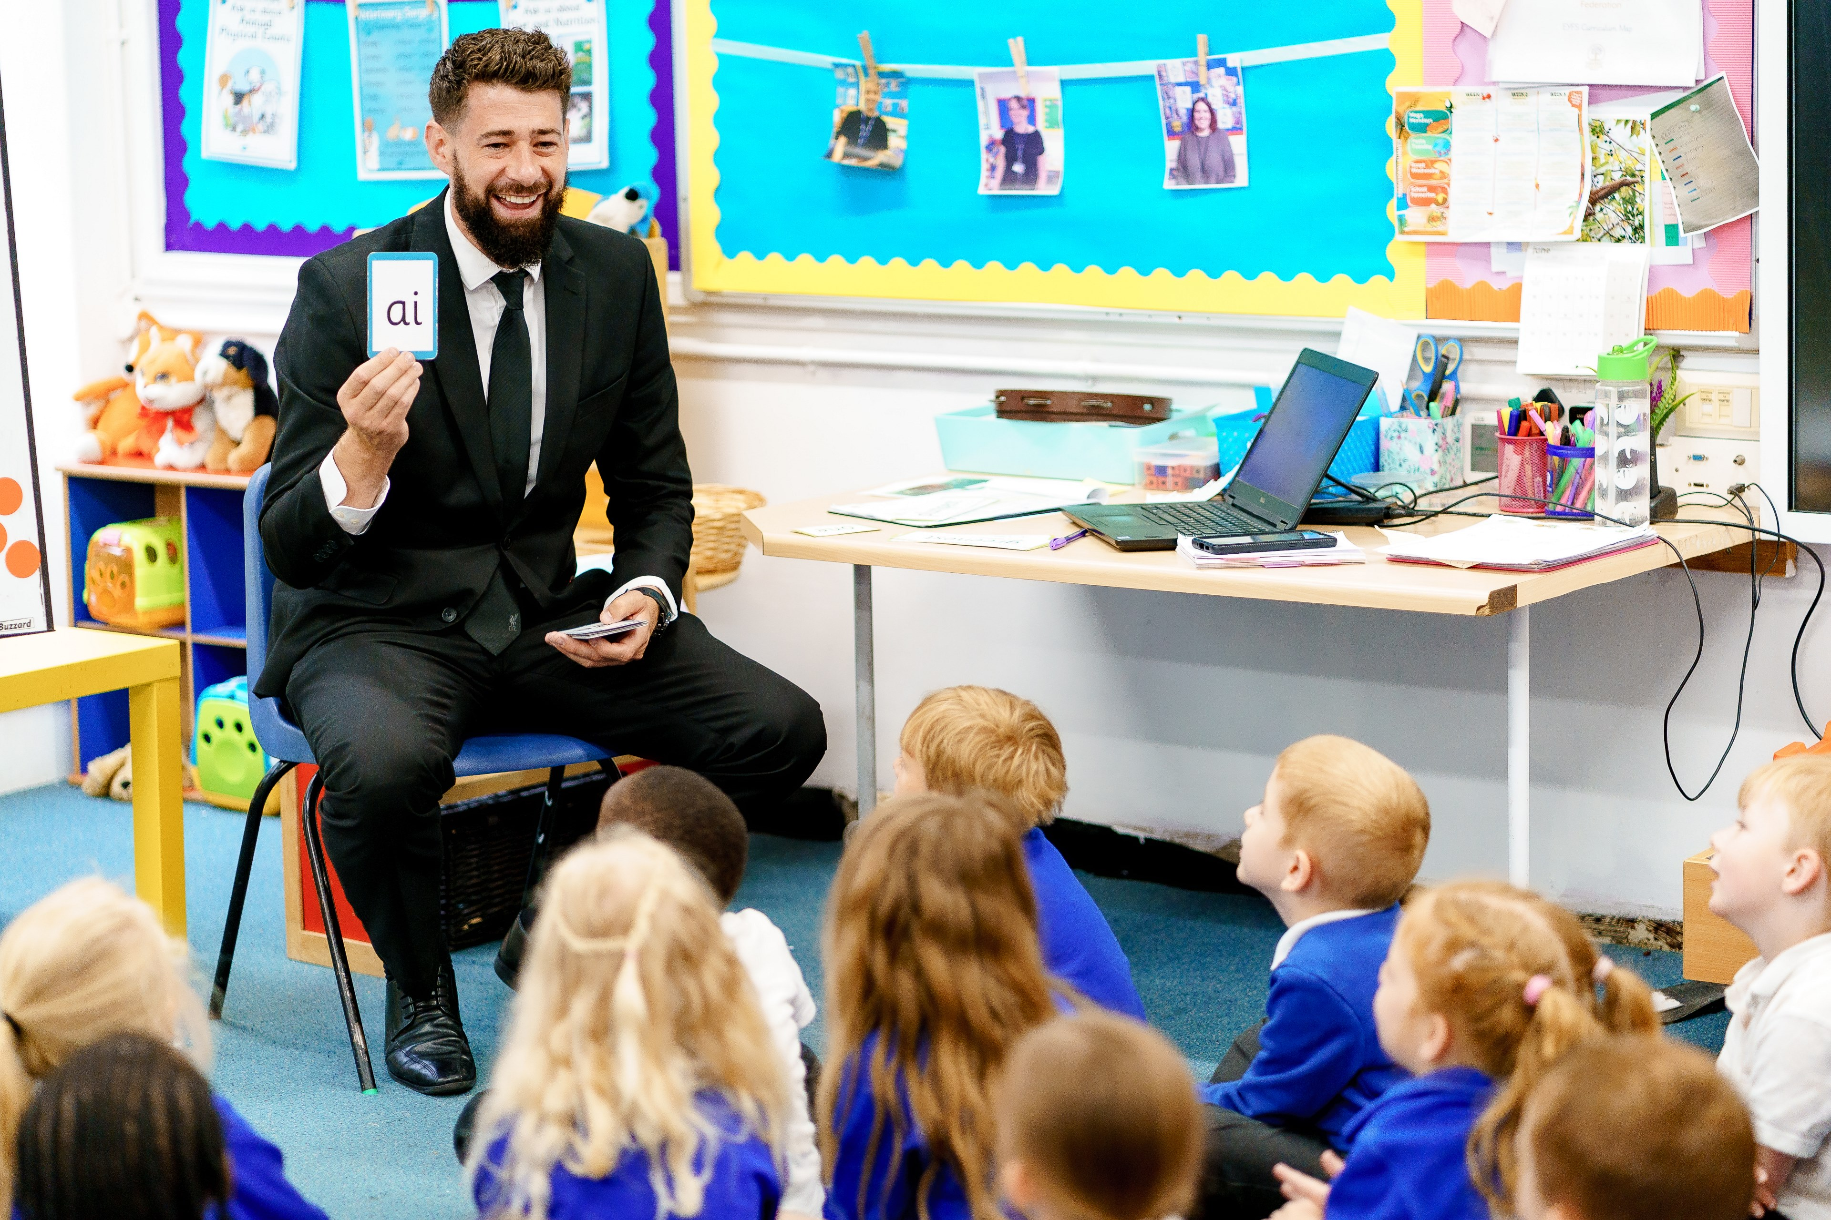
Dear Parents and Carers,

Another half term is nearly complete! The children continue to be an absolute credit to you and to the school. As we get further into the summer term and closer to the end of the academic year, there is so much to look forward to!
Sports Days, Run Weston Run, The Olympics and a TTRS competition to name but a few examples of reasons to be excited to come to school in Summer 2.
Added to which, there were Magic Moments! In this last week of the half term we had two! One was a triathlon of sports: skipping, football and basketball.
I also want to mention all the incredible music opportunities that we have on offer through our curriculum and our clubs. Rock bands, choir and individual music tuition.
It's an exciting time of the year and we are so delighted with your children's progress in their classes and as they begin to consider their transitions as they move through their education.
Have a peaceful half term break and we will see all the children back in school on Tuesday 2nd June after the INSET day on Monday 1st June.
Best Wishes,
Mr. J. Wiltshire
Headteacher

This Term in Key Stage One

Reception
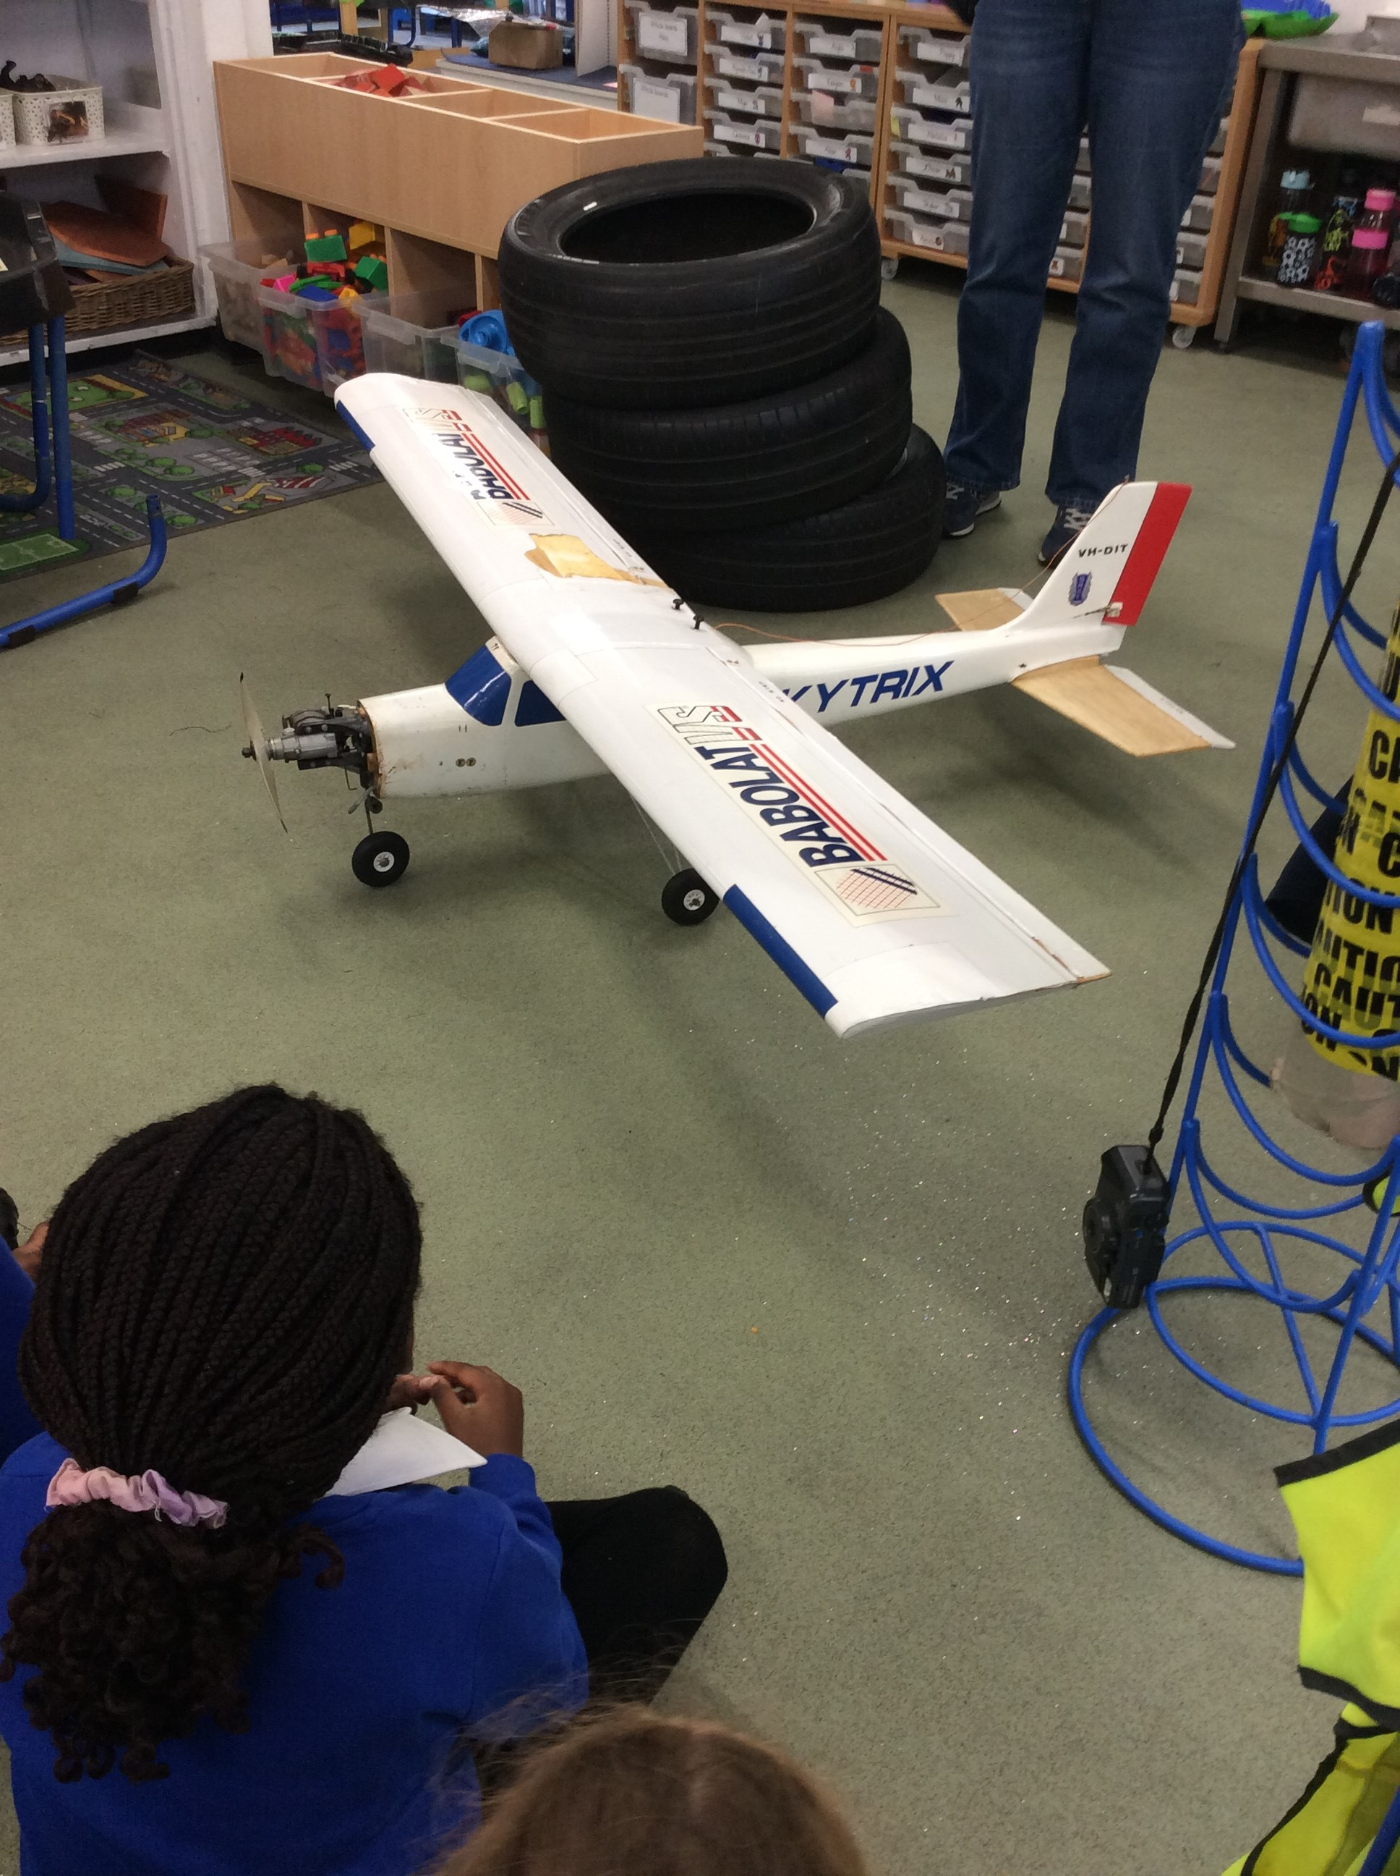
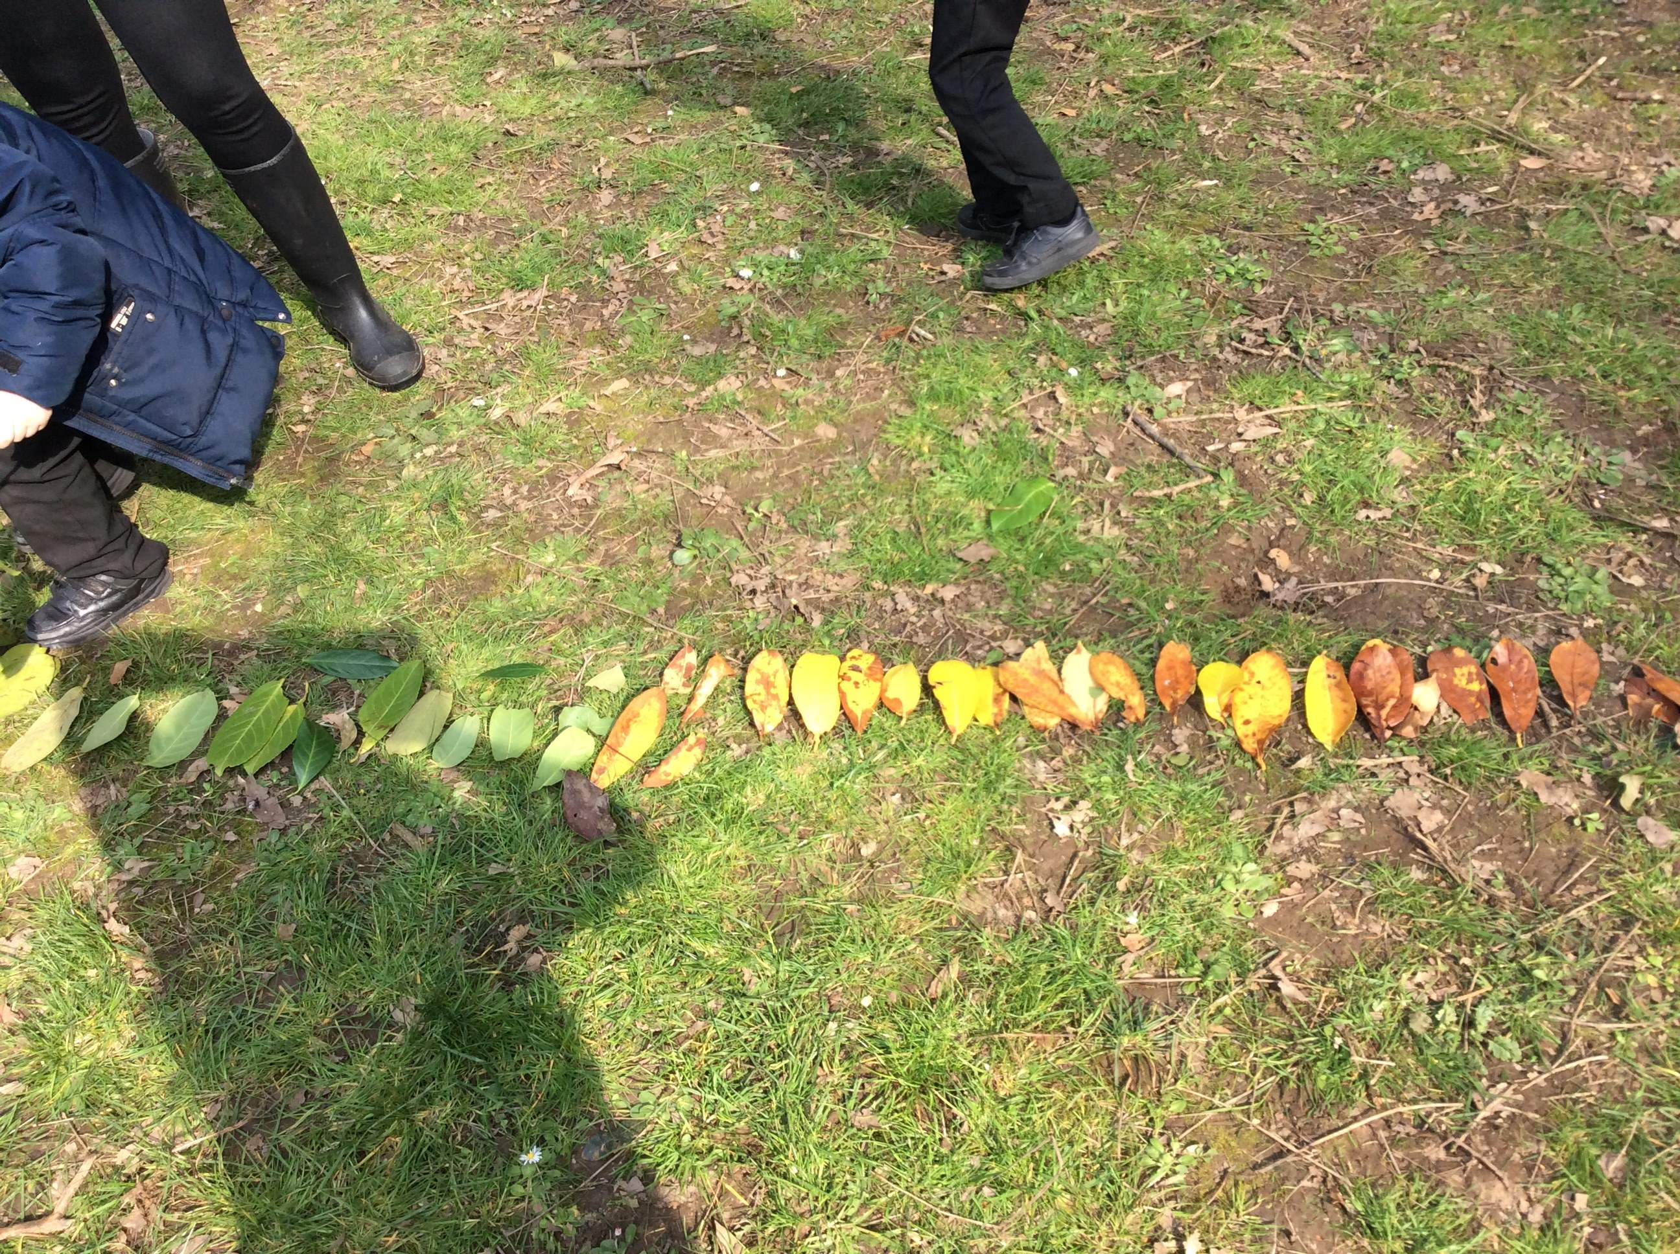
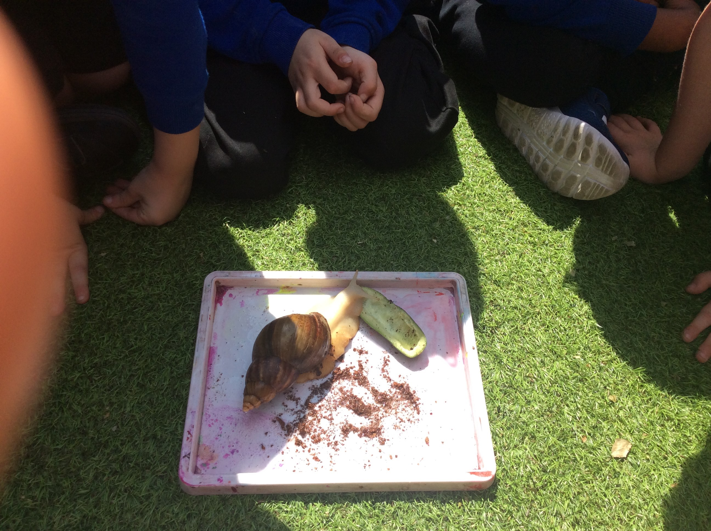
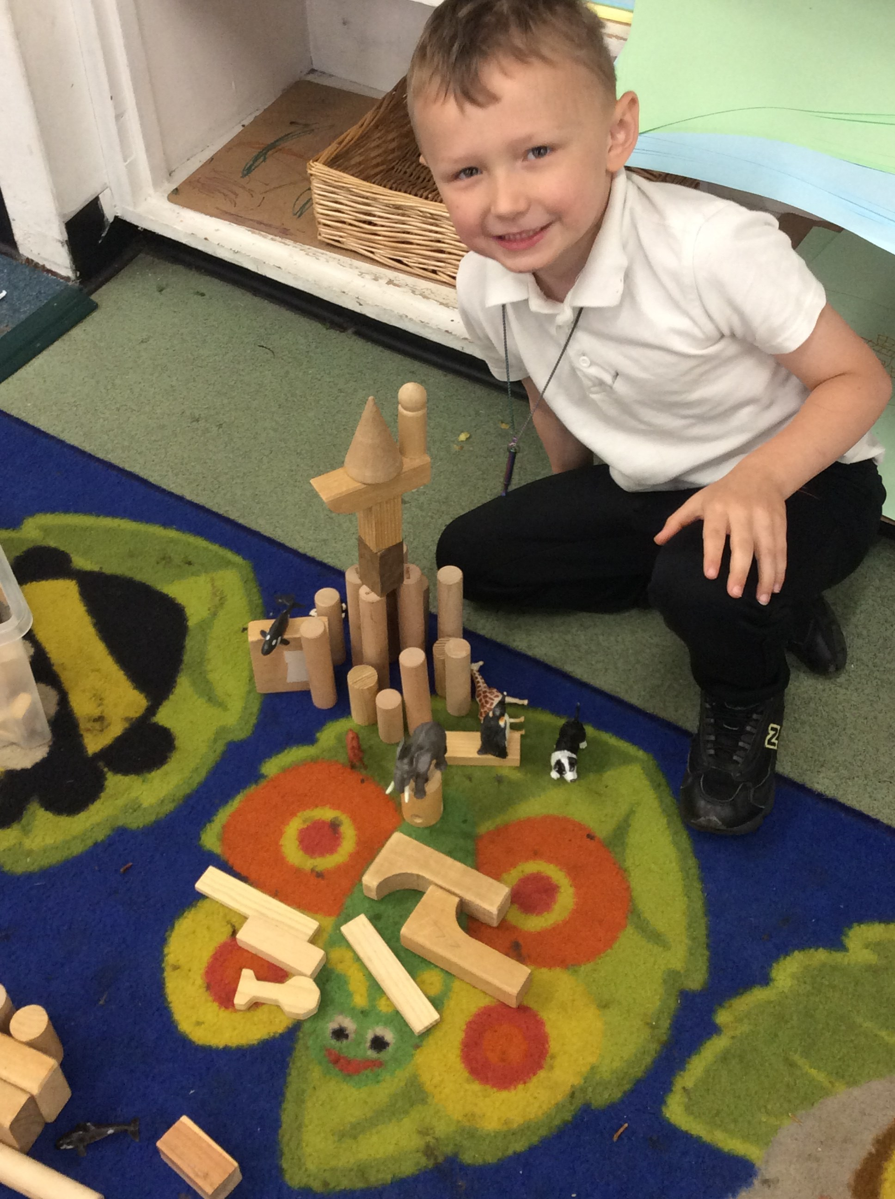
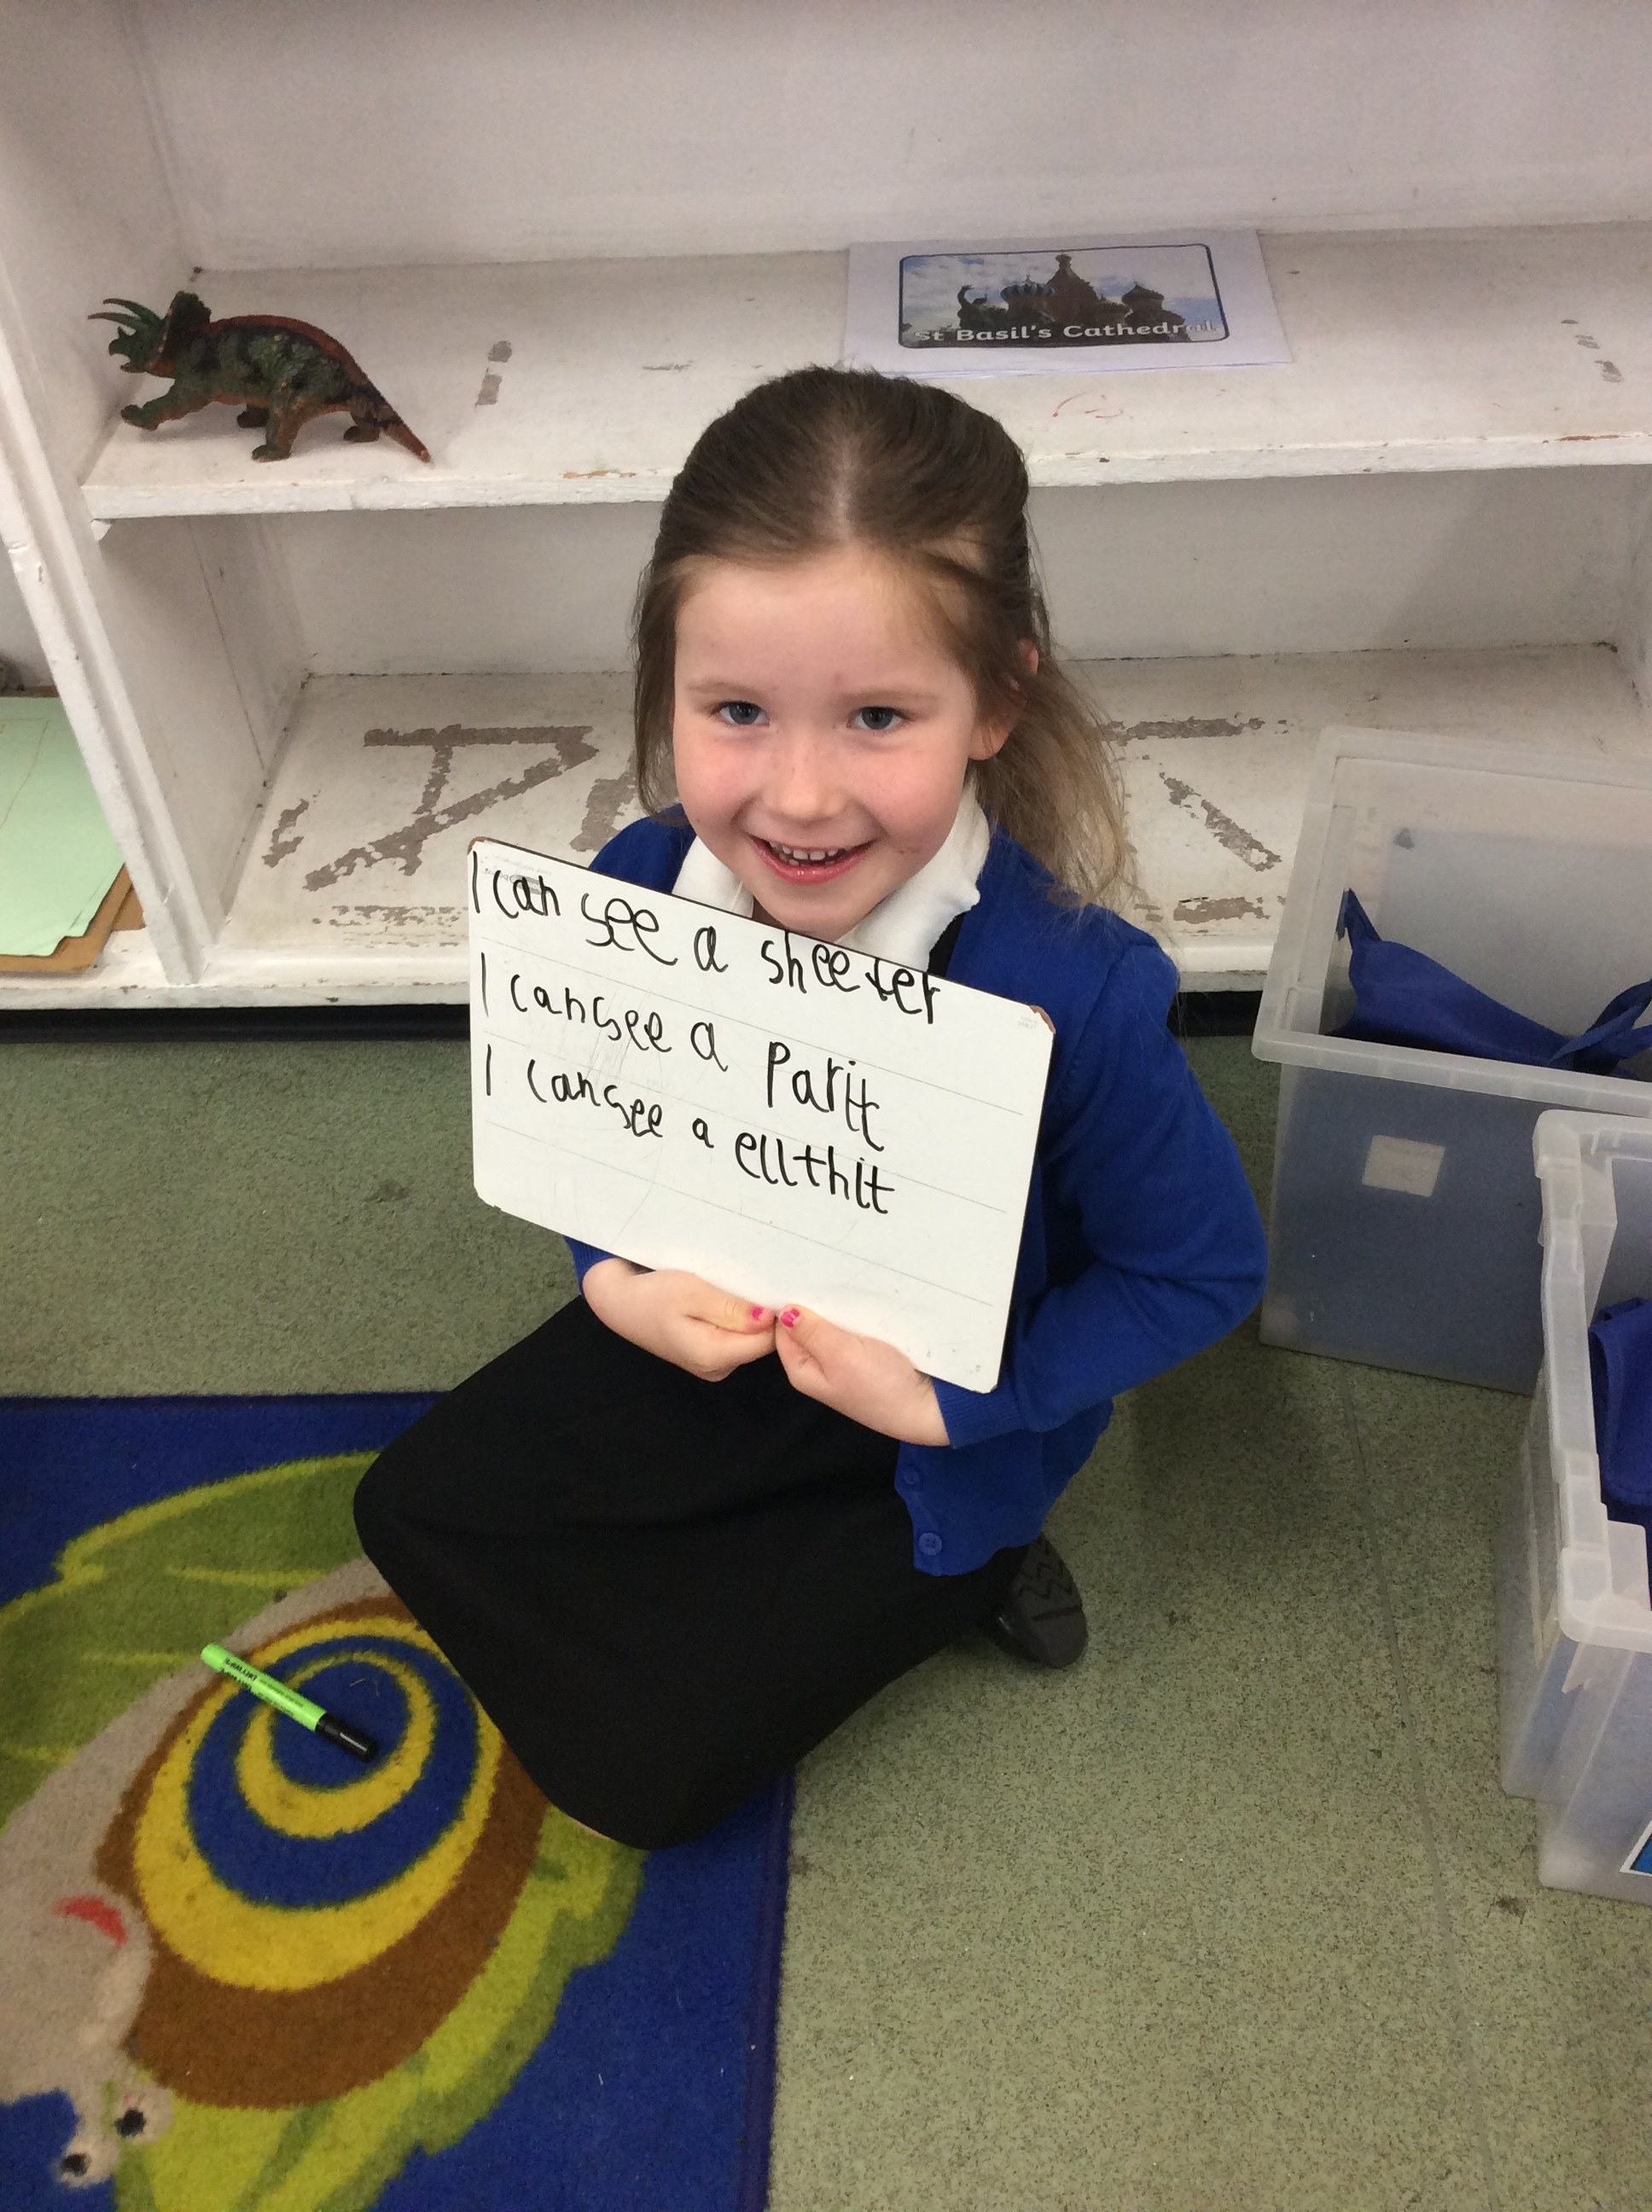
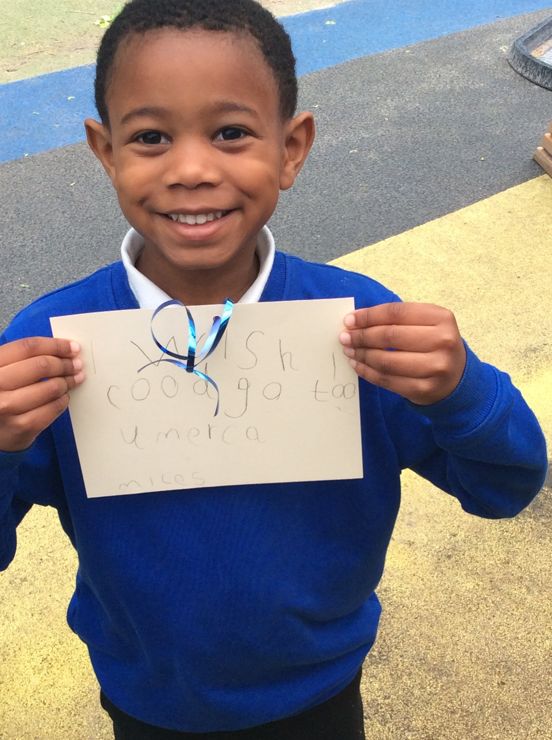
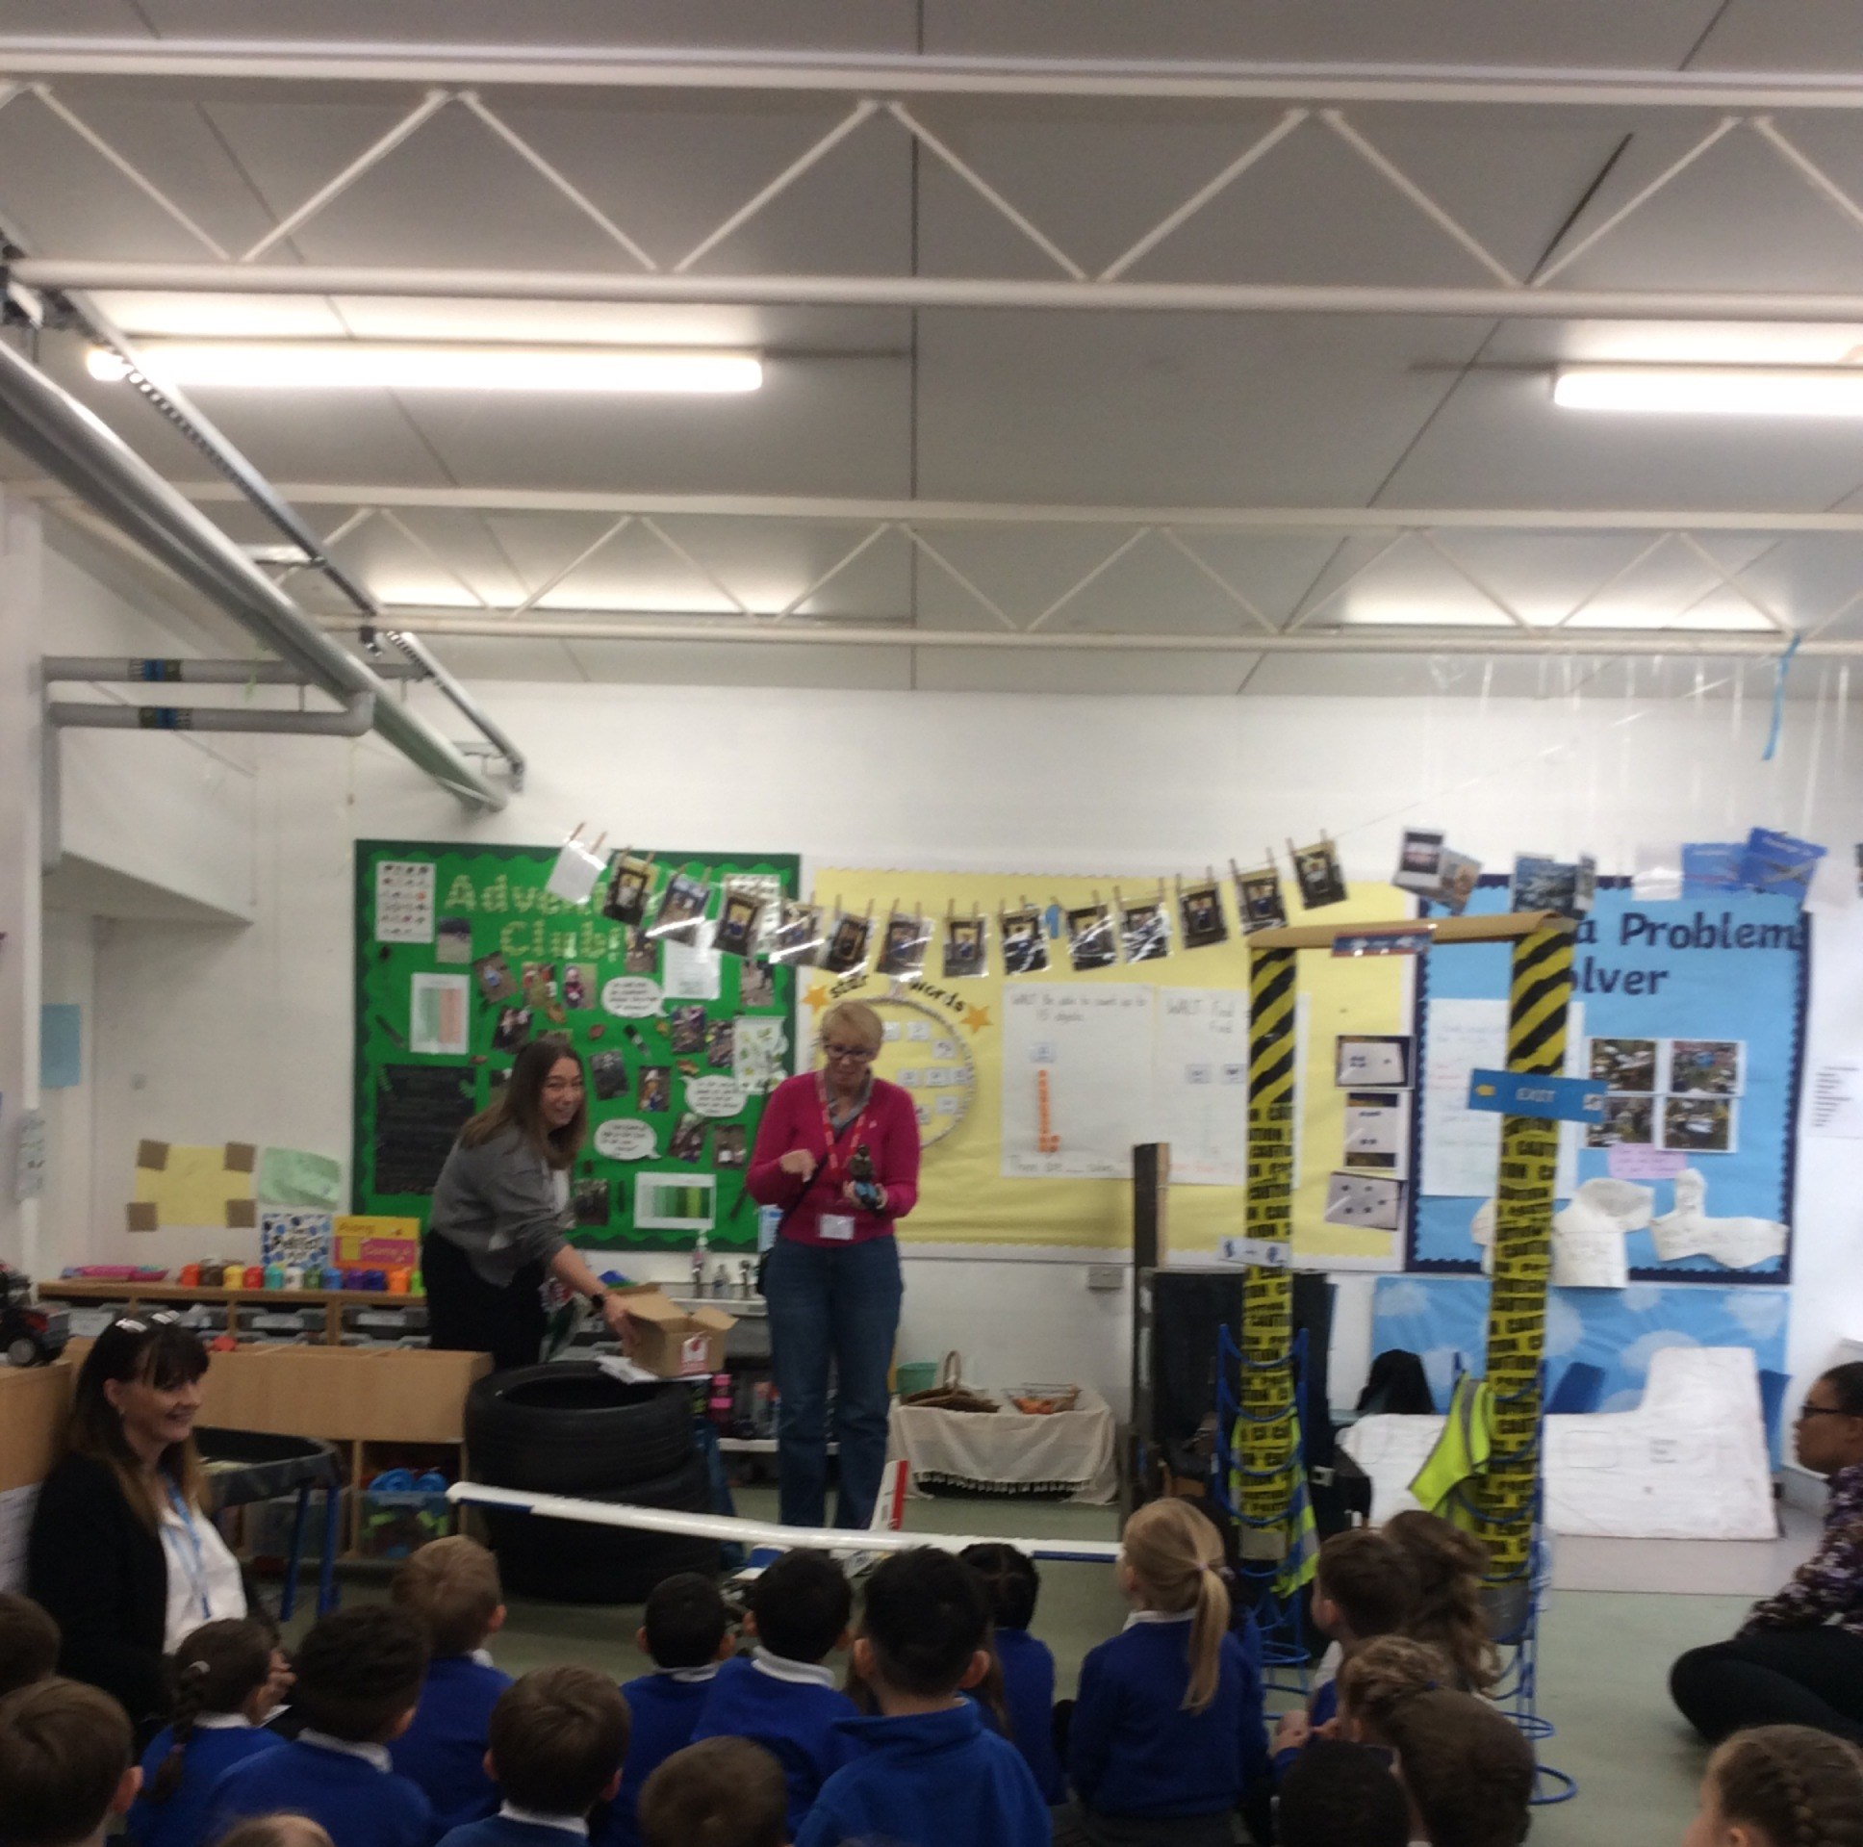
This half term has been a fantastic and exciting one in Year R as our topic took us on a journey around the world!
Throughout the topic, the children explored and discussed the similarities and differences between where we live and where people around the world may live. We used a range of storybooks to inspire our learning and to help us understand how homes and lifestyles can vary across different countries and cultures.
One of the highlights for the children was using the VR headsets. They were incredibly excited to immerse themselves in different environments and imagine they were travelling around the world. The experience allowed them to explore underwater creatures and observe polar animals up close, bringing our learning to life in a memorable way.
As part of our learning linked to Handa’s Surprise, the children had the opportunity to taste a variety of different fruits and vegetables. The passion fruit proved to be a particular favourite and a pleasant surprise for many!
We were also very fortunate to welcome a special visitor, Dawn, who kindly donated her father’s model plane for the children to explore. The children were fascinated to learn about how the plane was made and how it could fly. We would like to extend a huge thank you to Dawn for her generosity. We will treasure the model plane for many years to come.
To end the half term, the children wrote wishes to place on our wishing tree. It has been wonderful and inspiring to hear them talk so enthusiastically about the places they hope to visit in the future. Through this topic, we have truly discovered that the world is an exciting and fascinating place to explore.

Year One
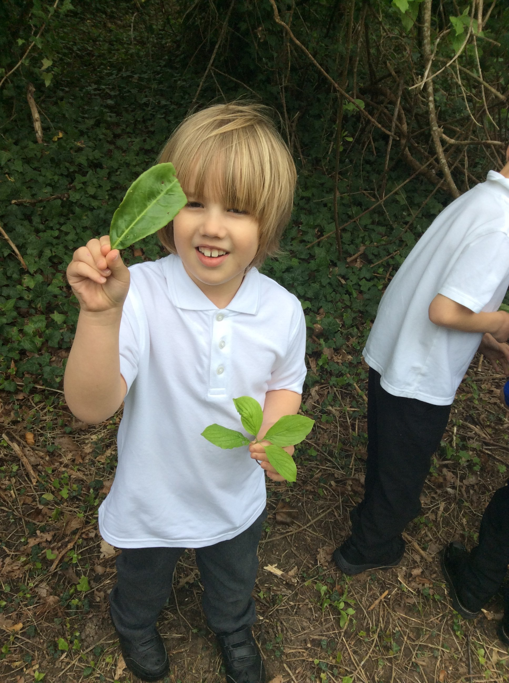
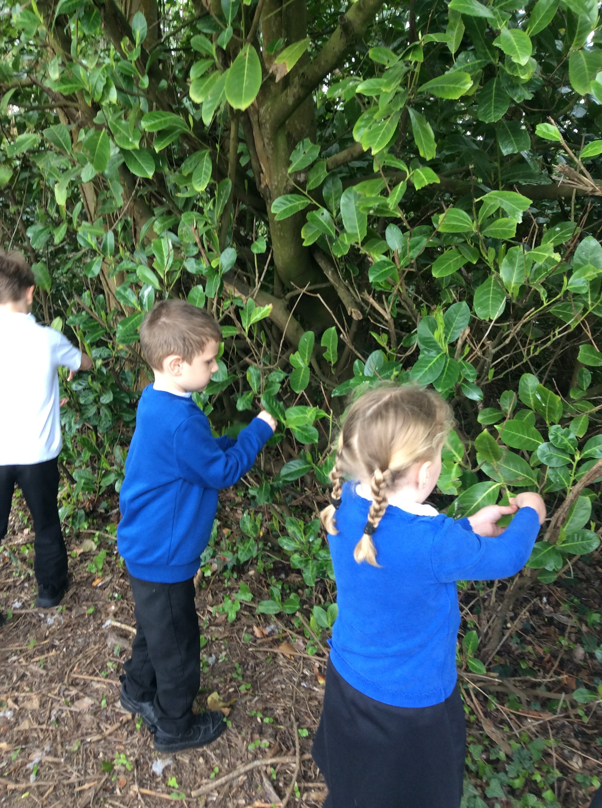
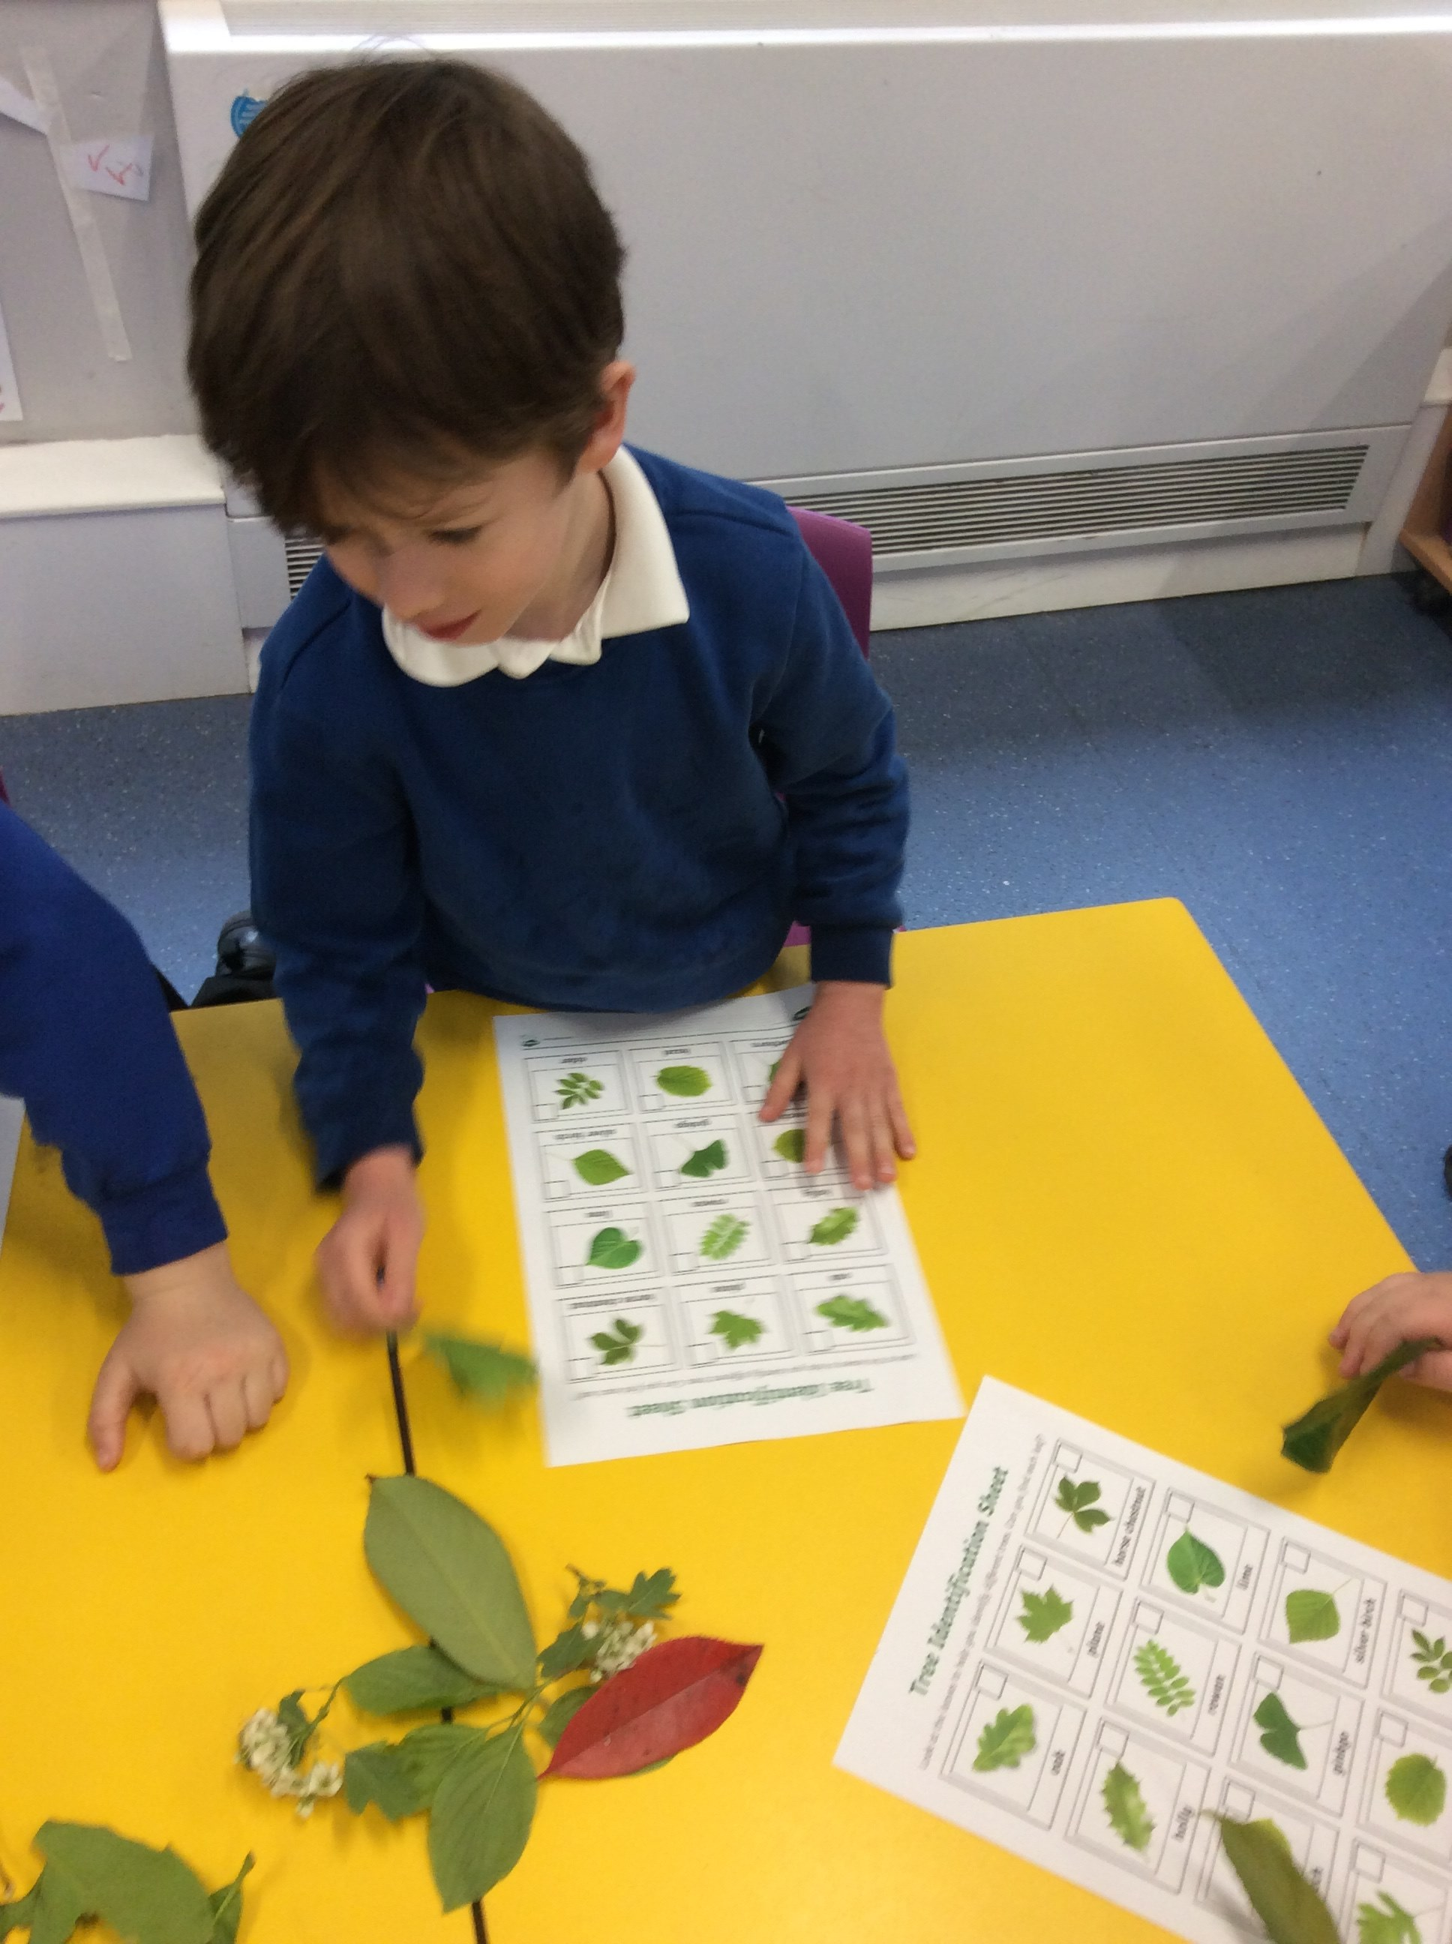
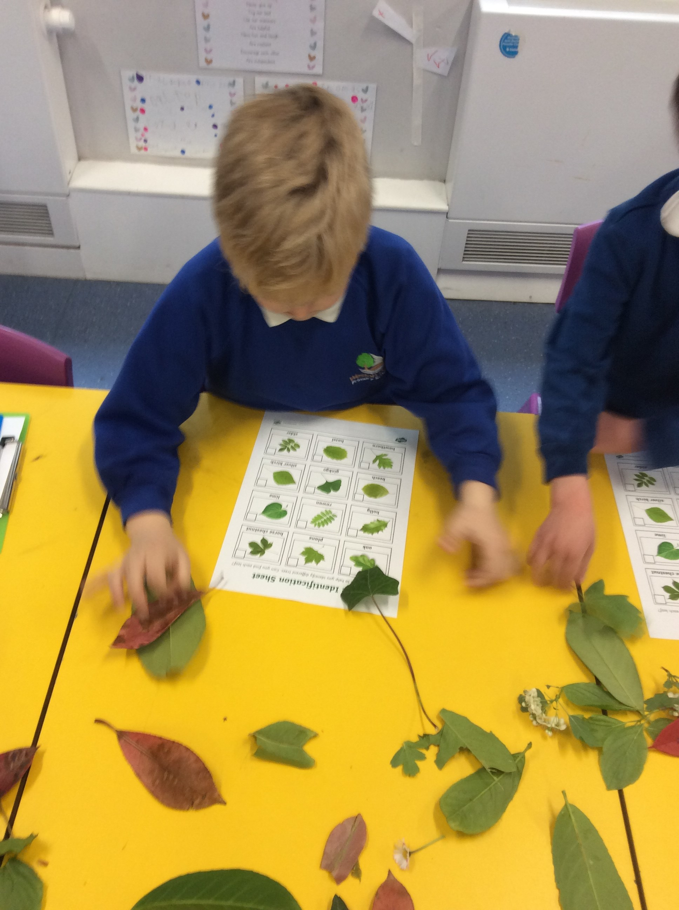
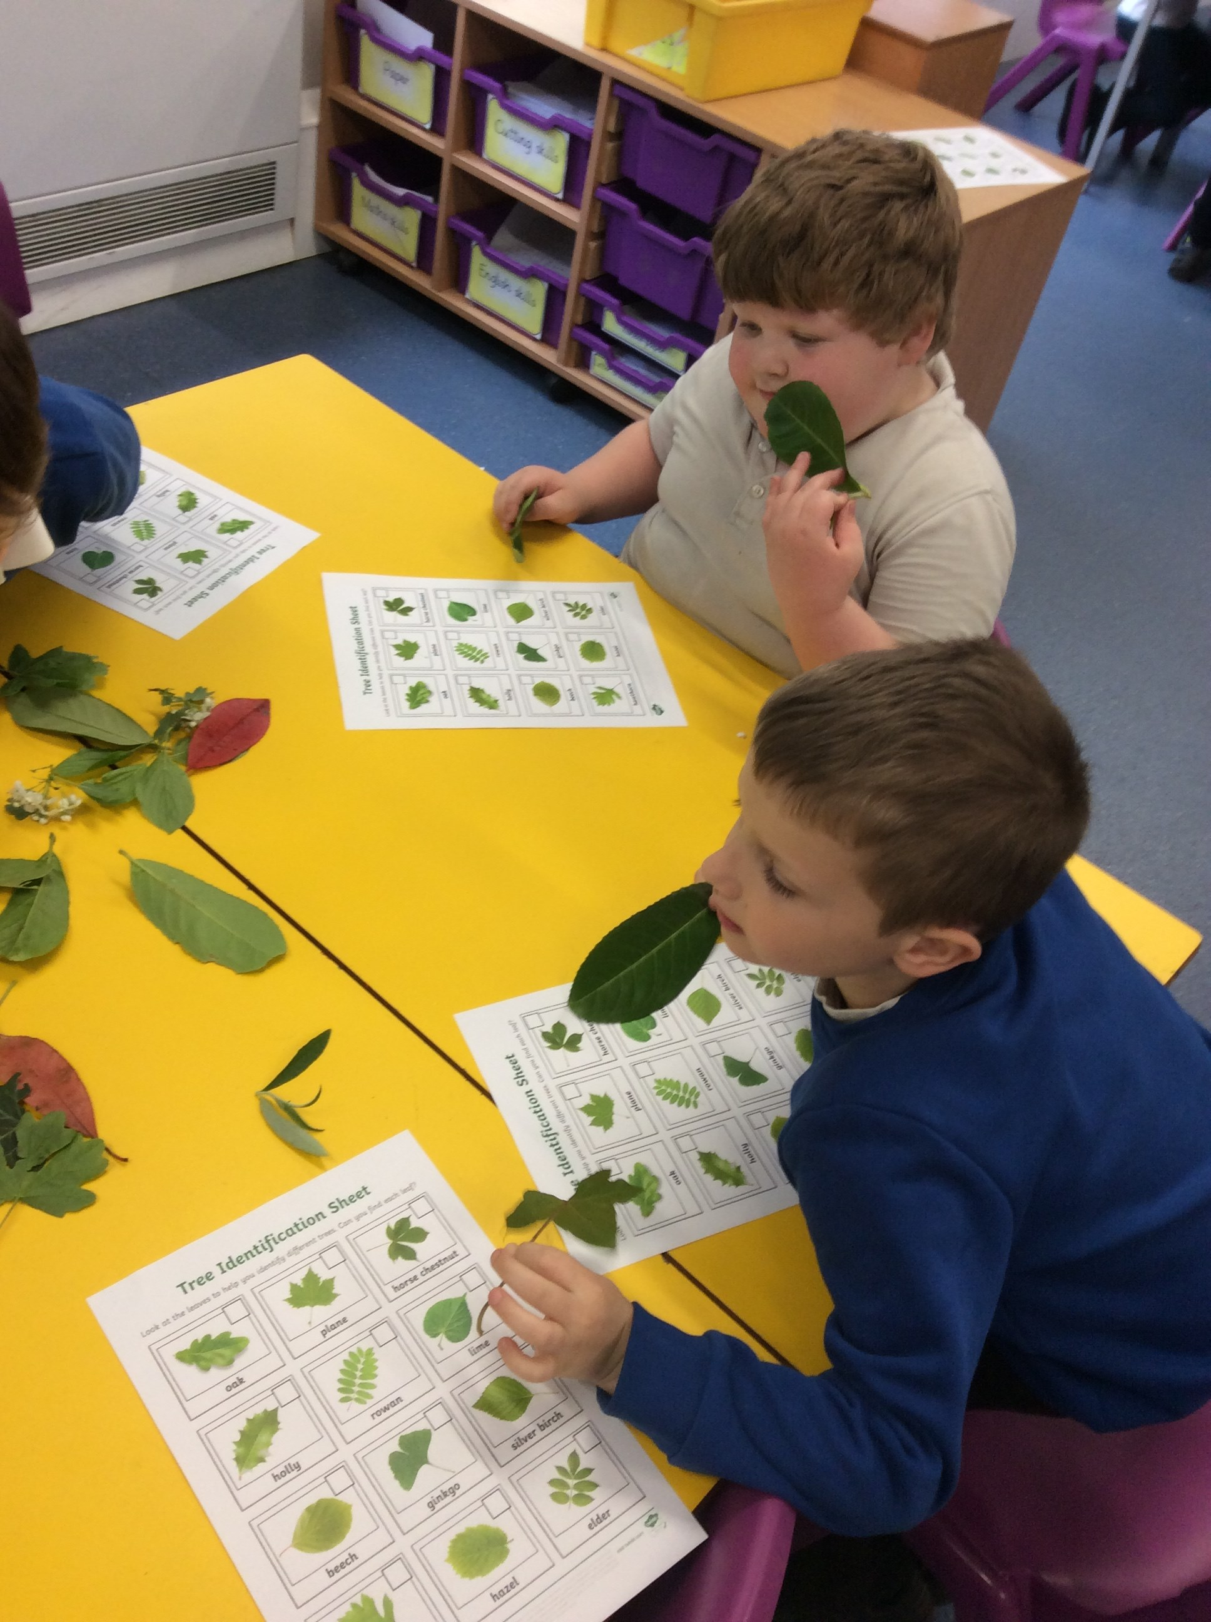
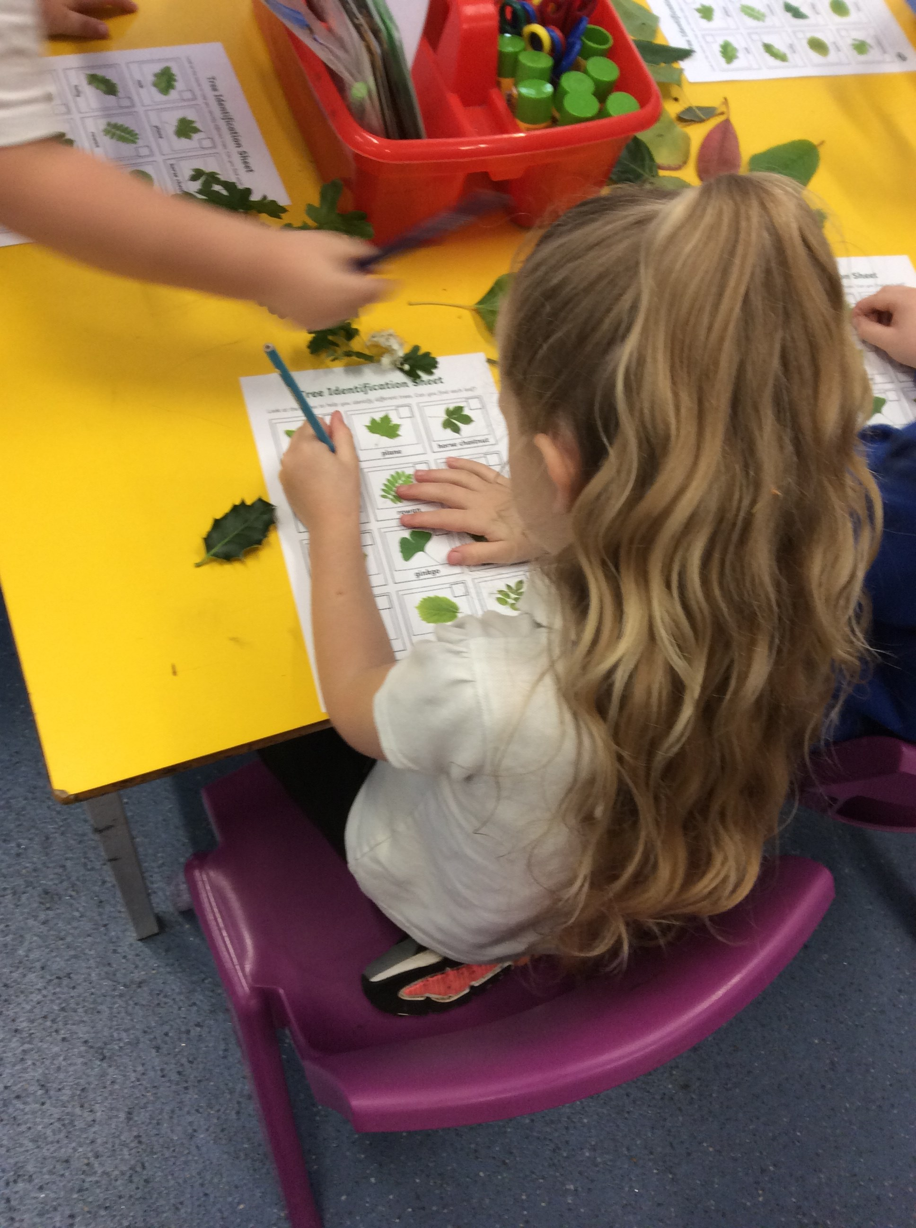
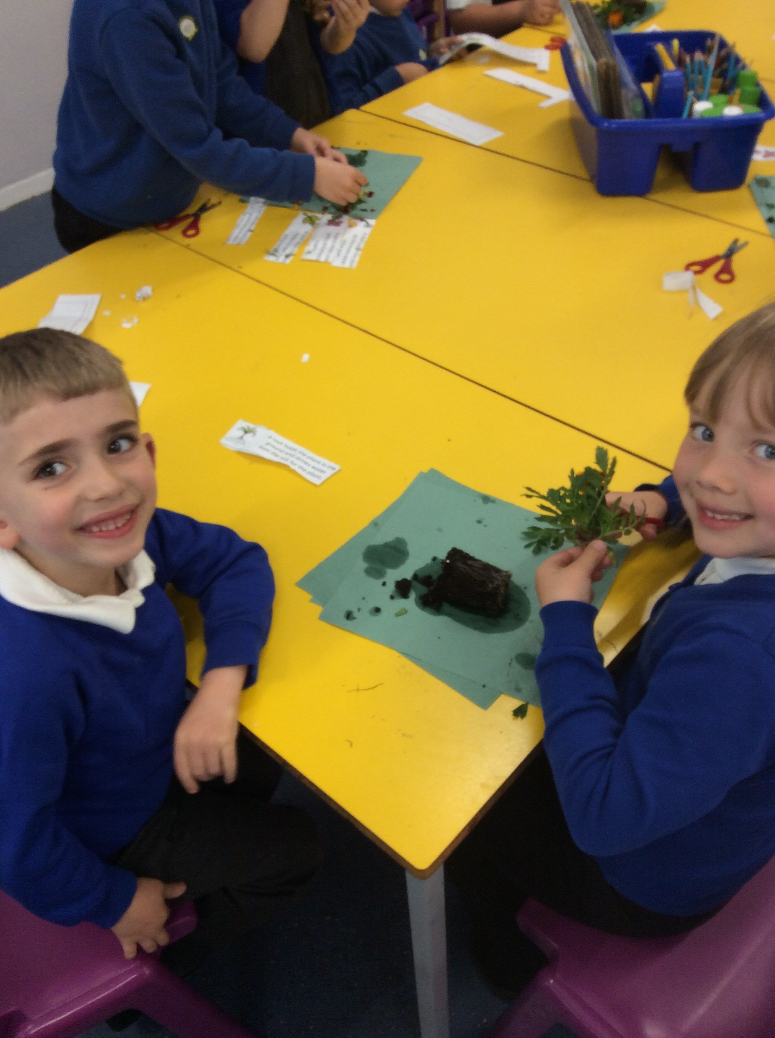
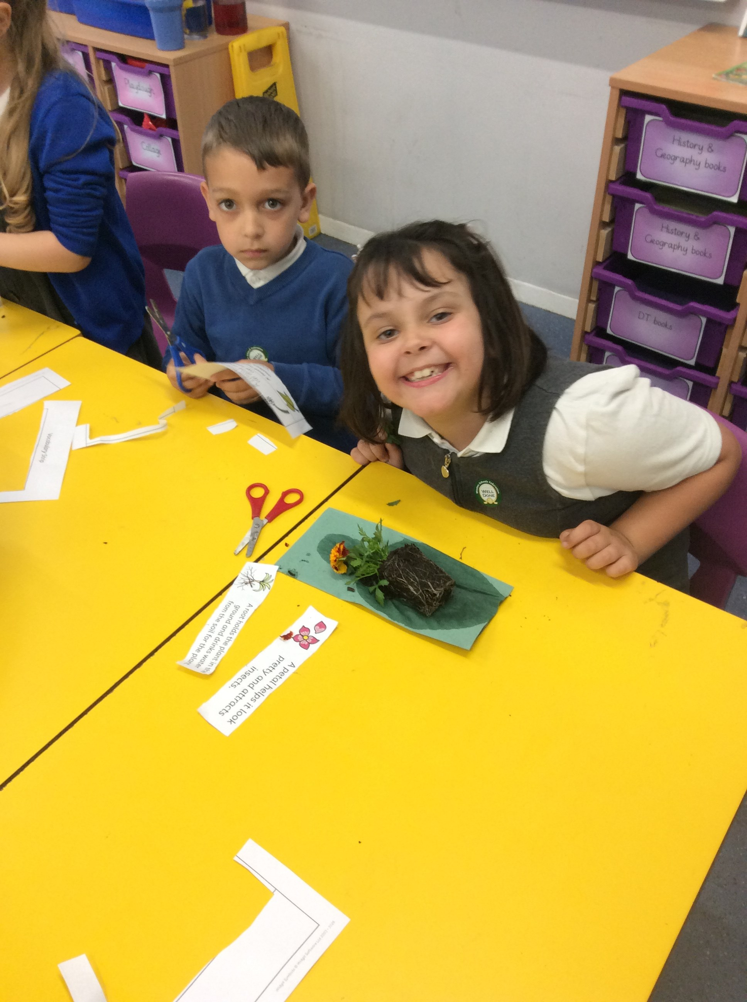
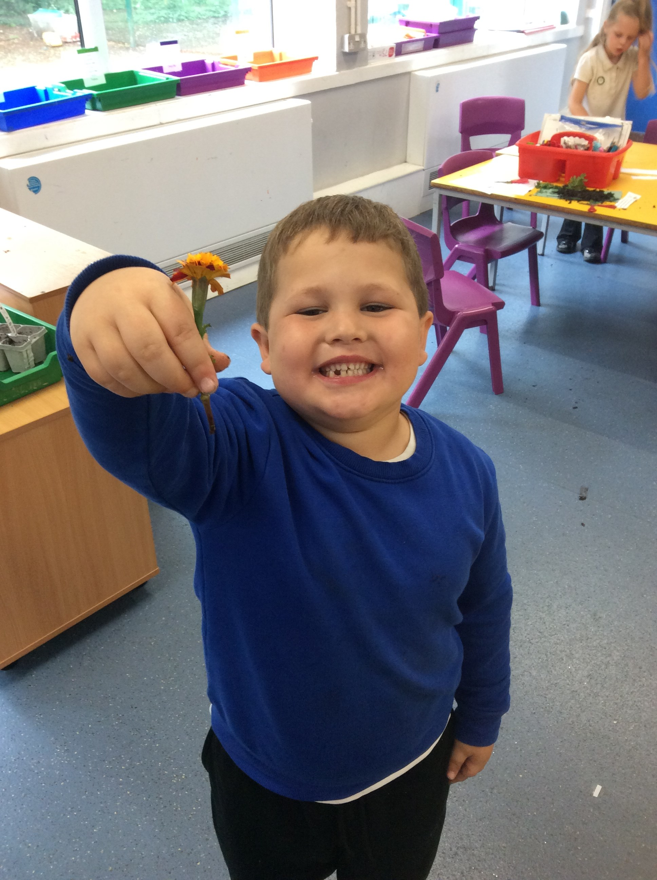
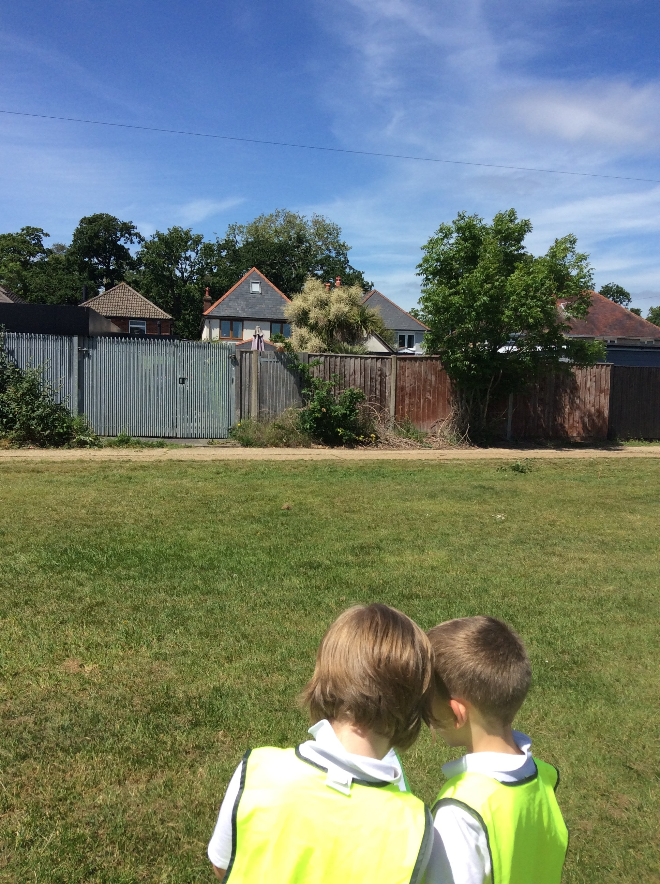
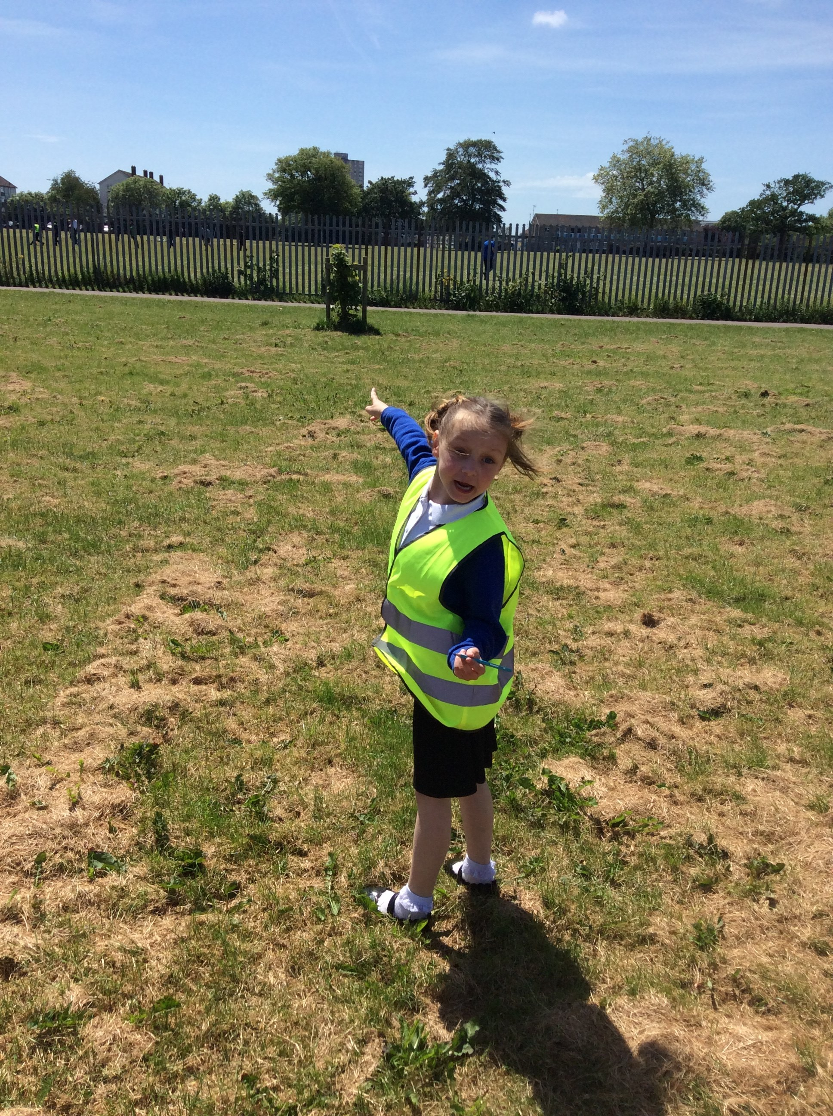
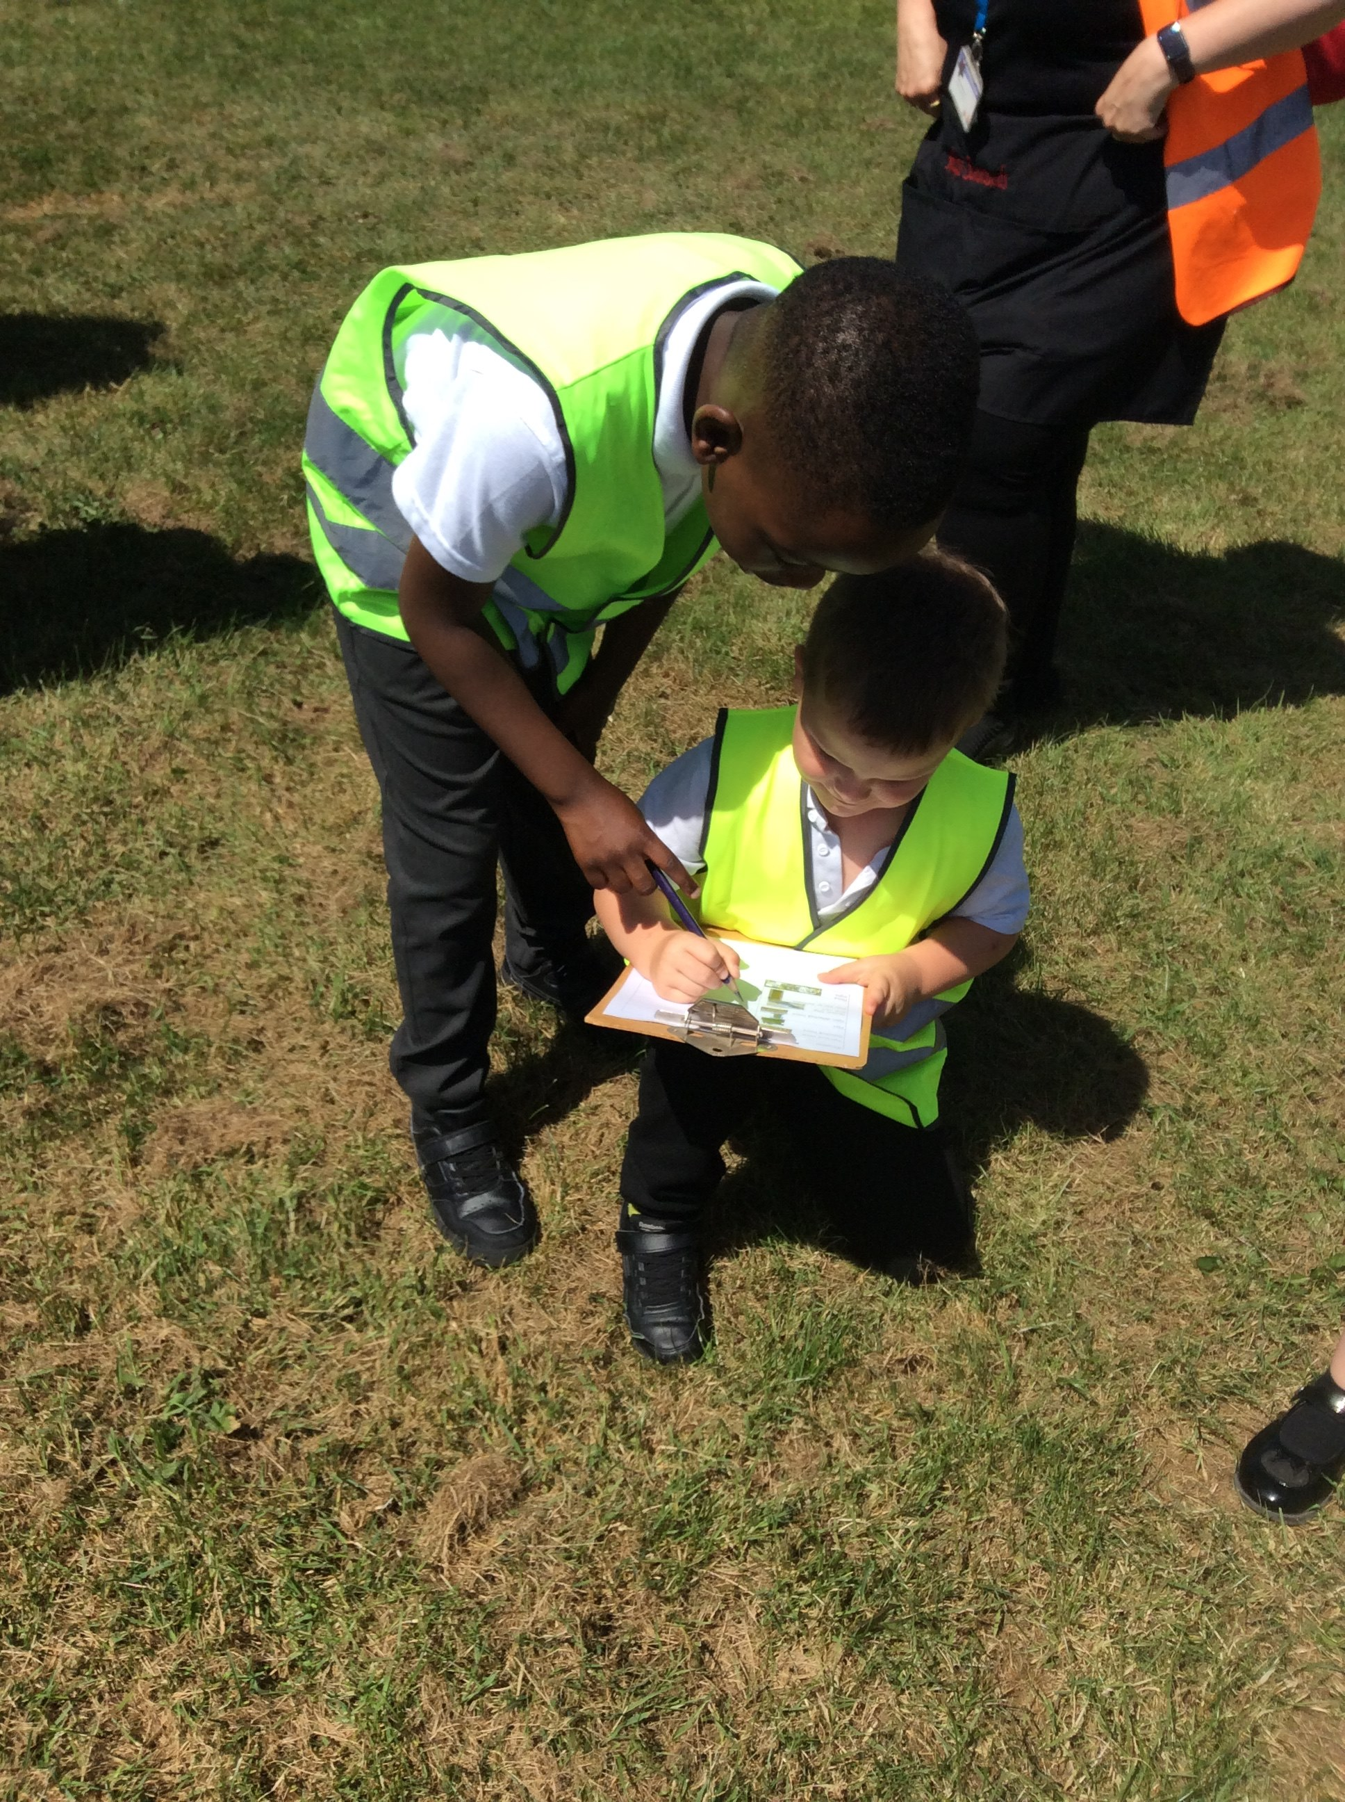
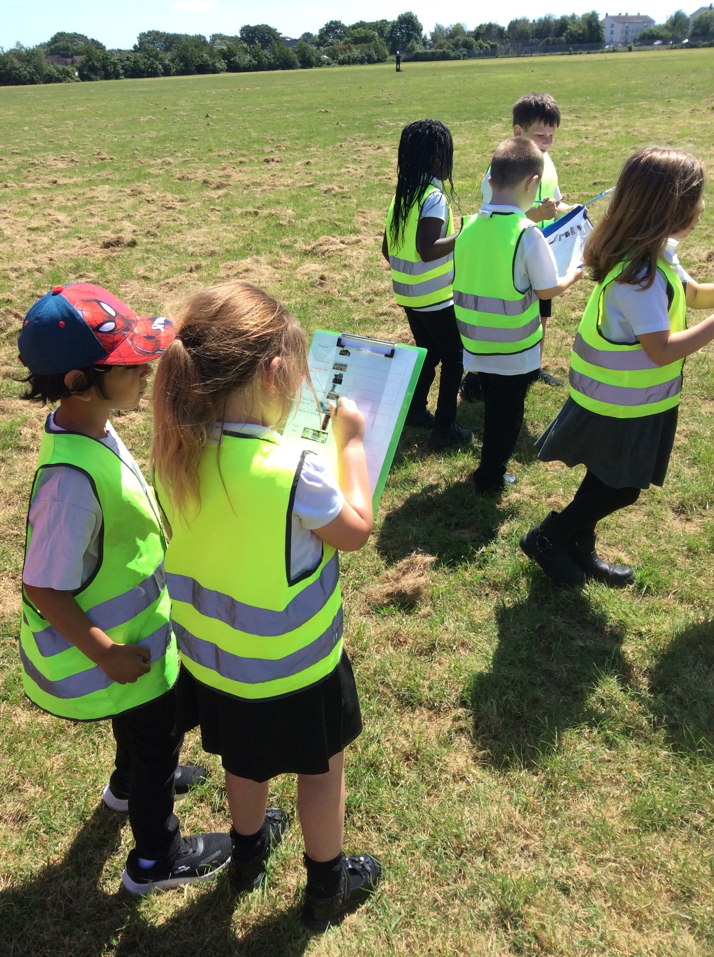
Year 1 have had a wonderful term, with an exciting outdoor theme running through much of their learning. In Science, the children explored plants, learning about their different parts and how they grow. They enjoyed growing their own sunflowers and identifying both garden and wild plants, showing fantastic observation skills when dissecting them.
In Geography, we focused on our local area. The children created impressive 3D maps and learnt about different types of homes, including flats, terraced and semi-detached houses. They showed great engagement, as well as pride and respect for where they live.
In Art, the children explored a range of printing techniques, from finger and block printing to mono-printing. They selected natural materials and created their own stencils, producing some creative and unique artwork.
In Maths, we developed our understanding of numbers to 100, learning efficient strategies for addition and subtraction.
In English, the children studied Little Red Riding Hood and wrote some excellent retellings. They finished by learning to write letters with an environmental theme, linking to the celebration of David Attenborough’s birthday, and showing the fantastic progress they have made in writing.
We are very proud of all the hard work and enthusiasm Year 1 have shown this term!

Year Two
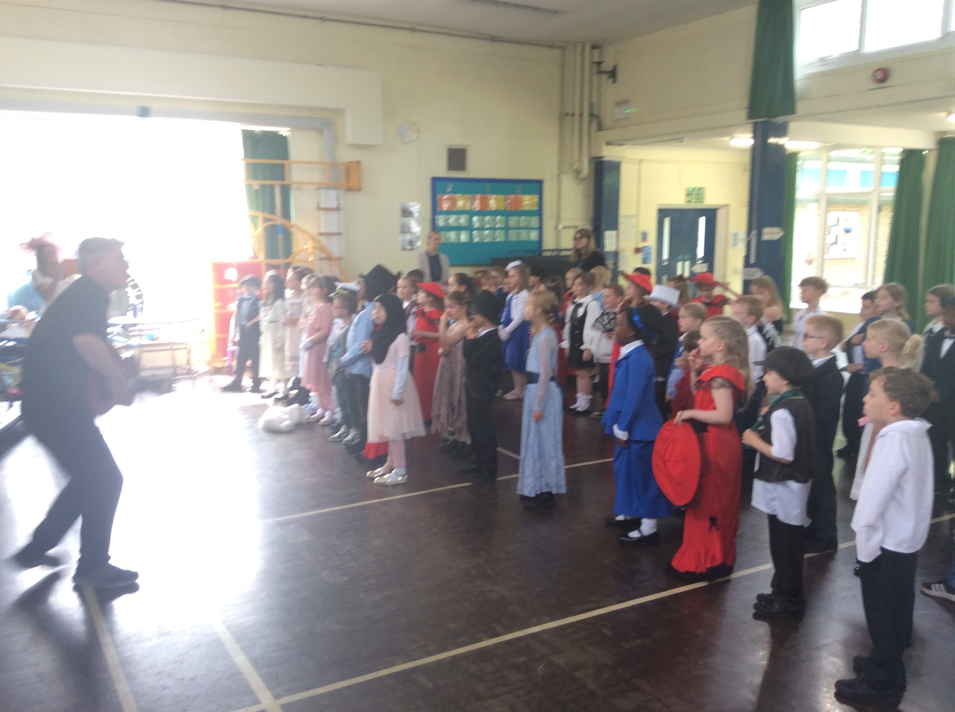
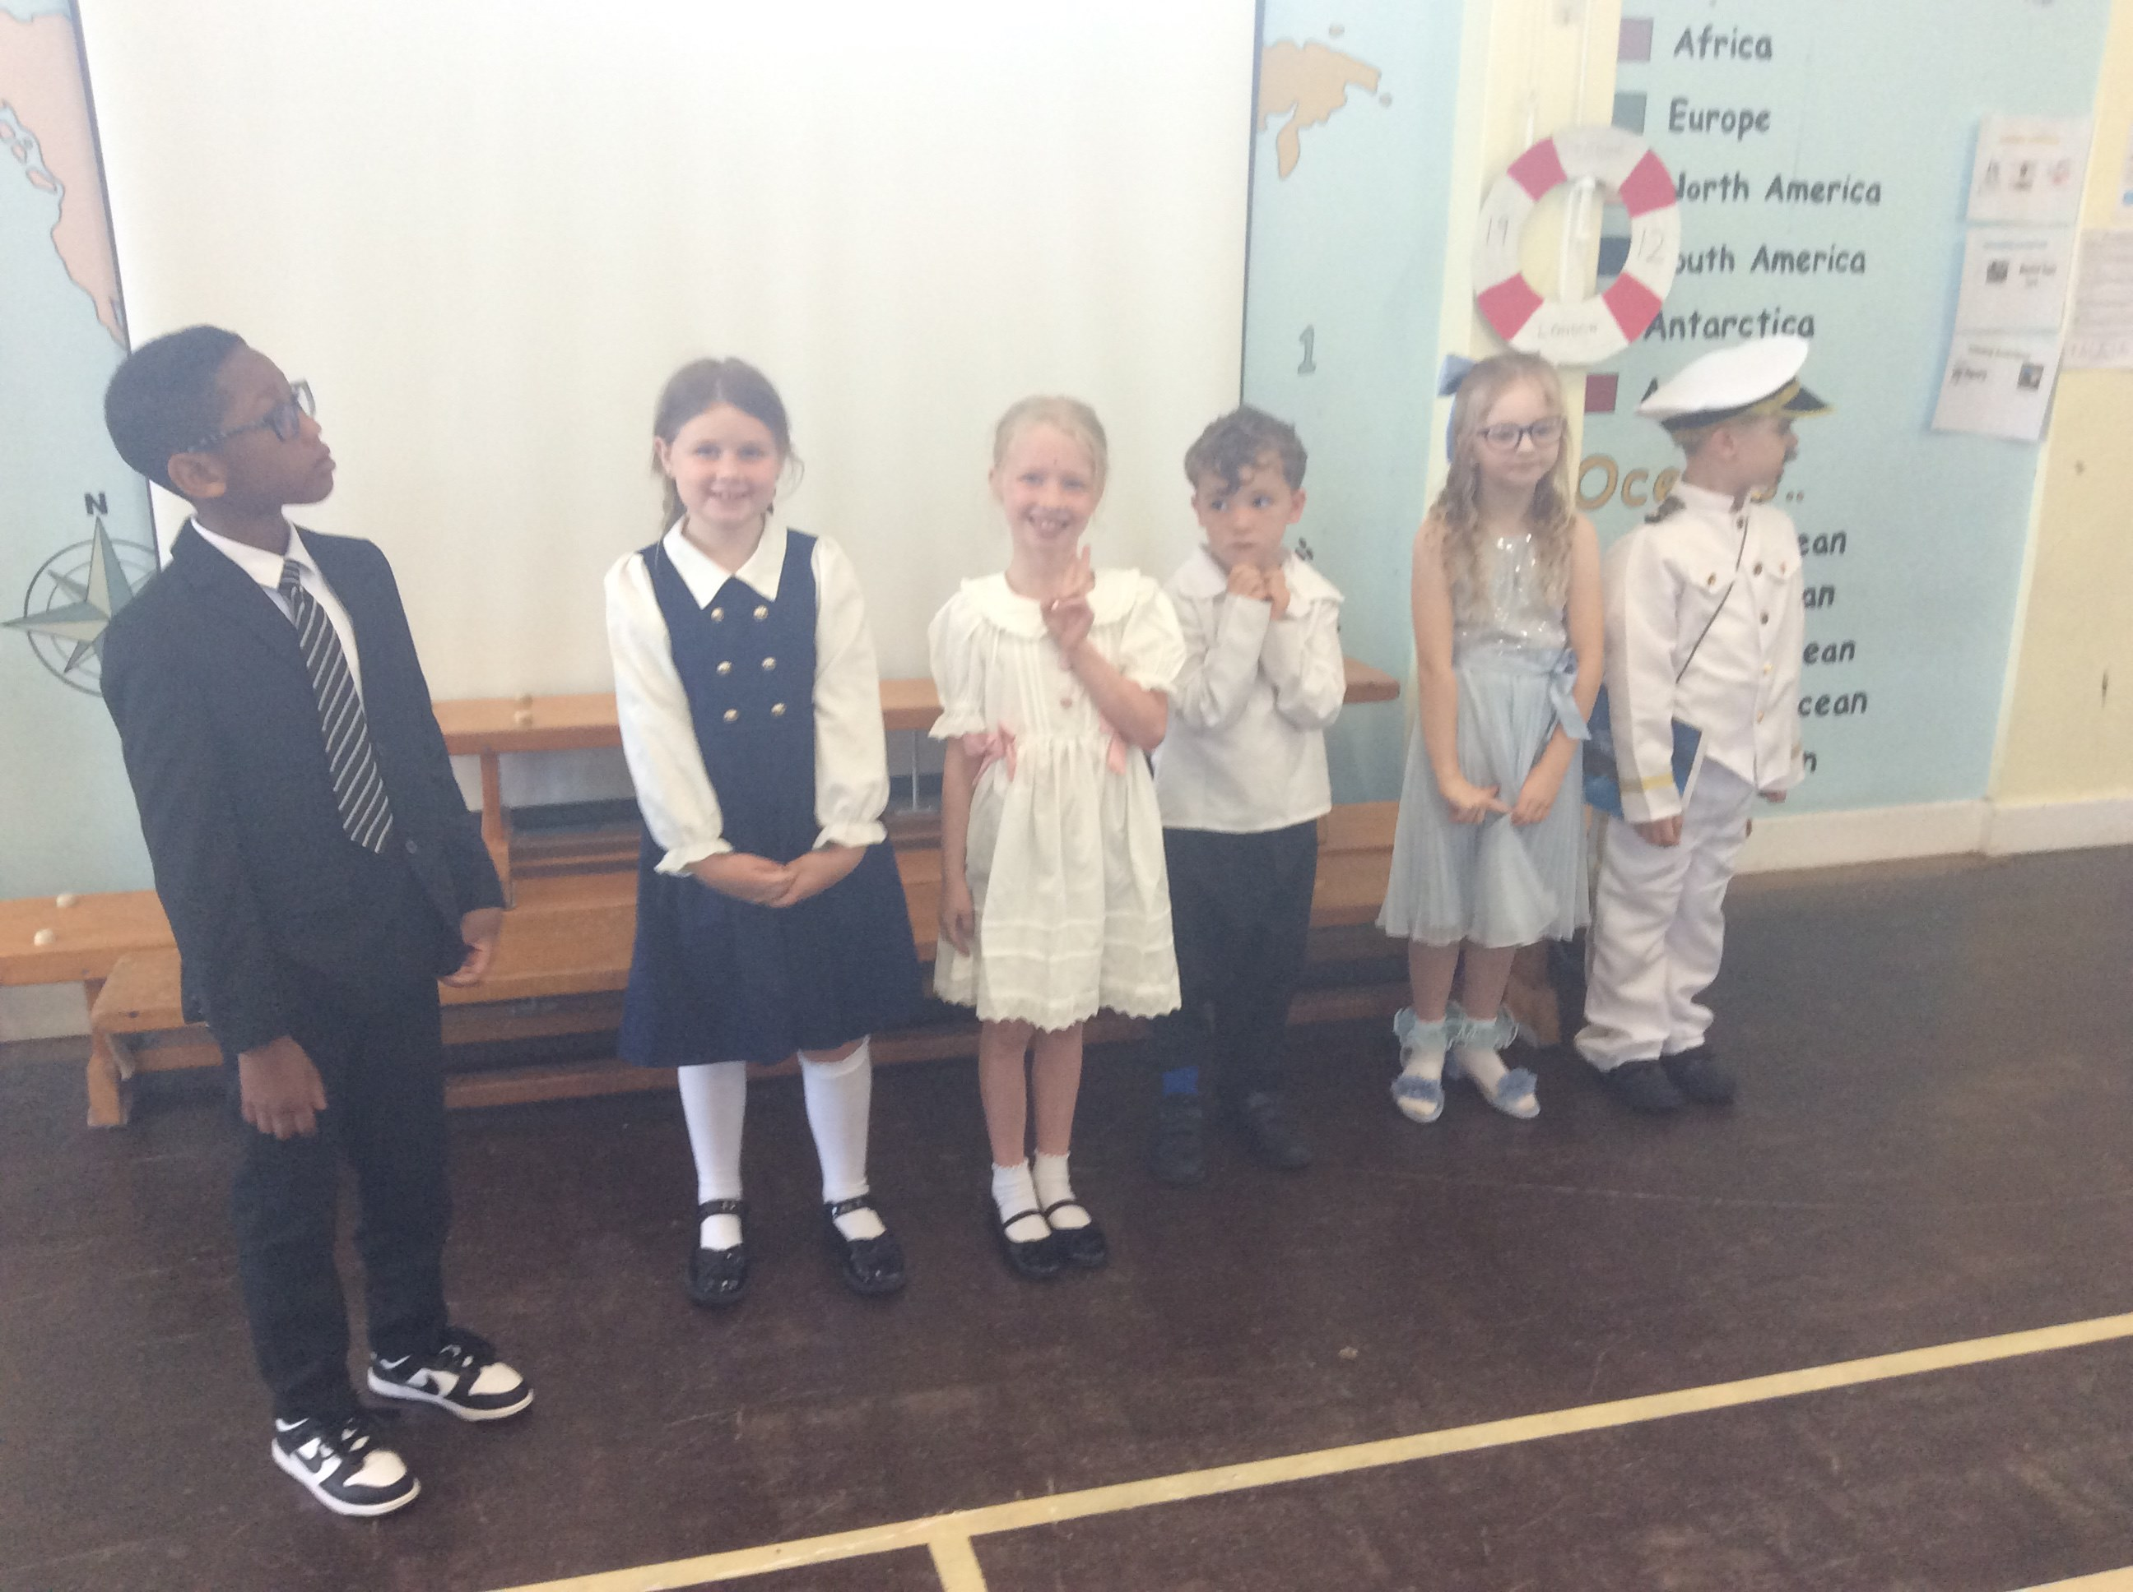
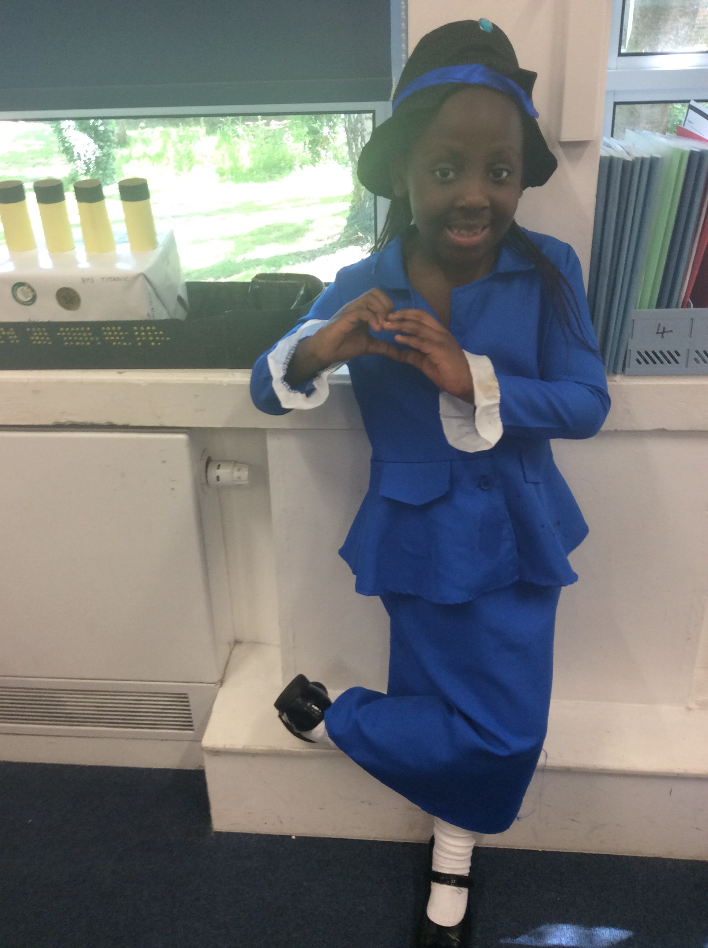
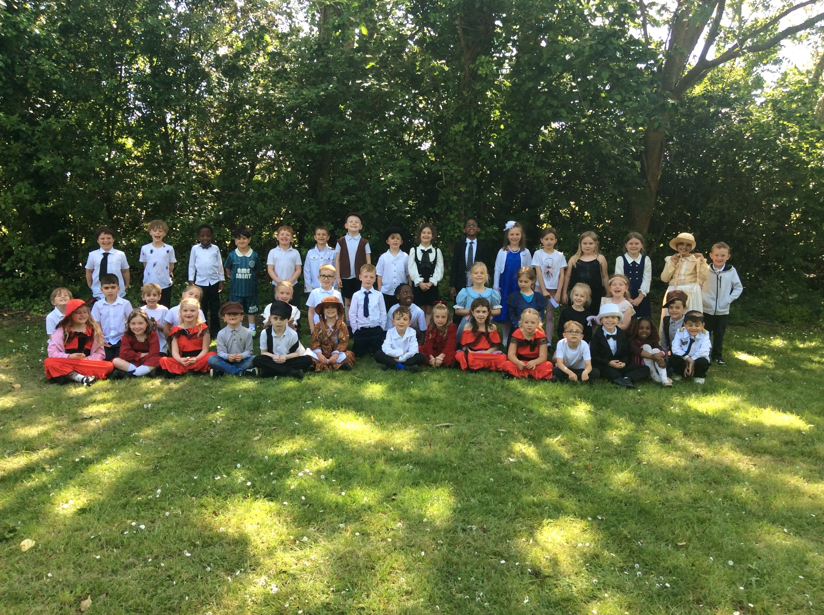
Year 2 have had a really exciting half term learning all about the Titanic. From the first 'hook day' right the way to our final outcome day yesterday, it's fair to say the children have been well and truly Titanic mad! Thank you so much for your incredible effort with costumes, the children looked amazing on the outcome day. As for the Titanic home learning, it has been unbelievable. Nearly all the children have participated and the bar has been set very high indeed for next year. Thank you once again because it really does make a huge difference to the children's enjoyment and learning.
We have had a wonderful time learning all about the events of the Titanic. We particularly loved learning sea shanties in Music like they would have sang together in third class and performed these altogether on our outcome day. We roleplayed a courtroom and decided collectively as a year group who was the most to blame. 39% of votes went to Bruce Ismay, the Chairman of the White Star Line. Ask your child who they would blame!
In English, we have written diary entries in role as Samson, the Titanic mouse and we have also created our own information pages about endangered animals based on the book The Journey Home. This also linked in nicely with David Attenborough's birthday which the children also enjoyed celebrating.
In DT, we designed and made our own healthy sandwiches and enjoyed them as part of a Titanic tea party.
In Maths we excitedly learnt our most efficient addition and subtraction strategies yet, the column method and we are now revisiting our multiplication and division knowledge.
Wishing you all a wonderful, restful half term.

This Term in Key Stage Two

Year Three
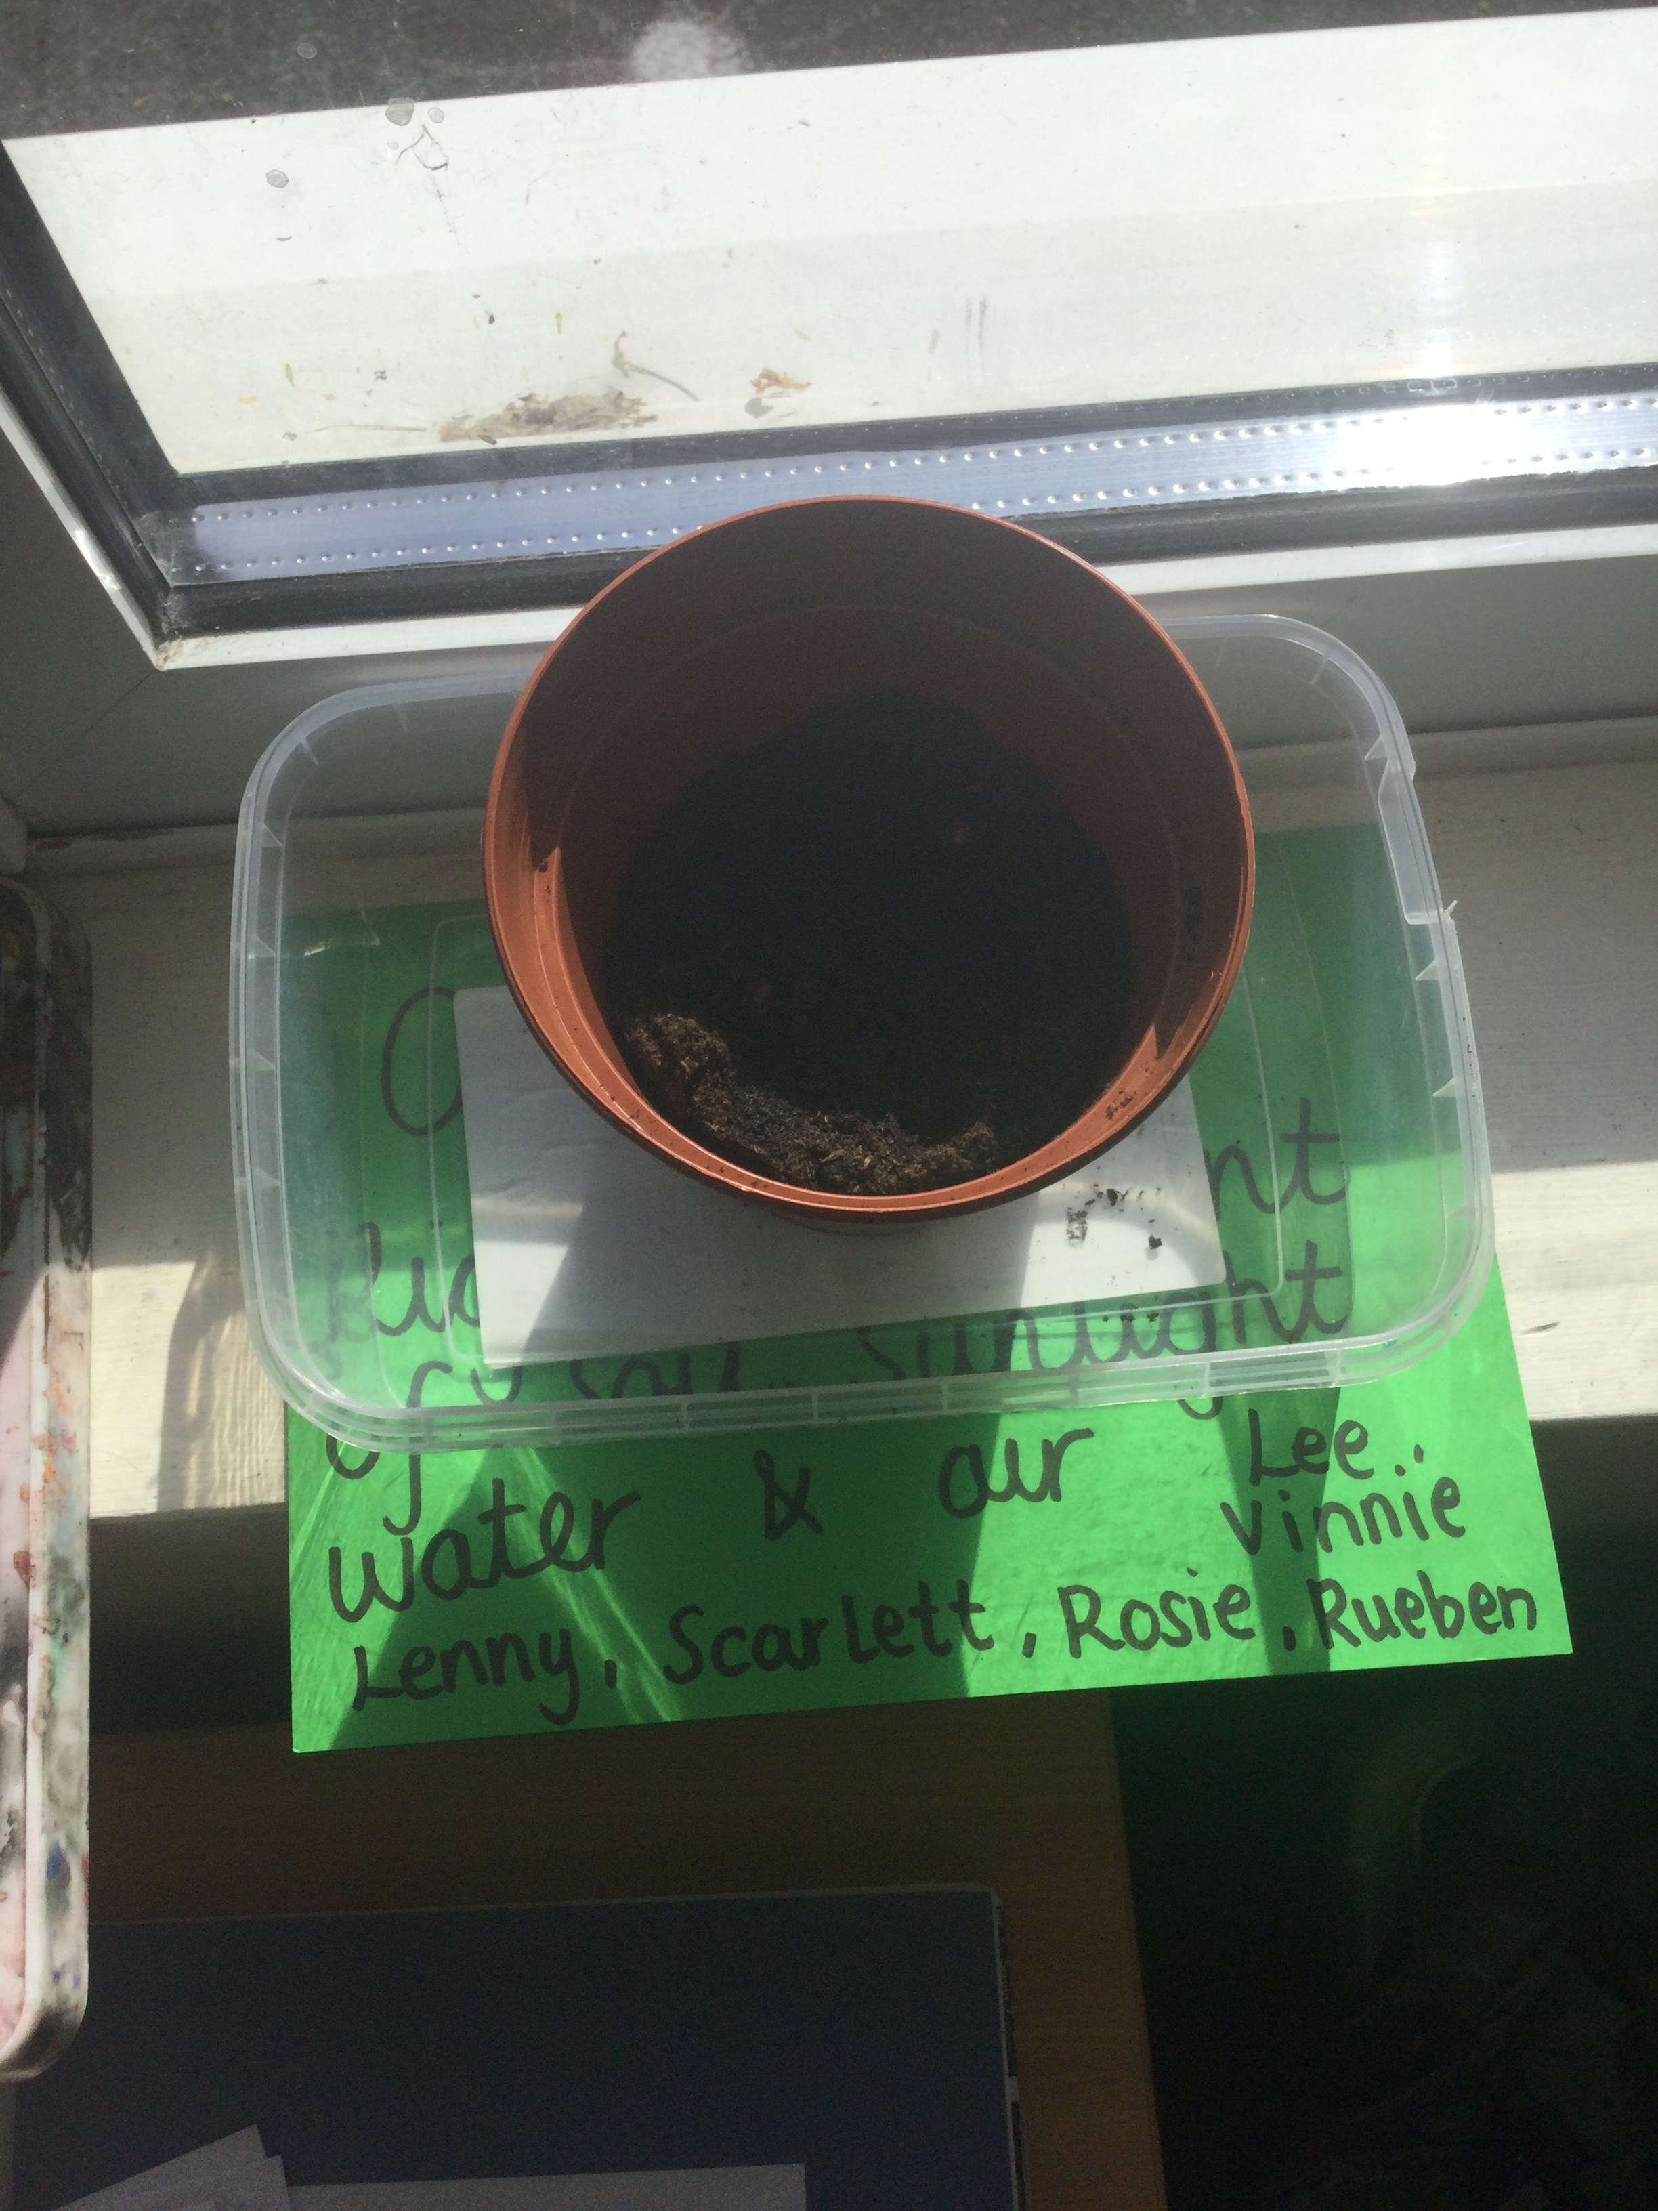
This half term, Year 3 have been experimenting with plants in science. In the main experiment, we tested different variables to see what works best to make a plant strong. The control had enough water, light and soil to help it grow as it should. The plant with little light grew very tall, but it was very weak, while the others did not grow anywhere near as much as the control. We also experimented with wilted celery and food colouring, showing how plants draw up and distribute water.
Away from science, our maths work has also been very hands-on this half term with lots of estimation and measuring of weight and capacity. A particular favourite was estimating the capacity of a range of different-sized bottles, using a 500ml drink bottle as our start point.
In History, we began to compare the eras we have learned about, deciding whether we would prefer to live in the stone age or the bronze age. Children debated their reasons for choosing one or the other and really showed off their oracy skills!

Year Four
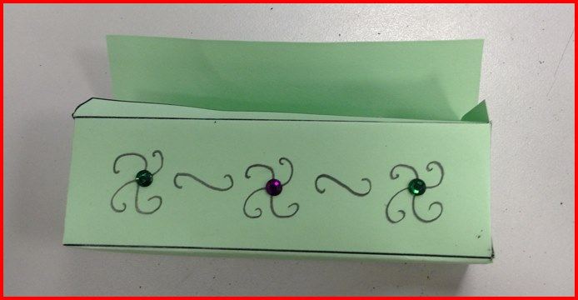
We’ve had a busy and exciting time in Year 4! Here’s a snapshot of what we’ve been learning recently and some important reminders.
In History, we have been exploring the fascinating world of the Ancient Maya civilisation. The children have learnt about where the Maya lived, their achievements, and what life was like in their society. They’ve especially enjoyed discovering how the Maya used clever systems for farming, writing, and mathematics. Linking to our history topic, we have designed and created our own Mayan treasure boxes in DT.
In Science, we are learning all about sound. We have been investigating how sounds are made, how they travel, and how we hear them. A highlight was using VR headsets to explore the inside of the ear, helping us to understand how sound vibrations are processed in a fun and interactive way.
In English, we have been reading the story “Rain Player”, which links beautifully to our Maya topic. The children have been inspired by the story to write their own newspaper reports, focusing on key events and using formal journalistic language. We’ve seen some fantastic writing!
📢 Important Reminder
As we approach the end of the year, please remember that the Year 4 Multiplication Tables Check (MTC) is coming up. We encourage children to continue practising their times tables regularly at home to build confidence and fluency.
Thank you for your continued support!
⭐ The Year 4 Team ⭐

Year Five
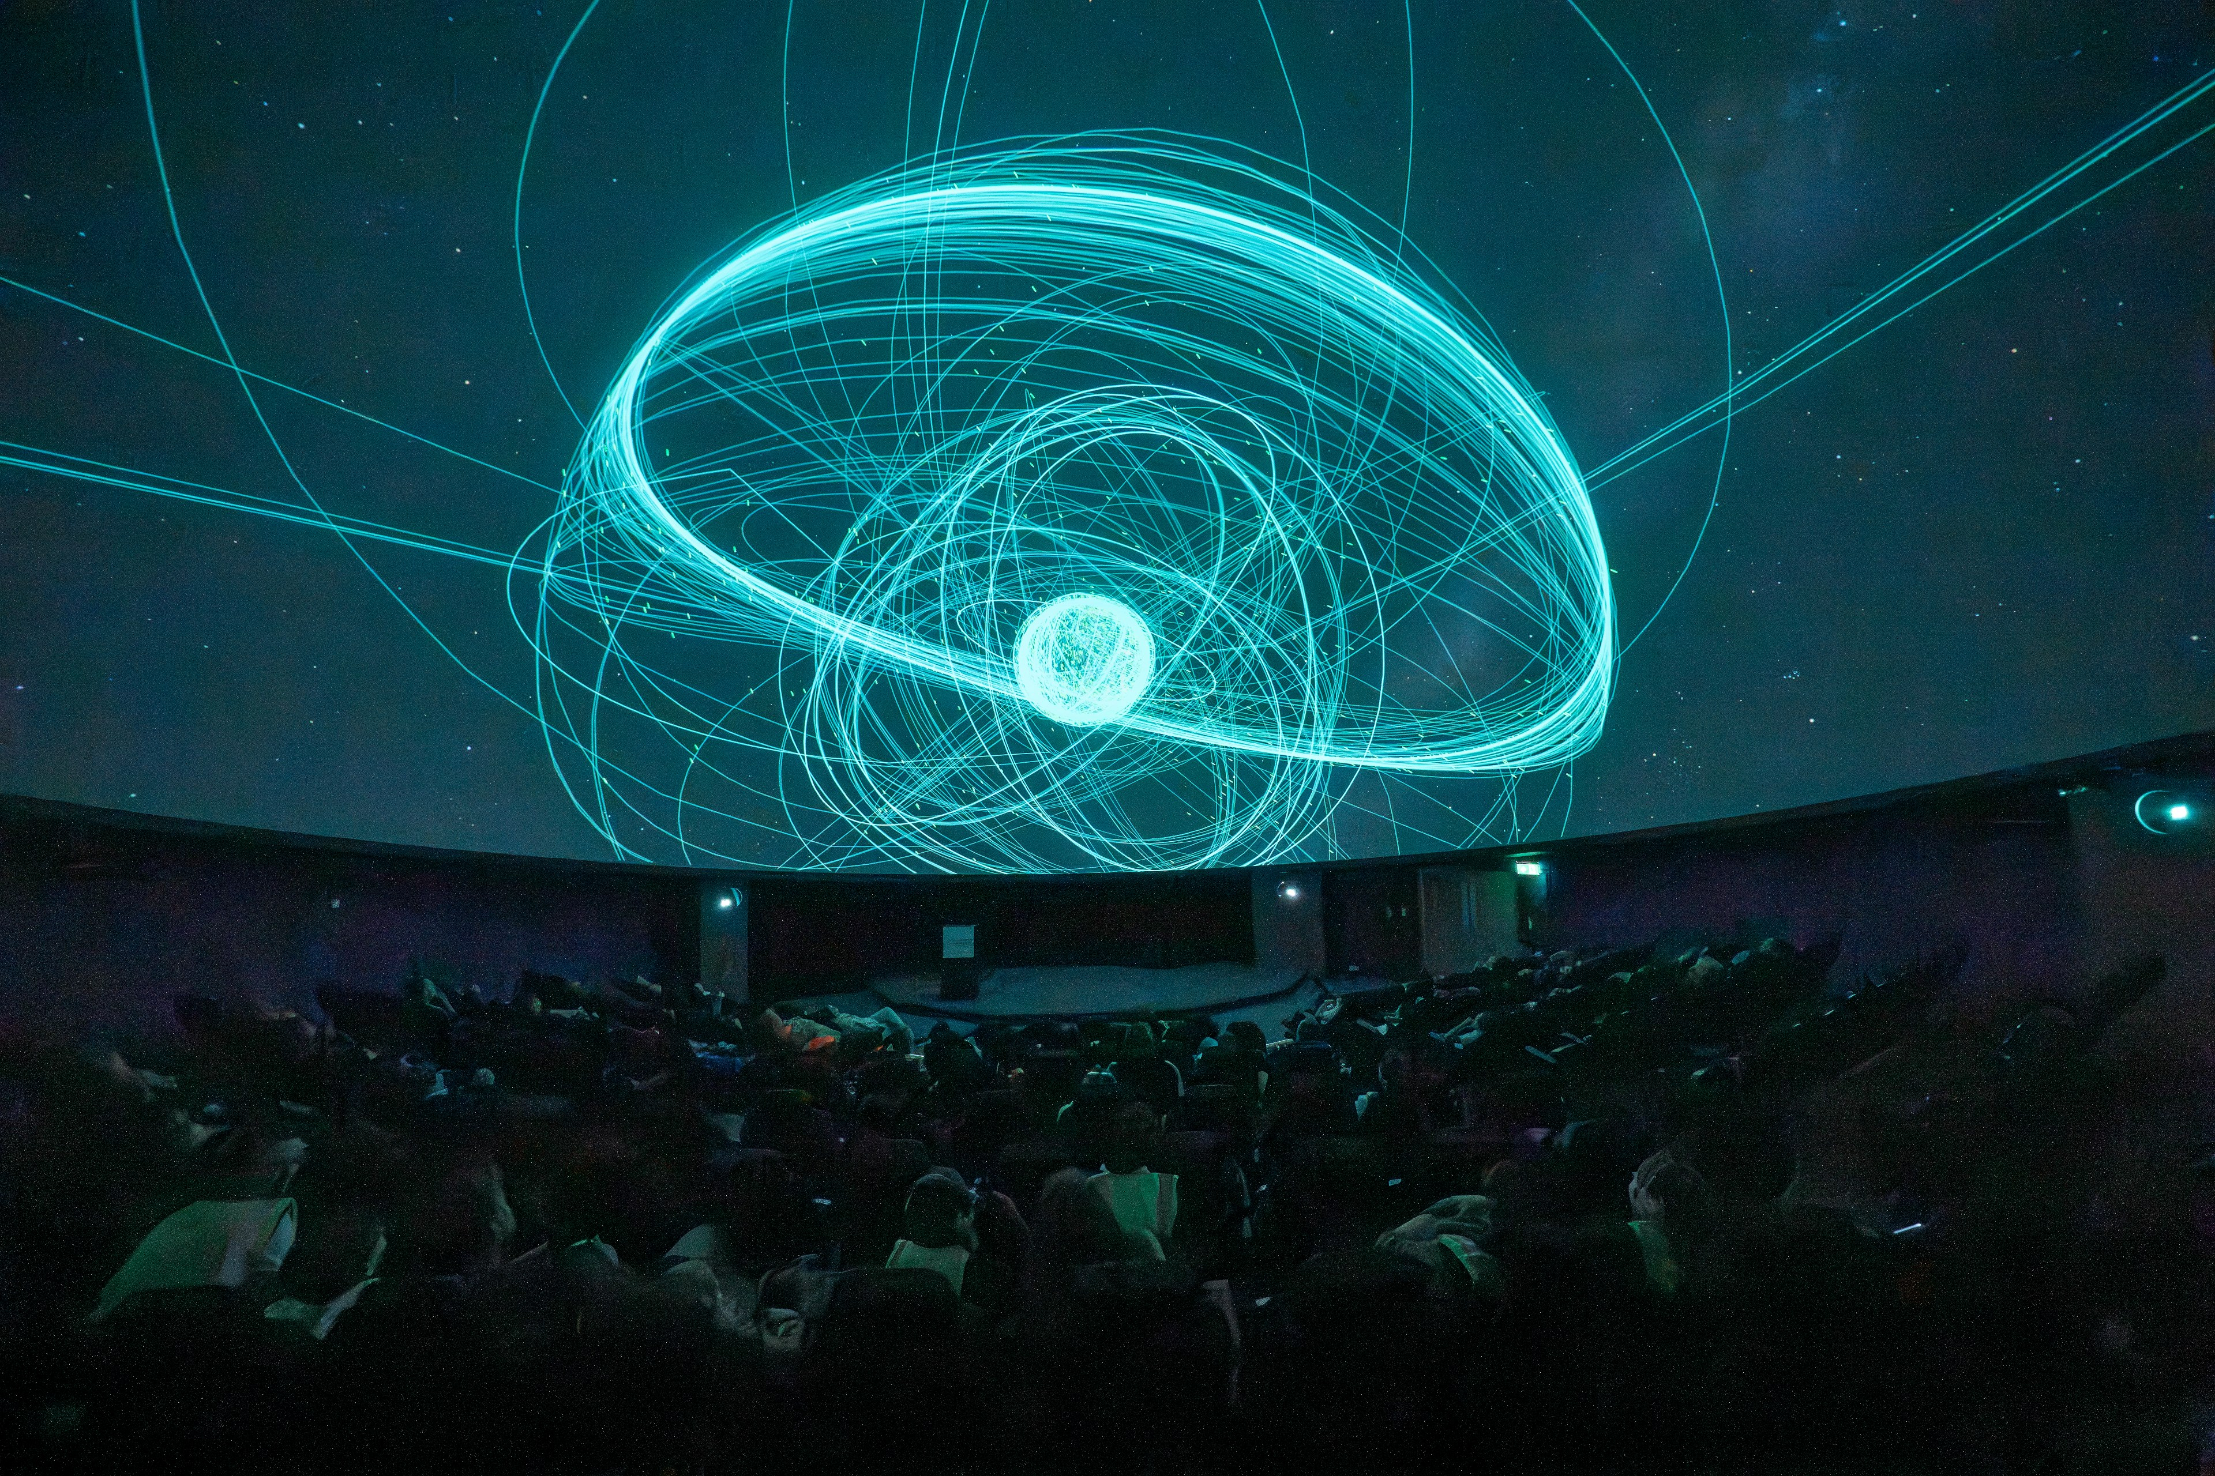
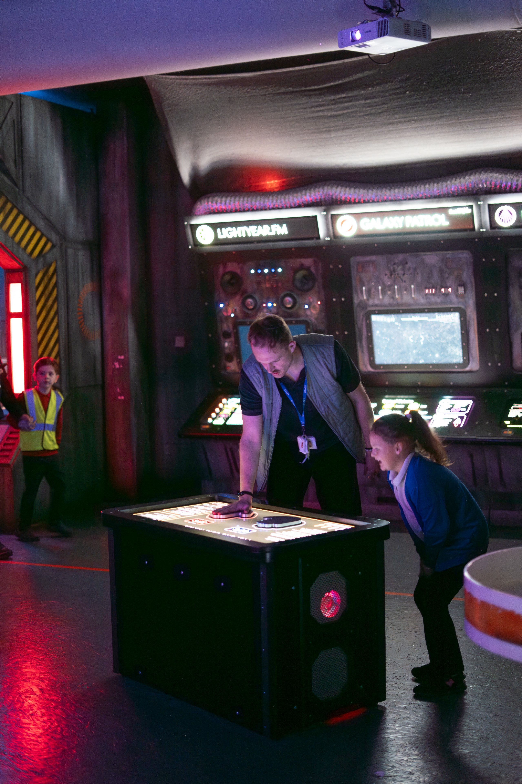
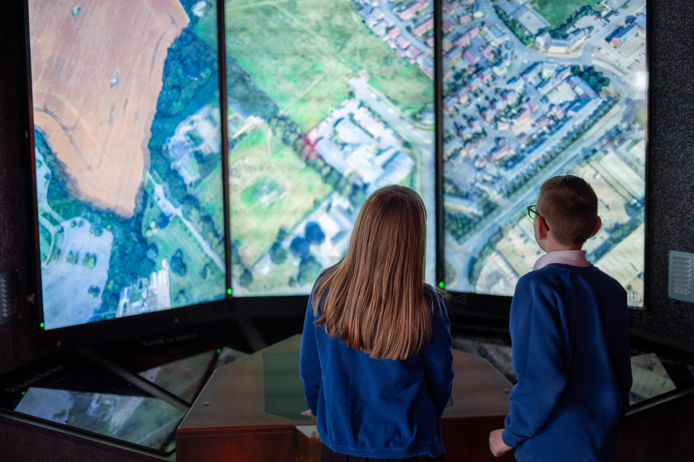
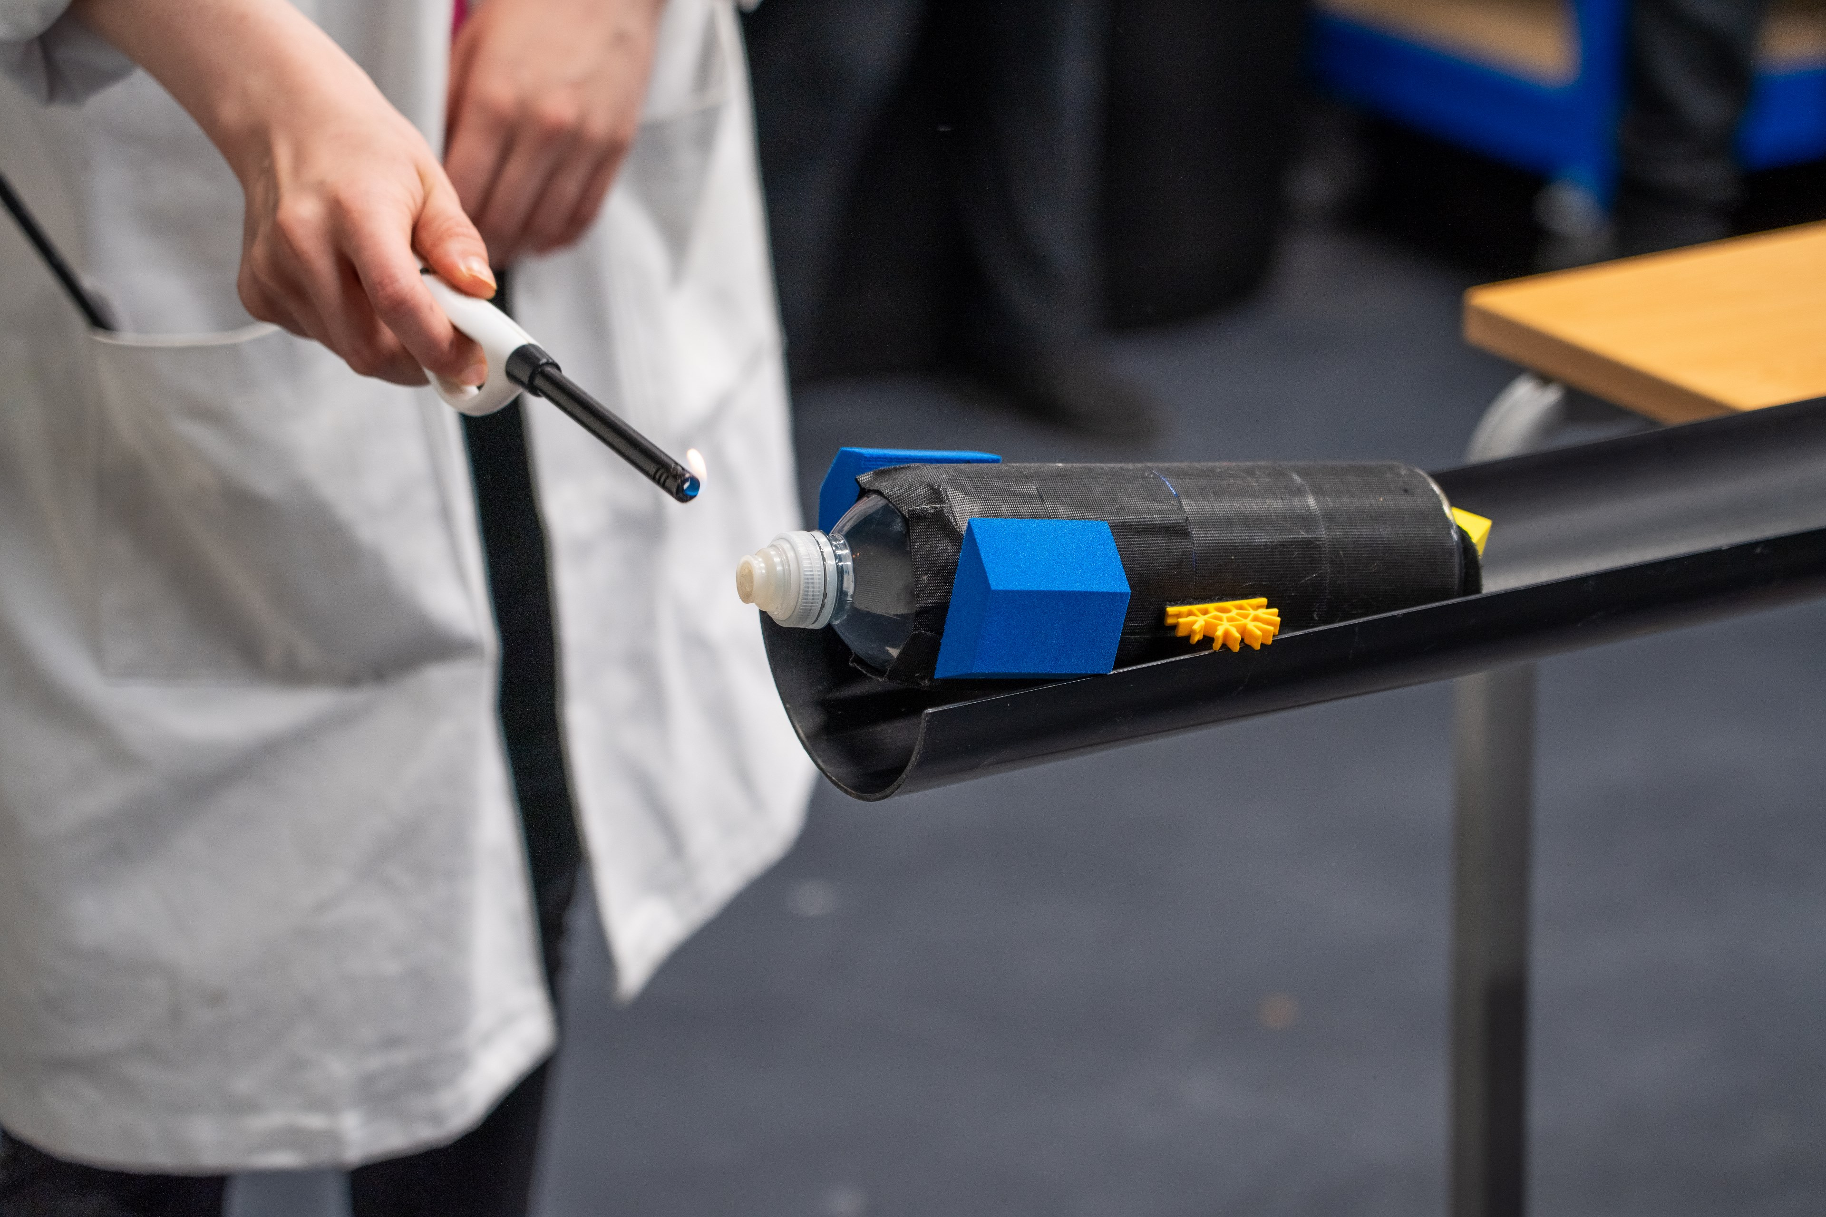
Year 5 have had a vibrant and memorable Summer 1 half term, filled with exciting experiences and opportunities to deepen their learning. A particular highlight was our trip to the Winchester Science Centre, where pupils explored hands‑on exhibits and engaged in fascinating workshops that brought scientific concepts to life. Their curiosity, enthusiasm and excellent behaviour made it a truly special day.
The children also embraced our ‘Triathlon’ magic moment, showing determination, teamwork and resilience as they took on a series of physical challenges. It was wonderful to see their perseverance and encouragement of one another throughout the event.
Stepping back in time, Year 5 fully immersed themselves in a Victorian school day. They experienced strict classroom routines, practised handwriting on slates, and gained a deeper appreciation for how education has changed over time. This linked brilliantly with their learning about the remarkable life and work of Sir David Attenborough, where pupils developed a strong understanding of his impact on wildlife conservation and the natural world.
In art, the children greatly enjoyed creating beautiful ink prints inspired by William Morris. Their creativity and attention to detail shone through in their intricate patterns and designs.
Looking ahead, we are thrilled to launch our Times Tables Rock Stars competition, ‘The Final Year 5 Frontier’, next half term, with exciting prizes to be won!
Finally, we encourage everyone to keep attendance high so that pupils do not miss out on the many fantastic opportunities coming in Summer 2.

Year 6
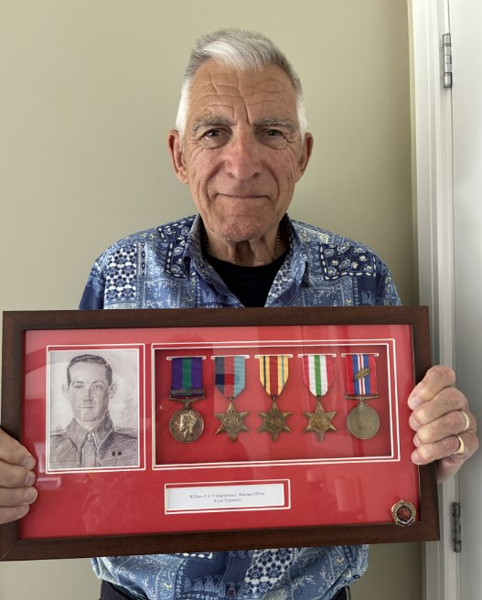
1 - Frank, one of our Govenors, visited us to talk about his experiences of World War 2 and share his father's war medals.
This term has been a busy one and probably the most important one for our Year 6s so far.
As part of our History learning on World War II, we were delighted to welcome our governor, Frank, into school to share his personal experiences. He spoke to the children about his time as an evacuee, offering a fascinating and heartfelt insight into what it was like to leave home and live with a host family during the war. The children were completely captivated and absorbed by his stories, asking thoughtful questions and showing great curiosity.
Following this, the children produced some truly insightful letters written from the perspective of an evacuee. They demonstrated a fantastic range of Year 6 writing skills, combining historical understanding with creativity and empathy. Mr Osborne thoroughly enjoyed visiting the classes to listen to the children perform their work, and it was wonderful to see their confidence, engagement and fantastic oracy skills.
We continue to be immensely proud of the children for their excellent effort and determination during their SATs. To celebrate this achievement, they enjoyed a well-deserved ice cream treat, which was a lovely way to recognise all of their hard work. As a team, we are also incredibly thankful to parents and carers for their continued support throughout this important time.
As we look ahead to Summer 2, there is still so much to look forward to, including our exciting trip to Paultons Park and the Year 6 Leavers’ Assembly. Please keep an eye out for further details and key dates.
We look forward to welcoming the children back in what will be their final term.

Attendance
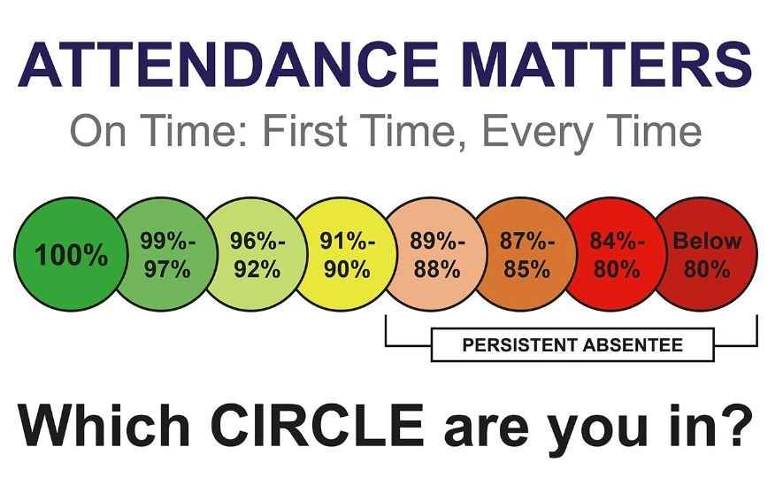
The government have placed huge emphasis on the monitoring of attendance in schools and have published guidance on 'improving attendance in school'. This initiative stems from vast research that proves that children who achieve great academic success in Year 6 (KS2 SATs) and Year 11 (GSCEs) are those same children who have good attendance in school above 96%. We want (as I am positive you do too) for your child to have the best opportunities in life and to grow up to be successful young adults. To ensure this, it is our joint responsibility to ensure children receive their entitlement and right to an education, this means attending school every day. We have shared with you our school's approach to managing and challenging poor attendance. If you have any questions, please feel free to contact us.
Moments Matter / Attendance Counts. We are working hard to support you and your children overcome their barriers to attending school every day and on time - if you need help or support please see Nicki Windle, Jan Carr or Charlotte Dugdale. Let's work together to make sure your children don't miss out!

ELECTION OF PARENT GOVERNORS: NOMINATIONS

Admissions
Admission information for 2027 to follow shortly.

After School Clubs
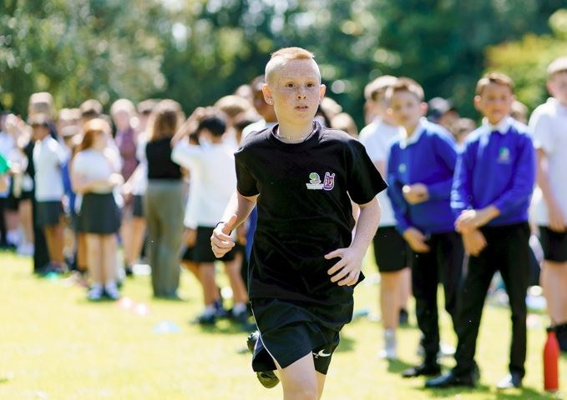
The following after school activities still have spaces. If you are interested, please contact either office.
Weston Park Primary
Monday -
- Board Games - Years 1 & 2
Tuesday -
- Choir - Years 4, 5 & 6
Friday - No school run clubs available

Weston Shore
Tuesday -
- Paper Art - Years R, 1 & 2

Superstar Sports
We have partnered with Superstar Sports who provide wraparound after school clubs for Weston Park pupils. These clubs run from 3.15pm - 5pm. For more information please visit their website www.superstarsportsuk.com or call them on 02382 127331 to book.
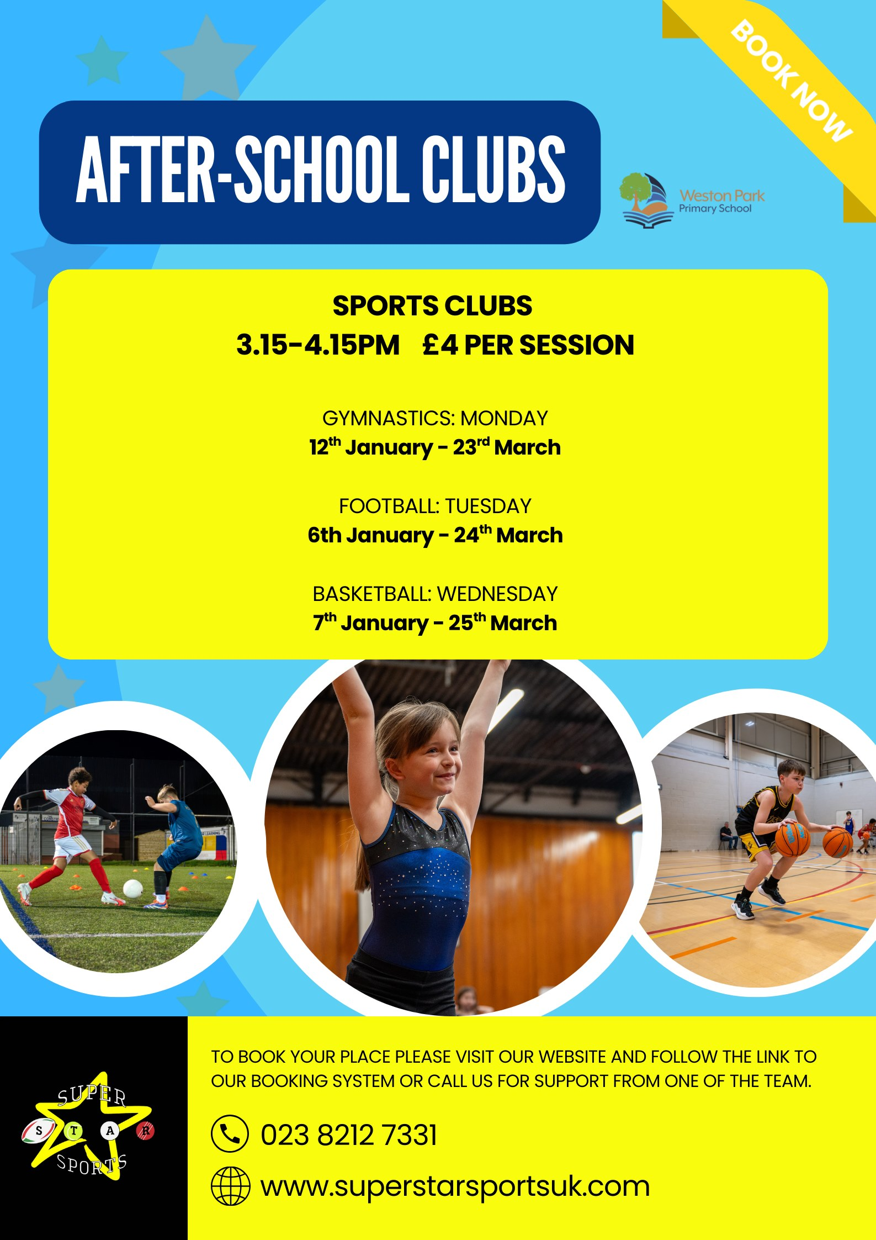
2 - Superstar Sports clubs available for Weston Park

Key dates

1/6/26 - Inset Day
2/6/26 - First day back of Summer Term 2
2/6/26 - 12/6/26 - Year 4 Multiplications Tables Check
5/6/26 - Run Weston Run event??????
8/6/26 - 12/6/26 - Year 5 Bikeability
17/6/26 - Class Photos - Weston Shore
19/6/26 - Class Photos - Weston Park
1/7/26 - Transition Day to new Year groups
7/7/26 - Year R, 1 & 2 and Weston Shore Sports Day (times to be confirmed)
8/7/26 - Years 3, 4, 5 & 6 Sports Day (times to be confirmed)
15/7/26 - Year 6 Paulton's Park Trip
22/7/26 - Last day of Summer Term 2
1/9/26 - 2/9/26 Inset Days
3/9/26 - First Day of Autumn Term 1

For further dates please see our websites.

Community News


Wake up Wednesdays
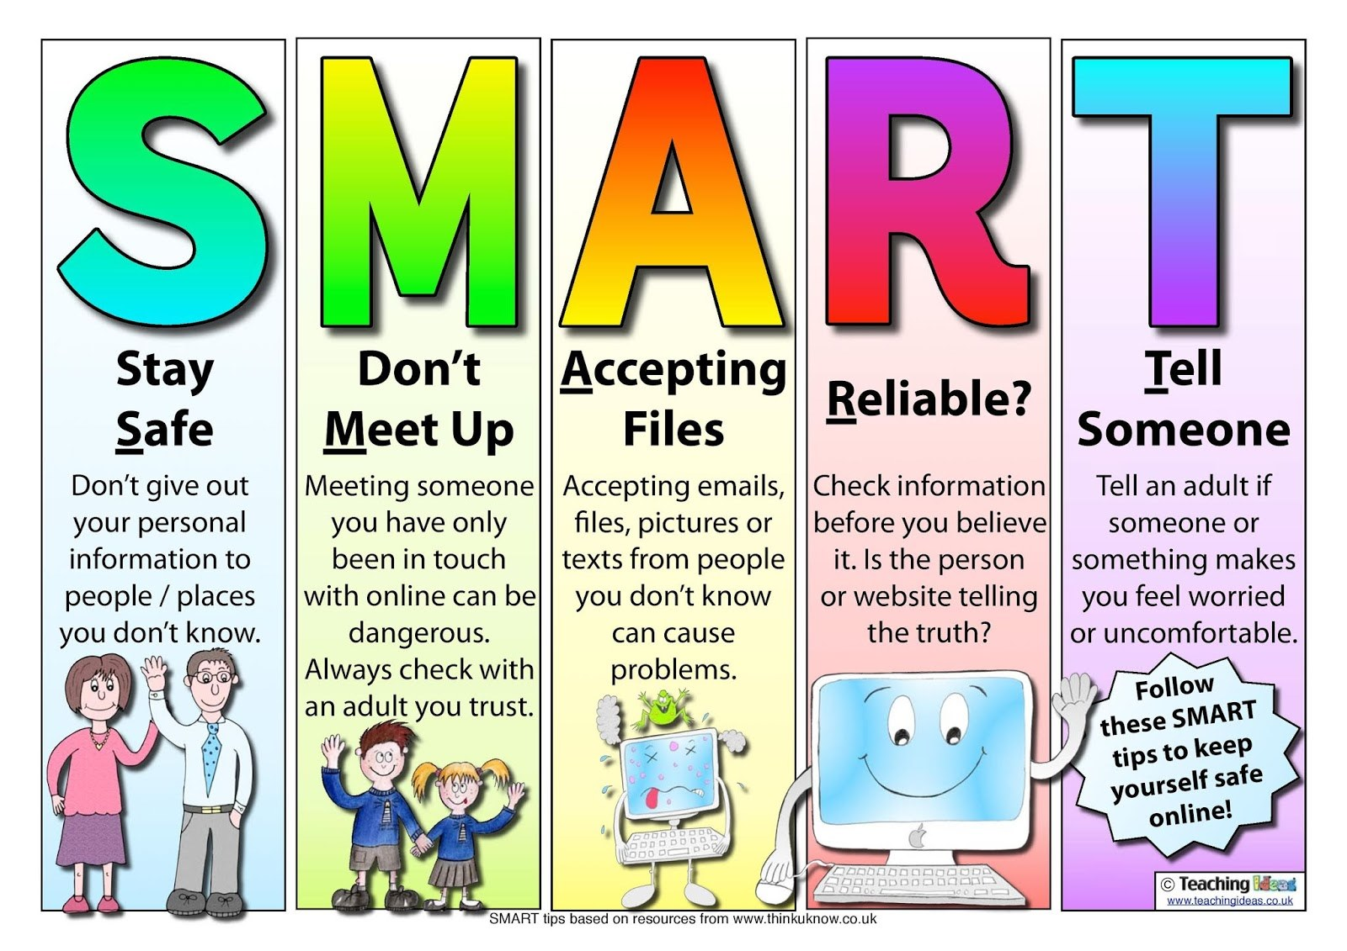
Understanding online safety is tricky for all ages, so we have joined forces with the Wake Up Wednesday campaign to keep you updated with tips and tricks for keeping your children safe whilst online. So, every Wednesday keep an eye out on our Website and social media pages for the latest online safety advice.

SEND News Splash
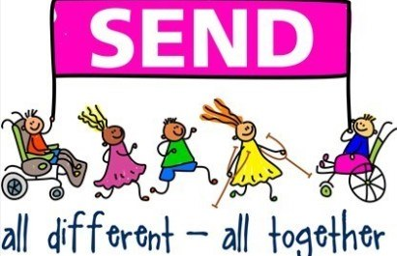
We are very excited to be sharing SEND News Splash!
This will be a half termly newsletter where we will share any updates, support and overall successes that are happening in the world of SEND.
As always if you have any concerns or would like to talk about your children regarding supporting them in their neurodiversity please contact Miss Windle who will be happy to support where they can.

Keeping Children Safe Online
Miss Windle will be holding a series of online safety sessions for parents during the Spring term. These sessions are designed to help families understand how to keep children safe online and support responsible digital behaviour at home.
Further details, including dates and how to join, will be shared soon.

NVR is back!
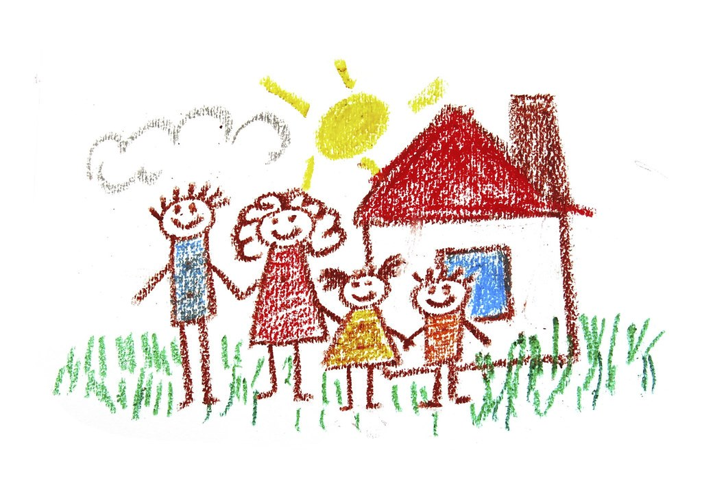

We’re excited to remind families that our Non‑Violent Resistance (NVR) parenting course. This supportive programme is designed to help parents and carers develop practical strategies for reducing conflict, strengthening relationships, and creating a calmer, more harmonious home environment.
Please keep an eye out for further details, we’d love as many families as possible to benefit from this valuable opportunity.

Book review: Mrs Windle
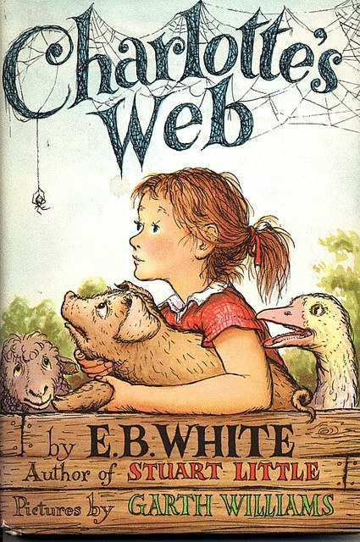
Charlotte’s Web by E. B. White
Reviewer: Mrs Windle
Hello everyone,
It’s Mrs Windle here, and I’m delighted to share my review of a beautiful and much‑loved story: Charlotte’s Web by E. B. White. This book follows the unlikely friendship between a lively little pig named Wilbur and a gentle, intelligent spider called Charlotte, who lives in the corner of his barn.
At the start of the story, Wilbur feels lonely and unsure of his place in the world. But everything changes when Charlotte decides to help him in the most extraordinary way—by spinning special words into her web. These magical messages amaze the humans on the farm and begin to change Wilbur’s future. As the seasons pass, we see how kindness, bravery, and loyalty can make even the smallest creatures truly remarkable.
I enjoyed this book because it teaches us about the power of friendship and the importance of looking after each other. Charlotte’s quiet wisdom and Wilbur’s hopeful heart make the story both moving and memorable. It also encourages us to appreciate the wonders of nature that we might usually overlook.
I highly recommend Charlotte’s Web to anyone who enjoys stories filled with warmth, adventure, and gentle magic. A wonderful 5‑star read!

Contact
Weston Park Primary School
Newtown Road
Southampton
SO19 9HX
Tel: 023 8044 8962
Email: info@weston-park.org.uk
Our Business Manager, Teresa Bulpett, or Senior Admin Officer, Tasha Coleman, will be happy to help.

Weston Shore Infant School
Foxcott Close
Southampton
SO19 9JQ
Tel:023 8039 0399 or 023 8039 0400
Email: info@westonshore.co.uk

