Weston Schools Federation Weekly Winners & Attendance Newsletter

Celebration - Friday 5th June 2026
At Weston Schools' Federation, we celebrate and value children being in learning because it fosters a love of education and personal growth. By working hard and meeting our core values - being safe, responsible, respectful and being a learner, - pupils thrive academically and socially, becoming well-rounded individuals ready to succeed in school and beyond.
Congratulations to the following children who have been awarded the 'Pupil of the Week' certificate this week for upholding the Weston Schools' Federation core values.

Reception

Class FD winner is Reggie
Reggie has been a superstar in Phonics this week! He has been spelling CVC words such as ‘sat’ and ‘top’. He has also been really excited about our new topic, saving the sea creatures. He made a poster about pufferfish! He is a delight to have in the class. Well done Reggie!

Class FR winner Violet
Violet is such a fantastic member of our class. We are really proud of the confidence Violet is showing during oracy and when standing to give an answer during lessons. Violet can talk to others about her learning and what she plans to do during discovery time. Violet is kind, caring and always polite. Well Done Violet!

Class FC winner is Alayia
Everyday Alayia demonstrates what it is like to be an Outstanding member of her class, her school and her federation. She always follows our code of conduct by being safe, responsible, respectful and being a fantastic learner.
Alayia always shows respect by listening to her teachers and her friends. She turns her whole body to listen to her peers in Oracy and remembers what her friends have told her in pair work.
Alayia, we are incredibly proud of you and your journey so far at Weston Shore.
We hope you are really proud of yourself!

Year One

Class 1R winner is Rickie
Rickie has had a fantastic week! He has shown a very positive attitude and has put great effort into everything he has done. Rickie has been really engaged in his learning and has worked incredibly hard. He has excelled in our money lessons and has also produced some wonderful descriptive writing.
Well done, Rickie—we are so proud of you!

Class 1G winner is Finley
You have had a fantastic week and shown incredible resilience with your writing. Your can -do attitude has enabled you to create descriptive sentences with a range of adjectives. You are always so focused and accurate in phonics which encourages others to do the same. We are really proud of the hard work you are doing.
Well done Finley- keep up the great work!

Class 1S winner is Esmae
Esmae consistently demonstrates excellent listening by turning to track the speaker and giving her full attention. She speaks with growing confidence when sharing ideas, always tries her very best, and regularly goes above and beyond. It has been wonderful to see her resilience develop each day as she perseveres even when things feel challenging. Esmae is a fantastic role model for responsibility, always being the last to help ensure the classroom is tidy and ready for learning. Thank you for being amazing!

Year Two

Class 2M winner is Kobi
Kobi always shows respect to all of his classmates and makes sure that his friends are happy by showing them kindness. He looks out for others and shows care and consideration when his friends are upset. Additionally, he has worked really hard this week, trying hard to focus on his learning and trying his absolute hardest with his work. I have been particularly pleased with the effort he made in a recent reading quiz to make sure he read the questions carefully. Well done Kobi, you are a superstar!!

Class 2A winner is Calla

This week Calla has impressed us with her ability to respectfully put across her ideas and include those around her to ensure everyone is happy. She has shown great teamwork and flexibility when working with those around her as well as making sure her thoughts, feelings and ideas are heard. She is kind to everyone and spreads happiness with her infectious smile! Well done Calla!

Class 2T winner Joshua

Joshua has come back after half term with a fantastic attitude and is working hard to learn our classroom routines. He engages positively in all tasks and tries his best in every lesson, showing he is a great learner.
I have been so proud of his “never give up” attitude, especially when applying his phonics knowledge. Joshua shows our school values by being responsible, respectful, and helping to create a safe classroom environment.
We are all very proud of him—well done, Joshua!

Year Three

Class 3RM winner is Corly
Corly has begun this final half term brilliantly! He has come back with a positive energy and is putting 100% effort into all his work. He is focussing hard on his handwriting, and this has been evident in his writing this week. Corly brings an enthusiasm to the classroom, and I can’t wait to see the progress he makes in this final push before Year 4! Keep it up Corly!

Class 3TJ winner is Arlo
This week, Arlo has shown incredible effort across all of his work, but his determination and progress in maths have been especially impressive. He has approached every challenge with a positive attitude and worked hard to improve his understanding.
Well done Arlo, keep it up!

Class 3D winner is Teddie
Teddie has had a magnificent week. She has demonstrated all the core values, especially being a learner. She absolutely smashed her addition, subtraction and telling the time lessons and amazed us with her excellent use of prepositions in writing. Well done Superstar Teddie!

Year Four

Class 4C winner is Pheobe
This week, Pheobe has shown that with her focused determination over the past weeks, her handwriting and presentation has improved. Across her books, she makes sure she has clear finger spaces and that her letters go below the line. Pheobe now takes extra care when writing sentences.
Well done Pheobe! Keep it up!

Class 4V winner is Perrie
Perrie has had an exceptional week showcasing her oracy skills and hard work in writing and maths. Perrie always works hard to complete her work to a high standard and she has done this in every subject, every day this week. An absolutely fantastic effort! Well done, Perrie!

Class 4K winner is Elsie-May
This week, Elsie has been working incredibly hard and has shown some good understanding of her learning. She is always polite, well mannered and kind towards her peers. Keep up the hard work, you are a star!

Year Five

Class 5F winner is Ronnie
Ronnie has had a hugely improved week. I have been very impressed with how he has treated others with respect and maturity. Additionally, in writing, Ronnie has chosen a range of high-quality vocabulary that has engaged his readers.
A huge congratulations on a successful week, Ronnie!

Class 5D winner is Albie
Albie has been helpful, kind and considerate to members of the class throughout the week. What a fantastic start to the new half-term.

Class 5G winner is Jerry
Jerry has made a fantastic start at Weston. He is a lovely member of 5G and shows a very caring attitude towards others. I have been really impressed with the progress he has made in reading. Keep up the great work!

Year Six

Class 6G winner is Liam
Liam has excited his audience this week with his sharp, energetic writing with his action sequence. His writing burst with tension, vivid detail and fast paced moments. It will be exciting to see how he applies this to his independent writing. Well done Liam!

Class 6P winner is Imogen F
Imogen has been awarded Pupil of the Week as she has made an excellent start back after half term. She has entered her final half term at primary school with such maturity and has demonstrated all of our schools core values. Imogen has also demonstrated kindness and patience when trying to support other children in the class.

Class 6L winner is Lexon
I have been really impressed with Lexon this week. He has shown excellent focus in lessons and a strong determination to do his very best. Over the course of the year, he has consistently made us proud with his positive attitude towards learning and his willingness to improve and succeed. Keep up the great work Lexon!

Weekly Appreciations

At Weston Schools Federation, one of our key Oracy Benchmarks is “Values Every Voice.” This reflects our commitment to ensuring that every child is supported to take part confidently in spoken language activities and to know that their ideas matter.

This week, our children have been practising this benchmark by expressing gratitude and sharing kind words with others. Below, you’ll find some of the thoughtful messages of thanks they have chosen to share.
Year R - Pazu - "I appreciate friends"
Year 1 - Malachite– "I would like to show my appreciation to Miss Rivitt because she always helps me with my learning."
Year 2 - Cooper. My mum and dad. My mum got my Titanic dressing up outfit. My dad got all the stuff out I needed to make my Titanic home learning!"
Year 3 - Summer. I would like to show appreciation to Somaiya because she is a good friend.
Year 4 - Maggie - "I appreciate Miss Cornell for helping me improve my handwriting."
Year 5 - Fabian, "I want to show appreciation to Harry for always lending me his glue."
Year 6 - Noah - "I would like to show appreciation to Rory for always being a good friend."

Attendance
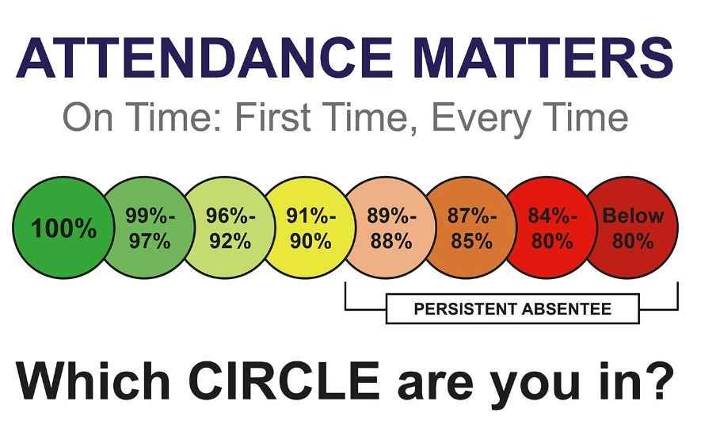
The government have placed huge emphasis on the monitoring of attendance in schools and have published guidance on 'improving attendance in school'. This initiative stems from vast research that proves that children who achieve great academic success in Year 6 (KS2 SATs) and Year 11 (GSCEs) are those same children who have good attendance in school above 96%. We want (as I am positive you do too) for your child to have the best opportunities in life and to grow up to be successful young adults. To ensure this, it is our joint responsibility to ensure children receive their entitlement and right to an education, this means attending school every day. We have shared with you our school's approach to managing and challenging poor attendance. If you have any questions, please feel free to contact us.
Moments Matter / Attendance Counts. We are working hard to support you and your children overcome their barriers to attending school every day and on time - if you need help or support please see Nicki Windle, Jan Carr or Charlotte Dugdale. Let's work together to make sure your children don't miss out!

Weekly Attendance

This weeks attendance winners are Year 2 in Weston Shore and Year 2 and Year 5 at Weston Park.
Congratulations to all the children in the winning year groups, what an outstanding attendance this week! Your dedication to being present and engaged in your learning is truly commendable. Keep up the fantastic work, and continue to set a great example for the rest of the school.

Safety at Weston Schools' Federation
At Weston Park Schools Federation, we learn how to stay safe in lots of ways. Our curriculum teaches children about online safety, road safety, health and wellbeing, and how to keep themselves and others safe. Pupils practise speaking up, asking for help, and making sensible choices. Assemblies, visitors from the community, and regular drills help reinforce key messages, ensuring children feel confident, supported, and safe every day at school. Working together builds trust, awareness, and responsibility across our school community.


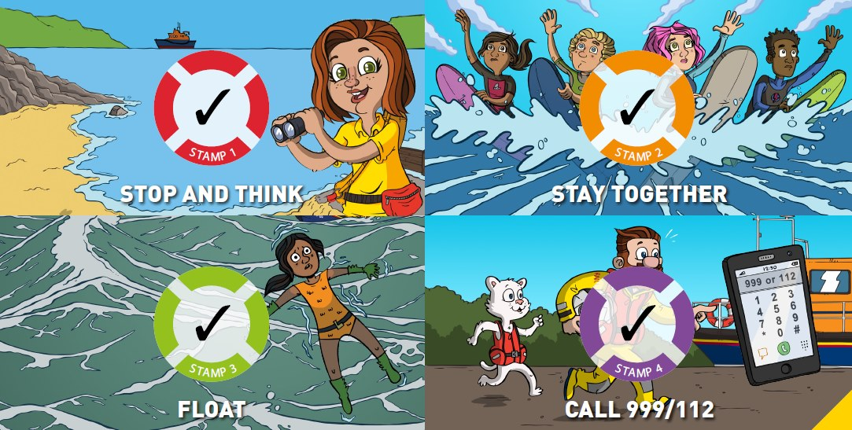

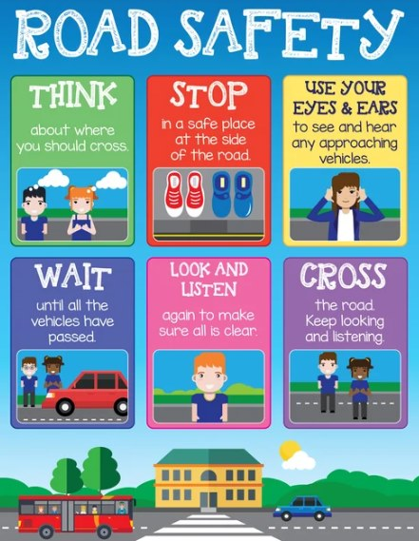
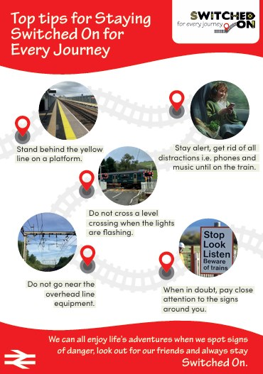

Admissions
Hamwic Education Trust are now consulting on the Infant/Primary Admissions Policy, Southampton Partnerships for 2027 – 2028. The consultation ends on 24th January 2026. There are no changes to PAN or oversubscription criteria for Weston Shore Infant School or Weston Park Primary School. There is a proposed reduction in PAN to 60 for Glenfield Infant School.
Please click on the following link to access our admissions policy - Admissions - Weston Park Primary School
If you have any comments you would like to make about the policy, please send them to Claire Shaw, Education Access Officer, at claire.shaw@hamwic.org

Contact
Weston Park Primary School
Newtown Road
Southampton
SO19 9HX
Tel: 023 8044 8962
Email: info@weston-park.org.uk
Our Business Manager, Teresa Bulpett, or Senior Admin Officer, Tasha Coleman, will be happy to help.

Weston Shore Infant School
Foxcott Close
Southampton
SO19 9JQ
Tel:023 8039 0399 or 023 8039 0400
Email: info@westonshore.co.uk

