

Weston Schools Federation
Designated Safeguarding Lead is Nicki Windle
Contact on 02380448962
n.windle@westonschoolsfederation.co.uk

Key Reminders:
The weather is changing, and it is getting warmer and the sun is shining. Please make sure the children have what they need to be safe in the sun as it warms up – bottled water, sun hat, sun cream…
Hello and welcome to our monthly safeguarding newsletter / update.
If there is any aspect of safeguarding and staying safe you would like us to share please let one of the team know.

Attendance Matters!

At Weston Shore Infant School and Weston Park Primary School we aim for every child to achieve and be successful during their time at school, providing them with endless opportunities for life.

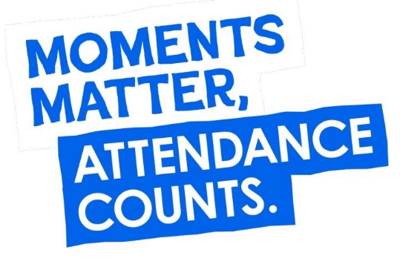



To promote positive attendance, we offer the following for all children –
- Termly events like a school disco during the school day
- Magic Moments – these have included taping Mr Wiltshire to the wall, throwing wet sponges at SLT, inflatables, sensory play, a pantomime and more! These can happen at any time on any day – make sure your child is in school to take part.
- Attendance stamps to ‘spend’ in the school attendance shop
- Postcards home, class attendance bears, extra breaks and more…

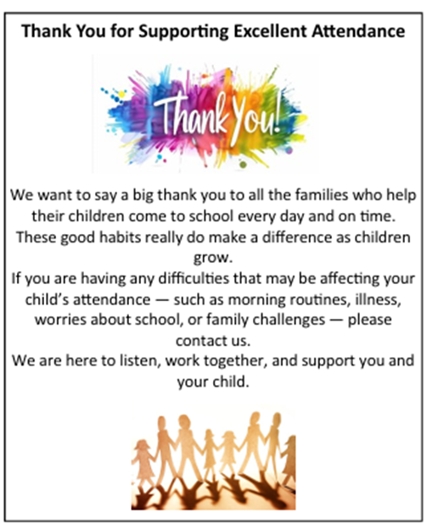

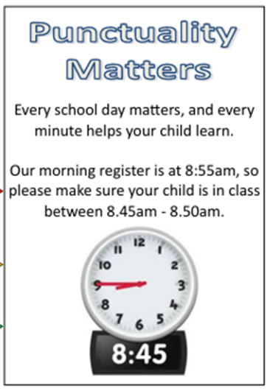



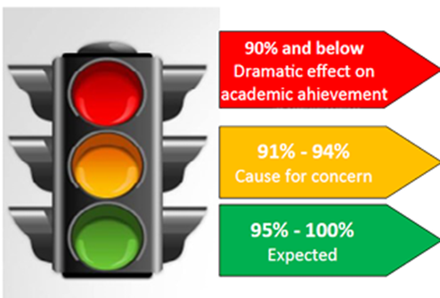





W
We asked the children why it was important to come to school every day- this is what they said –

1 – you see your friends and have fun
2 – you learn new things
3 – you increase your chances of a good job
4– new experiences
5 – sense of belonging
6 – it’s the law!



We asked the children why it was bad not to come to school every day- this is what they said –

1 – you may develop bad habits, like doing nothing
2 – you won’t have such good friendships
3 – you may have less success in getting a job
4 – you will miss out – on lots of different things!
5 – you will feel left out or like you don’t fit in
6 – grown-ups at home will get into trouble.

What the law says?

As a parent / carer, ensuring your child’s regular attendance at school is your legal responsibility and permitting absence from school without good reason is an offence and may result in referral to the Education Welfare Service, the issue of Penalty Notices and fines and eventually prosecution.

We understand that there can be tricky times and so we offer our full support with any attendance issue … communication with us and keeping us in the loop is the key.



If there are problems, we will do everything that we can to make attending school as simple as possible whilst ensuring your child is happy and reaches their full potential.

Charlotte Dugdale
Attendance Officer


Jan Carr
Pastoral Support


Nicki Windle
Attendance Champion


If there are ever any problems, please do not hesitate to come and see us.

